North Carolina’s Southeast Competitive Positioning 2020
Executive Summary
To continue to be successful, North Carolina’s Southeast is engaged in a process of continuous improvement. This report provides the region with actionable intelligence that will anticipate future business opportunities and lead to more marketing success. Throughout the report national best-practice examples provide ideas that can be used in the region.
We came into 2020 facing trends like urbanization, slowing globalization, and disruptive technological transformation. The Covid-19 pandemic has accelerated many trends and created new opportunities for industry reshoring and talent relocation. The future of value-added agriculture, the defense sector, health care, foreign direct investment, and outdoor recreation is in transition and will have a profound impact on the region’s economy.
Workforce skills and availability remains the top competitive issue. Successful places balance the demand for a growing, skilled workforce with abundant education and training resources. The Southeast’s school systems and higher education institutions have responded to the challenge with a broad range of opportunities, but more must be done. Population growth is mixed across the 18 counties with projections showing the trends will continue. More focus on specific occupation training, better information to encourage increased interest in skilled trades and a talent attraction effort are needed to better meet employer needs.
The Targeted Industry analysis recommends that the region target Advanced Textiles with a focus on health and safety, Value-Added Agriculture and Food Processing, Medical Technology with a focus on medical devices, Distribution and Logistics, and Production Technology and Heavy Machinery. Construction and building products are also expected to grow. There will be opportunities in the broader Technology sector for the Wilmington subregion, especially in Life Science, opportunities in Plastics in the Wayne, Lenoir, and Craven counties subregion, and manufacturing and research in the Golf sector for Moore County.
Successful marketing requires a good product. The Southeast has many assets, but must continuously make improvements to successfully compete. Best Practice research to strengthen rural competitiveness recommends six areas of focus:
- Expand, support & champion innovation for legacy industries and entrepreneurs
- Continue to aggressively expand rural broadband
- Prioritize population growth, talent retention and attraction
- Strengthen rural health care
- Develop new housing strategies and financing for small towns
- Support rural leaders and incent regional cooperation

North Carolina’s Southeast’s mission is to provide strong economic development leadership through innovative marketing and collaborative regional initiatives that will support the creation of new jobs, generate capital investment, and secure new business locations.
Table of Contents
Introduction 4
Future Trends Analysis 5
Anticipating the Post-Pandemic New Reality 5
Future Focus on Southeast Priorities 7
Value Added Agriculture and the Fourth Agriculture Revolution 8
Military and Defense Spending 13
Outdoor Recreation 16
Healthcare Operations 17
Foreign Direct Investment and Exports 18
Exports 19
Other Post-Pandemic Trends Impacting North Carolina’s Southeast 20
North Carolina’s Southeast Workforce Analysis 21
Workforce Data 22
Regional Population 22
Regional Labor Force 23
North Carolina’s Southeast Population Educational Attainment 24
Southeast Jobs 2019 29
NC’s Southeast Region – Non-Government Jobs by Sector 2006-2030 29
Largest Industries Compared to National Averages 30
Occupations 33
Skills in Demand 41
Building a Regional Supply of Workers to Meet Demand 43
Current Southeast Education and Training Resources 44
Higher Education 47
Top Certificates and Degree Subjects 2019 48
Workforce Development Boards 49
ACT WorkKeys 51
Stakeholder Workforce Development Input 51
National Best Practices in Workforce Development 53
North Carolina’s Southeast Marketing Target Analysis 60
Sector Concentration and Employment Growth Mapping 63
Example Chart for Industry Mapping 64
Sub-Regional Analysis 74
Industry Opportunities 76
NC’s Southeast Current Targets 77
Matching Strengths to Industry Needs 83
North Carolina’s Southeast Supply Chain Analysis 84
Supply Chain Value by Sector 86
Conclusions and Recommendations 92
Top Industry Groupings Descriptions 94
Regional Data Comparisons 98
Best Practices Examples to Strengthen Competitiveness in North Carolina’s Southeast Rural Places - Six Focus Areas 101
Final Thoughts 114
Appendix 1: Workforce Analysis 115
Appendix 2: Regional Education and Training Programs 134
Appendix 3: Target Marketing 173
Citations for Best Practices 208

Introduction
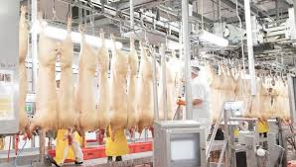
Competition for new jobs, residents and investment has never been fiercer. North Carolina’s Southeast is a regional public-private partnership that markets the state’s 18 county Southeast Region – nationally and globally – to encourage new economic growth. Leaders from the public and private sector work together to promote the region and its assets. The organization’s mission is “To provide strong economic development leadership in southeastern North Carolina through innovative marketing and collaborative regional initiatives that will support the creation of new jobs, generate capital investment, and secure new business locations.”
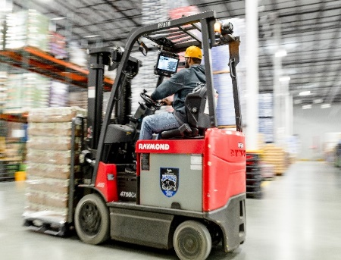
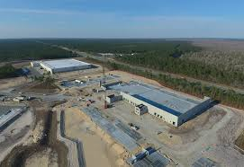
To continue to be successful, the region is engaged in the process of continuous improvement. In late 2019 two North Carolina firms, Economic Leadership and Creative Economic Development Consulting, were hired to provide the region with actionable intelligence that will anticipate future business opportunities and lead to more marketing success. The work included identification of business sectors that offer opportunities for growth, a workforce growth and gap analysis, and a future trend analysis. The project scope also included helping the region to incorporate the findings into the region’s marketing program.
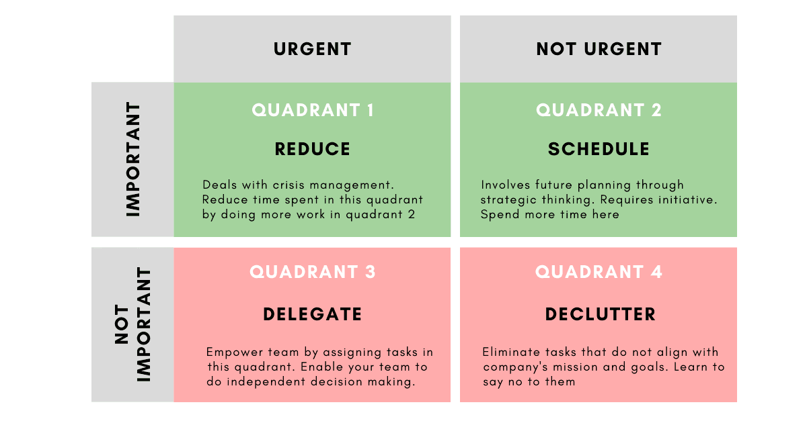
President Dwight D. Eisenhower is credited with the quote, “What is important is seldom urgent and what is urgent is seldom important.” The Eisenhower Matrix was developed to help organizations prioritize what is most important and commit resources to those activities that will yield the greatest results. The research and analysis that follows is provided to help inform those decisions.

Future Trends Analysis

Anticipating the Post-Pandemic New Reality
This project began prior to the Covid-19 pandemic and the subsequent global recession. In late 2019 the country was almost ten years into the longest continuous private-job expansion on record. All of that changed in March 2020. The lasting impacts that we all expect are now central to any future strategic planning.
Few businesses, or economic development groups entered 2020 with any scenario plans that included a contingency for an unprecedented global pandemic and a deep, medically induced, global recession. We came into the year facing trends like urbanization, slowing globalization, and accelerating technological transformation. Disruption was the watchword, and many of the economic drivers of North Carolina’s Southeast were witnessing change. Our national economic and health recovery from the pandemic continues to be slow, challenging, and uncertain, but at some point, we will all be facing the next new normal. Anticipating new opportunities is necessary to help the Southeast improve its competitive position and its economic development success over the next decade.
No one can focus the future picture clearly, but based on the best information currently available, the residue from the pandemic and the subsequent 2021 reset is likely to include many of these emerging trends.
- Remote everything will be more common. More people will work remotely, shop remotely, get their health, entertainment, and banking services remotely. We have all endured months of mandatory reprogramming of our personal and professional patterns. Companies have adjusted. Many of these shifts will become permanent. Experts expect market center communities’ commercial real estate needs will change. Our home design requirements will change to accommodate work and lifestyle shift. The region’s 1.9 million people, and thousands of businesses, will be even more dependent on reliable internet connectivity.

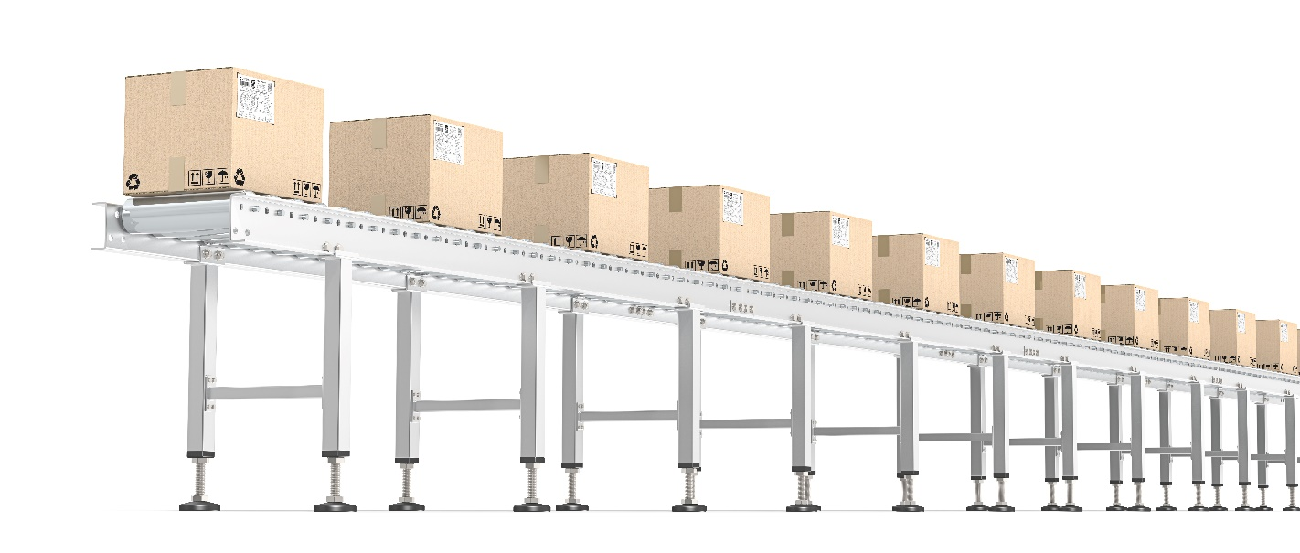
- Relocations could be more common. The trend of some Americans moving from high-priced urban centers to more affordable metros has been accelerating over the past decade. Mid-sized city centers prospered following the Great Recession with reimagined suburbia growing over the past five years. The Southeast has communities that have grown rapidly and communities that have seen population loss. News reports this summer have chronicled more movement, pandemic-induced, from density to less dense living options, and from high-priced to affordable. Nobody knows where the new hot spots will be, but they will need high-speed broadband, access to amenities and housing choices. Several areas of the Southeast offer good opportunities and enhanced talent recruitment and placemaking strategies could yield good return-on-investment.

- Reshoring accelerates. Covid-19 has shone a bright light on the security and safety advantages of having specific industries and their supply chains within our borders. Over the next few years, we should see growth in biopharmaceutical, medical devices, defense components and food processing. Efficiency will still be important, but redundancy will be a new corporate maxim. As detailed in the Target Market Analysis section of this report there will be significant regional opportunities. Affordability and access to good transportation infrastructure should be key advantages for the region. Building marketing around the supply chains of existing companies, and targeting the industries most likely to reshore, are smart strategies. A good regional supply of ready industrial and warehousing buildings and shovel ready sites will be necessary.

- Robot utilization will increase. The Covid-19 shutdown and stay at home orders exposed the vulnerability many businesses had. Manufacturing and construction businesses were already moving toward more robotics due to skill labor shortage. Employment in those industries were also the first to rebound. Expect service industries, currently highly dependent on face-to-face service to substitute robots wherever possible, to reduce their exposure to future, similar, disruptions. Early research suggests that the impact will disproportionately hurt small businesses and lower wage workers. Agile retraining options for Southeast workers that are being displaced will be a necessity and could be a longer-term competitive advantage.

- Expect more state competition, data analytics and scenario planning. Pre-pandemic, many states, including North Carolina, were experiencing economic transformations. Changes in demographics, technology, and consumer behavior continuously disrupt the status quo and confound both business and state economic planning. Businesses’ new investment decisions are now mostly driven by sophisticated data analytics that easily allow comparisons between “place” options. The region’s web site is the investor window to all the data.
Four competitive categories usually top the list for consideration.
- Business climate, including taxes, regulatory practices, and legal environment.
- Workforce availability and cost, with the skills in demand, and the ability to attract new residents.
- Infrastructure including roads, rail, ports, broadband, air service, affordable and reliable power, and water and sewer.
- Quality of life and other amenities that will promote talent attraction.
In a time of mass disruption, the pandemic has acted as an accelerant. Trends we expected are impacting us sooner, with a few unexpected tangents thrown in to upend even the best plans. States and every region recognize that they are in competition for new investments and have begun to develop new ideas for the next new normal.
Mike Tyson is often quoted, “everyone has a plan until they get punched in the mouth.” 2020 certainly feels like the proverbial punch. We entered the year concerned about technological unemployment, global trade uneasiness and labor shortages due to full employment. Then we added a pandemic, a recession, and a national election. Another ex-boxer, Ed Latimore, is credited with the quote “The future is coming, whether you’re ready or not. The past is gone, whether you’re over it or not.”

Future Focus on Southeast Priorities
While North Carolina’s Southeast’s economy will be heavily impacted by most national and international trends, the following sections dive deeper into five areas that have specific impact to the region. Each is experiencing rapid change. Mining the changes for opportunities and advantages should yield better results.

Value Added Agriculture and the Fourth Agriculture Revolution
Like farmers everywhere, North Carolina’s 46,000 farms are facing disruption and an uncertain future. Changes in trade policy, regulations, consumer preferences and weather events combine to create ambiguity. Despite the challenges, agriculture remains big business in the Southeast Region. More than 23,500 people are employed in food processing and 11,300 employed in agriculture and farming. The following table, from the 2017 census, shows just how big agriculture is in each of the region’s 18 counties.

County | Number of Farms | Acres in Farms | Market Value products Sold | Top Crop By Value | Top Livestock By Sales
Anson | 412 | 85,330 | $303,746,000 | Grains, oilseed, dry beans & peas | Poultry and Eggs
Bladen | 512 | 180,340 | $446,399,000 | Fruits, tree nuts, berries | Hogs and Pigs
Brunswick | 231 | 44,693 | $46,069,000 | Grains, oilseed, dry beans &peas | Hogs and Pigs
Columbus | 514 | 141,080 | $162,008,000 | Grains, oilseed, dry beans & peas | Hogs and Pigs
Craven | 245 | 81,360 | $71,606,000 | Grains, oilseed, dry beans & peas | Hogs and Pigs
Cumberland | 336 | 65,995 | $95,799,000 | Grains, oilseed, dry beans & peas | Hogs and Pigs
Duplin | 820 | 243,098 | $1,261,691,000 | Grains, oilseed, dry beans & peas | Hogs and Pigs
Hoke | 189 | 53,647 | $76,796,000 | Grains, oilseed, dry beans & peas | Hogs and Pigs
Lenoir | 386 | 113,708 | $311,373,000 | Grains, oilseed, dry beans & peas | Hogs and Pigs
Montgomery | 240 | 33,521 | $143,304,000 | Nursery, greenhouse, floriculture, sod | Poultry and Eggs
Moore | 733 | 89,375 | $150,349,000 | Tobacco | Poultry and Eggs
New Hanover | 59 | 879 | NA | NA | Horses, ponies, mules, burros, donkeys
Onslow | 340 | 52,473 | $171,574,000 | Grains, oilseed, dry beans & peas | Poultry and Eggs
Pender | 336 | 64,484 | $200,303,000 | Nursery, greenhouse, floriculture, sod | Hogs and Pigs
Robeson | 722 | 263,740 | $385,759,000 | Grains, oilseed, dry beans & peas | Poultry and Eggs
Sampson | 960 | 301,248 | $1,249,140,000 | Vegetables, melons, potatoes, sweet potatoes | Hogs and Pigs
Scotland | 108 | 54,853 | $112,158,000 | Grains, oilseed, dry beans & peas | NA
Wayne | 551 | 165,345 | $592,071,000 | Grains, oilseed, dry beans & peas | Poultry and Eggs

Significant economic growth opportunities exist for the region with a focus on value added agriculture and food processing. Traditionally, value-added agriculture is associated with taking raw material and processing them into a product with greater economic worth. The United State Department of Agriculture (USDA) (2015) definition of a value-added agricultural product is one that:
- Has undergone a change in physical state
- Was produced in a manner that enhances the value of the agricultural commodity
- Is physically segregated in a manner that results in the enhancement of the value of the agricultural commodity
- Is a source of farm- or ranch-based renewable energy, including E-85 fuel
- Is aggregated and marketed as a locally produced agricultural food product

Global Trends in Agriculture, Value-added Agriculture and Ag-Tech
A.T. Kearney, a leading research company in the agriculture field, created the following flow graphic to demonstrate the product flow of a typical agriculture value chain.

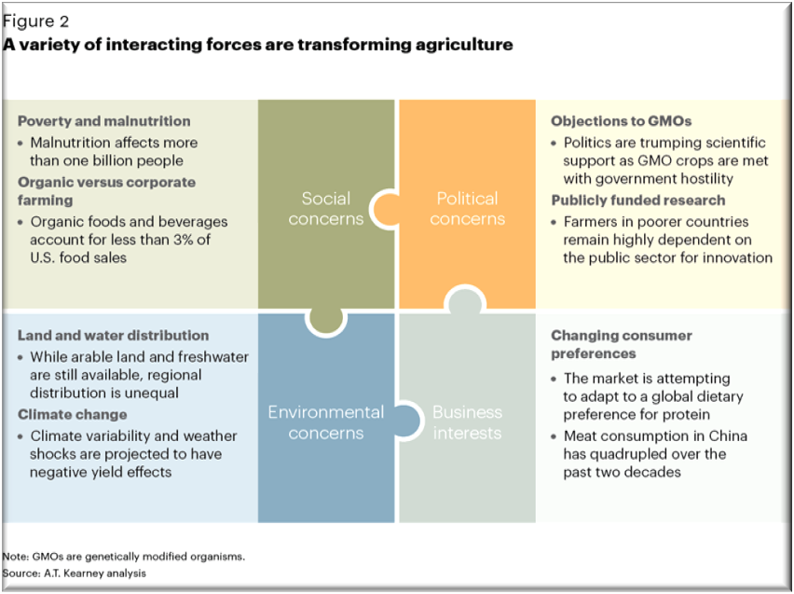
A great deal has been written recently on future trends in agriculture. Similar predictions in most other industries, the agriculture industry will almost certainly be impacted by rapid advances in technology, new thinking about global food chains, changing consumer preferences, and new scientific breakthroughs. New pressures from global demographic and environmental changes will also alter the economics of agriculture. A.T. Kearney compiled the chart to the right a few years ago, which shows how some of these changes are interacting.

The pandemic is likely to alter the expectations slightly. The past three decades have seen historic reductions in worldwide poverty and dramatically increased the markets for food, and especially proteins. North Carolina’s hog and poultry producers have prospered. Early predictions suggest that the pandemic could hurt developing countries’ food import capabilities severely. National investments in crop and animal research around the world will also likely be curtailed by government budget pressures. Aggressive marketing to broaden the region’s export options could provide some security against any specific impact.
Many emerging consumer trends that are further affecting value-added agriculture will continue. These include:
Consumer Purchasing Paths
Most purchasing decisions are now made online, even if the actual purchase is not done online. Internet reviews, especially among peers, are a highly trusted source of consumer opinion. The pandemic has further reduced face to face interactions and has solidified current remote purchasing habits. Continuous social media monitoring to ensure that the region’s products maintain a good reputation will be needed. There are good examples of international region’s that have built an on-line quality brand for their agriculture products, increasing both demand and price margins. A good example is the region (County) of Kerry in Ireland with their Kerry Gold Campaign.

Health Consciousness
In 2020 health considerations have taken the spotlight. An aging population is intent on preserving health and is investing in health and wellness monitoring tools. The trend continues for fewer highly processed convenience items, and more fresh produce. More buyers are willing to pay a premium for healthy and fresh items. Adequate cold storage facilities are needed to respond.

Due to evidence showing health benefits, fewer people are skipping breakfast, which improves the market for breakfast foods, although pre-pandemic cereals were being replaced by other options. Value-added farmers can fine-tune messaging to illustrate health benefits or develop new uses for existing products. Because of the society shutdowns in the United States more people have been cooking at home, reducing restaurant consumption.

Hangover from the Great Recession and Now the Pandemic Has Created Thrifty and Wary Consumers
Consumers shop around more, mostly on-line, and are more selective with the products and services they decide to buy. Many are looking for bargains. Value-added strategies include offering coupons and offering just-in-time delivery of products only when needed. Home delivery from food wholesalers and retailers is now an expectation.

Customization of Products and Services
Customers are demanding more individualized products, and companies are responding with more product lines to suit almost any taste or need. For example, a German company mixes and sells customized cereals online, to suit dietary needs, allergies, athletic training regimens, and varied tastes. A benefit for food producers is that they can often reduce the risk involved with introducing new products and can increase profit margins. Those in the value-added food chain can take advantage of this trend by involving customers early in product design, and offering simple personalization options.
A review of recent literature revealed some themes that could prove important to the future of agriculture in Southeast North Carolina.
- Technological advances in fast-growing climate-resistant genetic crops is changing farming habits and increasing yields while reducing some risks. Bio agriculture research in North Carolina may create new opportunities for communities across the state.

- The use of artificial intelligence and robotics in farming, harvesting, livestock growth and production is increasing productivity, and reducing new employment demands. The inability to find affordable farm labor is a consistent concern for agriculture firms. Again, North Carolina’s technology strengths in sensor technology and data analytics could complement and create opportunities in the Southeast region.

- There is a continued shift of farm business structures from smaller family farms to larger aggregated corporations. The pandemic should change the model of a limited number of larger processing facilities to more redundant facilities to guard against future shocks. However, the complexity of federal and state regulations still inhibits small farming.

- Artificial meat is showing signs of emerging as a viable new product that will require new production facilities. Recent studies have proclaimed growth of 30 percent over the past two years.

- Government regulations at the national, state, and local level continue to be in flux, seeking a balance between property rights, safety and security, economic concerns, and community priorities. Recent complaints have been about rapid change and regulators inability to respond at the speed of business.

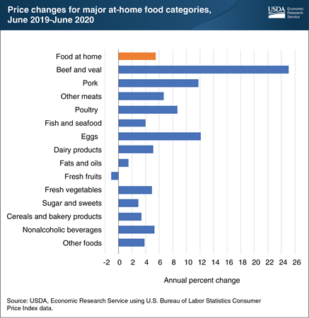
- In the past few years, the United States government has renegotiated many existing trade relationships. Any new trade agreements will dramatically change the economics of specific agriculture imports and exports. Future trade deals remain very political and will be influenced by upcoming elections.

- The pandemic has had a significant impact on food prices. The USDA chart shows current volatility.

Many current conversations center on the impacts of the upcoming the Fourth Agriculture Revolution. The third revolution included the introduction of fertilizers, pesticides, and big efficient machinery. The impacts of artificial intelligence, autonomous robots, drones, and advanced genetics will each alter current agriculture models. All of these technologies are already permeating agriculture planning for large companies and corporate farms. The pandemic may accelerate implementation. Like many transformations, there will be winners and losers.

Military and Defense Spending
North Carolina’s Southeast is home to seven military institutions (Fort Bragg Army Base, Pope Army Airfield, Marine Corps Air Station Cherry Point, Marine Corps Base Camp Lejeune, Seymour Johnson Air Force Base, Marine Corps Air Station New River, and Military Ocean Terminal at Sunny Point) and over 100,000 active duty
personnel. Annual Department of Defense spending approaches $3 billion. Future military operations and investments have tremendous impacts on the region.
For the past 70 years the U.S. military has consistently maintained a large, superiorly equipped force, deployed strategically around the world to deter attacks, and protect strategic economic interests. In recent years, the focus has shifted slightly to emphasize the current administration’s priorities, including border protection, is encouraging increased investments by allies, but remains focused on great power competition.
U.S. spending on defense has consistently been the highest in the world. As the Chart below, from the Center for Strategic and International Studies, shows an overwhelming percentage of Americans have consistently believed that military spending was about right or not enough. In the past few years there has been a drop in those believing that spending was “not strong enough”.
Shifting American Public Feelings on National Defense
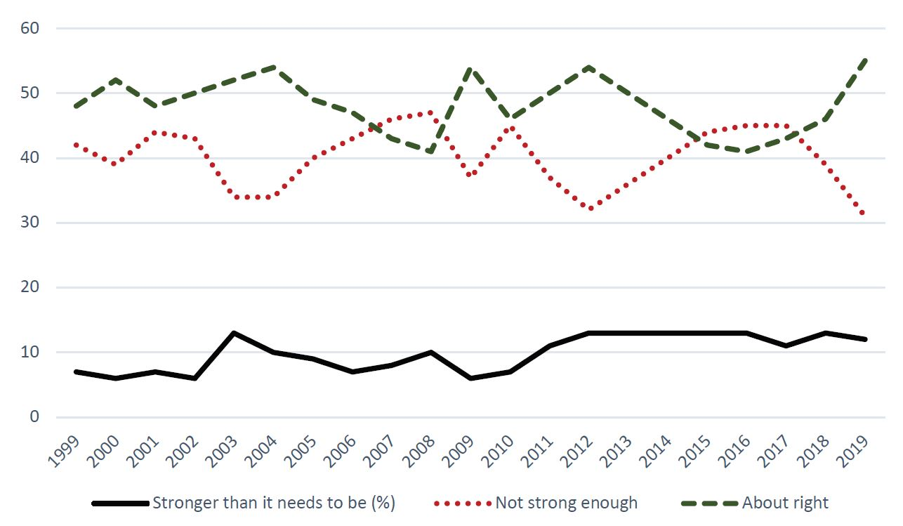
Pre-pandemic the federal debt was expected to keep future Department of Defense growth somewhat constrained. The additional trillions of dollars appropriated by Congress as stimulus to arrest the disruption in the economy has dramatically increased the national budget deficits, adding uncertainty to future budgets. What happens globally will heavily influence those budgets, and while there are deficit hawks that could suggest cuts, there are many advocates for increased and modernized capacity.
North Carolina’s Southeast has been impacted in the past by Base realignment and closures. The last round was in 2005. Future thinking is currently unknown.
COVID-19 may have some broader lasting impacts on future security thinking and strategy.
- Rethinking Security More Comprehensively.
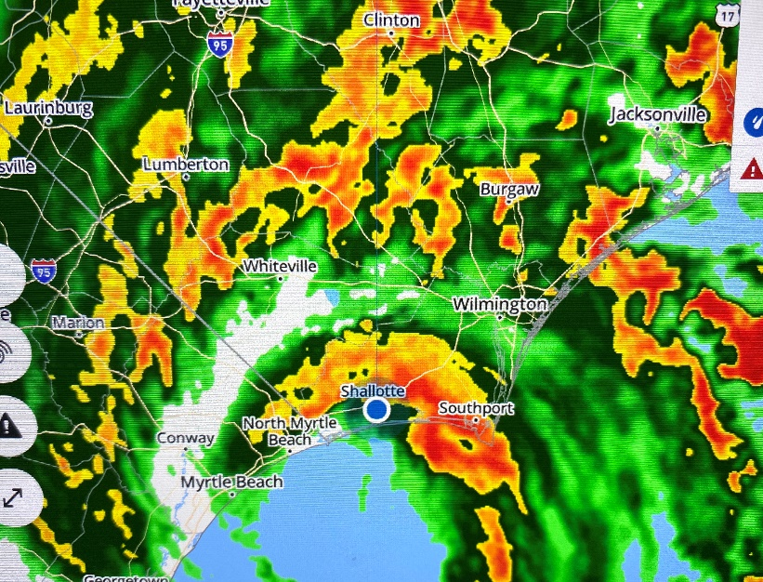
No one would suggest that we have entered an age where other state powers do not pose a military threat to the United States. During the past few years tensions around the world have remained high and the pandemic has sharpened some smoldering differences. Recently the Secretary General of the United Nations opened the session with a speech that included the comments, “We are moving in a very dangerous direction. Our world cannot afford a future where the two largest economies split the globe in a Great Fracture — each with its own trade and financial rules and internet and artificial intelligence capacities. A technological and economic divide risks inevitably turning into a geo-strategic and military divide. We must avoid this at all costs.” Military security will remain a priority for the US, but safety and security are also more often being discussed differently, and more broadly.
Health, weather, cybersecurity, and other threats are now part of the public conscience. Devoting increasing appropriations to those specific areas could change funding status quo. The National Guard has played a more visible role recently to help states deal with health and weather events. Having a flexible rapid deployment capacity seems sensible and is likely to expand. Whether this has an impact on troop counts in North Carolina’s Southeast is not predictable, but just like many major corporations, the military could be moving toward more flexibility to raise and lower their labor force to meet changing needs is a trend. An opportunity may be as a home base for staging the forward supplies to respond to these events.
- Forward Deployment Strategies.
According to research by the CATO Institute the US currently has 800 overseas facilities in 70 countries ranging from main operating base with more than 10,000 troops to small facilities with headcounts less than 100. In Europe alone the United States has over 80,000 troops. Many believe that these should be scaled back due to changing needs and, in some cases, increased risk to smaller facilities. If reshoring troops becomes a priority, major bases in the United States, and in the Southeast, could benefit.

- Technology Modernization
According to the Heritage Foundation, “the goals of modernization are to close a capability gap, provide a qualitatively improved capability, and/or reduce costs. Modernization entails the replacement of an existing military technology, generally a platform, weapon, or system, with one that is significantly more capable, even transformational.” More than upgrading specific systems or processes, the next round of transformational technology could be led by advanced materials, intricate information systems, smart sensor technology, and artificial intelligence. North Carolina’s private sector, and universities, excel in many of the emerging technology platforms. Opportunities exist to develop expanded and focused defense contracts in these budding areas.
Building relationships with companies that are already in North Carolina but may want to be closer to the Southeast’s bases as their specialties become more important to the military should be a midterm goal.

Outdoor Recreation
COVID-19 has accelerated the national focus on outdoor recreation. Camping and the use of public parks surged due to the safety concerns with other entertainment options such as theme parks, movie theaters, and urban travel. Equipment sales were up significantly this summer, and thousands of new campers are expected to underpin the industry for years.
This summer also saw growth in the cycling industry. Cycling sales are up 63 percent with June sales alone close to $700 million, according to the NPD Group. Another pastime gaining new enthusiasts is birdwatching. The New York Times recently published an article discussing the rise of bird-watching and a renewed interest in nature and outdoor activities associated with the pandemic. North Carolina’s Southeast is beautiful, with fishing, hiking, boating, and cycling opportunities at every turn. Promotion of these regional assets could lead directly to more tourism dollars, but it could also solidify the region’s appeal to new residents. Talent attraction remains critical to addressing workforce needs, and these emerging trends creates a new opportunity.
One of the activities most associated with the region is golf. The Southeast is home to over 100 championship golf courses. In early September, the United States Golf Association announced that it was establishing a second home in Pinehurst. Golf House Pinehurst will include a new equipment-testing facility, innovation hub, and museum and visitor center. With the additional announcements of Pinehurst #2 as a rotational home of the US Open, the region has solidified its place as golf destination. Even more exciting are the opportunities for a new, more complete, business sector.
It has been a turbulent decade for golf, but 2018 and 2019 saw a rebound in public interest and the pandemic has produced a strong resurgence in equipment sales and the number of rounds played. It is reasonable to expect that golf manufacturing and research will grow as a regional cluster. Much of golf’s testing and development is currently concentrated in California. North Carolina’s business climate and affordability offers a compelling case for relocation. An aggressive effort to testing, research and manufacturing companies could yield strong results.
Many hope that the recent surge in rounds played, and the new younger and female players that have been draw to the sport during the pandemic, will form the foundation for future growth. Growth in participation comes at a time where technology, fashion and membership are also changing to meet evolving customer expectations.

Healthcare Operations
Healthcare costs and availability were considered critical to the Southeast’s competitiveness prior to the pandemic. Looking forward, many believe that COVID-19 will permanently alter the delivery and economics of healthcare. In the upcoming target industry analysis, there is a discussion of healthcare work in the Southeast, but some industry trends are being felt everywhere.
Recent executive orders have reduced federal financial support for insurance exchanges, reduced Medicaid spending, expanded the use of health savings accounts and restricted access to insurance exchanges for undocumented immigrants. Each has an impact on availability and price.
Medicaid expansion has been implemented in 37 states and the District of Columbia, but has not been expanded in North Carolina. This is a hotly debated political issue, but it is also an issue that impacts the future business structure and delivery of health service.
The pandemic has caused a surge in telehealth, a trend that might provide greater access to those in need that are not proximate to an existing provider. It could also weaken rural delivery by siphoning off customers from rural centers that are already challenged by slow growth or population decline.
Mergers and acquisitions are widespread in the industry with efficiency as a key strategy. The greatest looming impact could come from new players like Amazon, Google, and Walmart. If their current forays into the industry continue to expand, as seems likely, they will attract both doctors and patients, further weakening smaller and more rural hospitals.
Customer driven healthcare is another emerging trend as people demand more transparency and the ability to compare costs and outcomes between providers. This shift often referred to as a move from fee-based to value-based, could reduce costs and improve overall health outcomes.
Reimagining how a community could remain economically competitive to attract new business with only remote healthcare is difficult. Advocacy to retain the existing hospital network and healthcare quality and availability in the Southeast will be critical to the region’s investment attraction efforts.

Foreign Direct Investment and Exports
Attracting Foreign Direct Investment and exporting goods and services are essential to a strong regional economy. North Carolina and the Southeast Region have benefitted from consistent, strong Foreign Direct Investment. According to research from the Raleigh Chamber, foreign-owned firms employ more than 250,000 people in the state and have contributed more than $14 billion to the state’s economy over the past eleven years. The Global Business Alliance estimates that there are over a thousand international employers in the state, and that close to half of the total workers are in manufacturing. They also report that employment growth from foreign owned firms has increased by 34.6 percent over the past five years, almost three times faster than overall private sector growth.
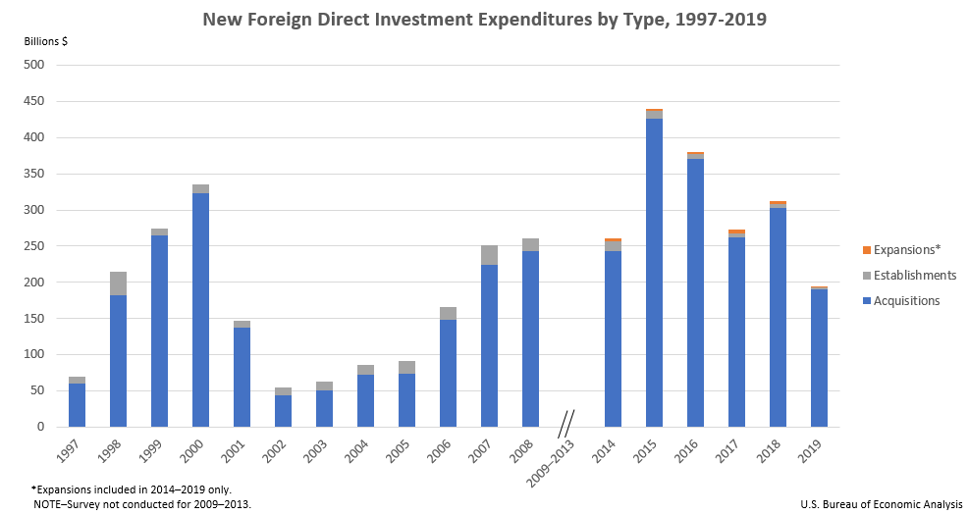
North Carolina’s overall business climate and cost structure offers a good opportunity for global firms to operate. Today, more than 60 international companies have a presence in the Southeast. Foreign Trade zones 214 and 93 and the Ports of Wilmington and Morehead City are critical to the region’s success. The Southeast’s strengths for all types of manufacturing, good infrastructure, affordability, and training capacity creates a good opportunity for attracting Foreign Direct Investment. International marketing, in conjunction with NCPED in the targeted industries, will remain a productive strategy.

Exports
North Carolina, which exported over $34 billion worth of goods in 2019, remains among the top 15 states for annual exports. The top exports for the state in 2019 were:
- Aircraft including engines and parts $2.3 billion
- Immunological products $1.6 billion
- Miscellaneous medications $1.1 billion
- Miscellaneous aircraft parts $806 billion
- Antisera, other blood fractions $775 million
Other significant exports important to the Southeast include Meat of Swine, Cotton Yarns, Tobacco and several types of machinery or machinery parts, Chicken and Chicken Parts and food preparations.
According to the Office of the US Trade Representative, North Carolina is the country’s 13th largest agricultural exporting state. The top agricultural exports for the most recent year
that statistics are available are pork, tobacco, other plant products, broiler meat and soybeans.:
After several decades of rapidly increasing globalization, many expect a slowing in the post-pandemic years. Trade conflicts and the hangover from the global recession will slow the growth in exchange of goods, but this trend is probably a slowdown in the growth, not a reversal. A greater focus on exports is another likely trend. The US trade deficit has surged in recent months, including July numbers that were the greatest in the past 12 years.

Other Post-Pandemic Trends Impacting North Carolina’s Southeast
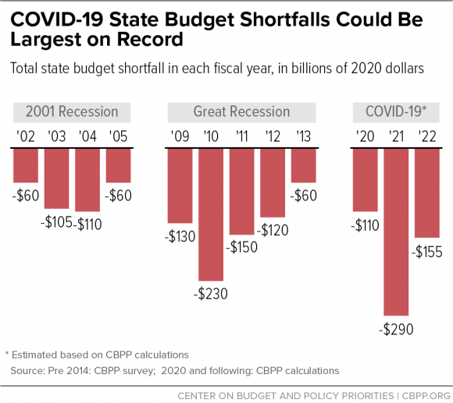
Constrained State and Local Budgets should be expected for the next few years due to losses in tax revenue. The Center on Budget and Policy Priorities is anticipating record state shorfalls in the next three years. Their chart shows that next year shortfalls could exceed those from the Great Recession.
Real Estate Needs Will Change with a greater short-term focus on industrial buildings and warehouse and distribution. There is currently a national shortage of good buildings with surging demand due to online shopping and reshoring. New office construction is likely to slow due to work-from-home shifts. New retail and hotel projects will probably be significantly slower due to reduced demand. Home construction has remained steady and is expected to be consistent.
Mental Health Needs Have Increased during the pandemic with many indicators experiencing big increases.
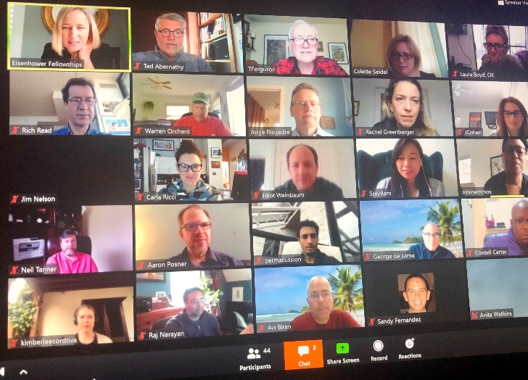
Face to Face Marketing will be Slow to Return. Economic developers will be using more drone video, ZOOM meetings, regular web updates with current research and data analytics substituting for trade shows and travel for at least the next 18 months, and maybe longer. Until an effective vaccine has been distributed some site selectors and clients will still be uncomfortable with business as it used to be.

North Carolina’s Southeast Workforce Analysis
North Carolina’s Southeast competes each day for new investment and new jobs. Success is determined by matching the regional assets with the needs of clients. Many factors are typically part of the client decision process. A good business climate, sufficient infrastructure and appropriate, ready to occupy buildings and ready to build sites are all critical. In recent years, the factor that has been the most important and received the most attention is talent - a workforce of sufficient size with the skills needed to meet the needs of current and potential employers. Despite current high unemployment, workforce will remain a top factor in post-pandemic economic development competitions.
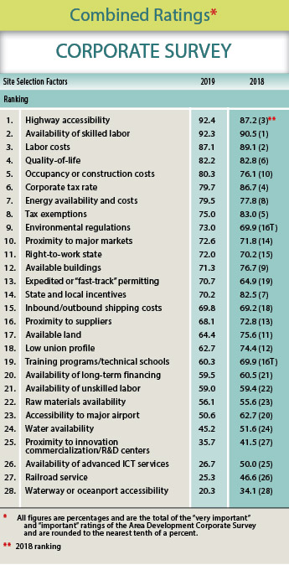
Area Development’s most recent survey of corporate decision makers rated the availability of skilled labor as the second most important factor, second only to highway accessibility. Continuous improvement in the region’s workforce quantity and quality will be an ongoing product challenge for all economic development organizations.
Contributors to a regional talent pipeline include parents and grandparents, preschool workers and teachers, guidance counselors, friends, clergy, the military, government programs and employers. Anyone that helps an individual gain the personal and professional skills for a successful career has a role to play. The complexity is inevitable and often frustrating. At a minimum, economic developers provide clients with the workforce-related information they need to make location or expansion decisions.

Workforce Data

Regional Population
Over the past five years (2014-2019) the region’s population grew by 2.9 percent from 1,784,217 to 1,836,745. Current estimates are for growth to continue to just over 1,881,000 in 2024.
Population growth over the past five years has been uneven across the 18 counties, with about half the region’s counties growing or remaining stable and the other half losing population.

Current projections are for this trend to continue with mixed population growth.

Regional Labor Force
Total Working Age Population 1,493,049
Current Labor Force 765,706
Labor Force Participation Rate 51.29%
The regional labor force totals approximately 765,000 workers. The largest county labor forces are in New Hanover and Cumberland which combined represent about 33 percent of the regional pool. Until recently the unemployment rates across the region were near historic lows. The impact of the current COVID-19 pandemic has raised unemployment rates across the country and the region.
The pie chart below shows each county’s total labor force and the percentage of the region’s total.

Note: Labor force totals include payroll employees covered by unemployment programs (US Bureau of Labor Statistics QCEW), payroll employees not covered by unemployment programs, and self-employed.

North Carolina’s Southeast Population Educational Attainment
About one third of the region’s adults, just over 400,000 people, have a college associate’s degree or higher.
As the chart below from the North Carolina County Commissioner’s annual Databook shows, educational attainment is another factor that varies widely across the Southeast region.

 | NC's SE Region | North Carolina | U.S.
Less Than 9th Grade | 6.0% | 6.0% | 6.5%
9th Grade to 12th Grade | 8.2% | 7.6% | 6.9%
High School Diploma | 28.7% | 26.3% | 27.5%
Some College | 24.1% | 21.4% | 20.6%
Associate's Degree | 9.9% | 9.0% | 8.1%
Bachelor's Degree | 15.5% | 19.1% | 18.8%
Graduate Degree and Higher | 7.7% | 10.6% | 11.5%
Twenty percent or more of the populations of New Hanover (39%), Moore (36%), Brunswick (28%), Pender (26%), Craven (24%), Cumberland (24%), Onslow (20%) and Wayne (20%) have attained a bachelor’s degree or higher.

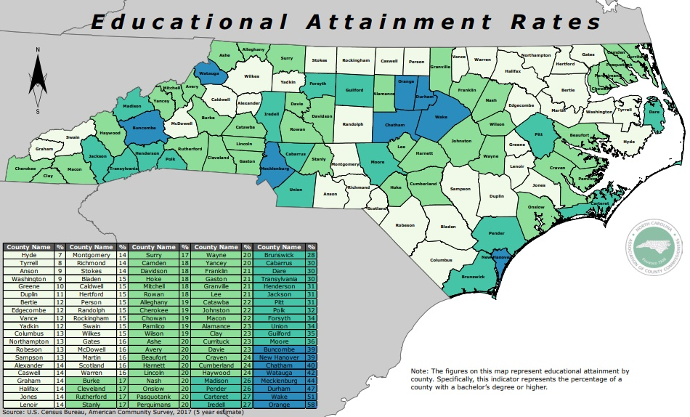
The population includes slightly over 363,000 millennials, reflecting a slightly older workforce than the national average, but with a “retiring soon” risk just at the national average. Racial diversity is slightly higher than the national average.
The skills honed in the armed forces are coveted by employers. The percentage of veterans in the region is well above the national average and several counties in the region are statewide leaders in the percentage of civilian veterans, including four of the top five.

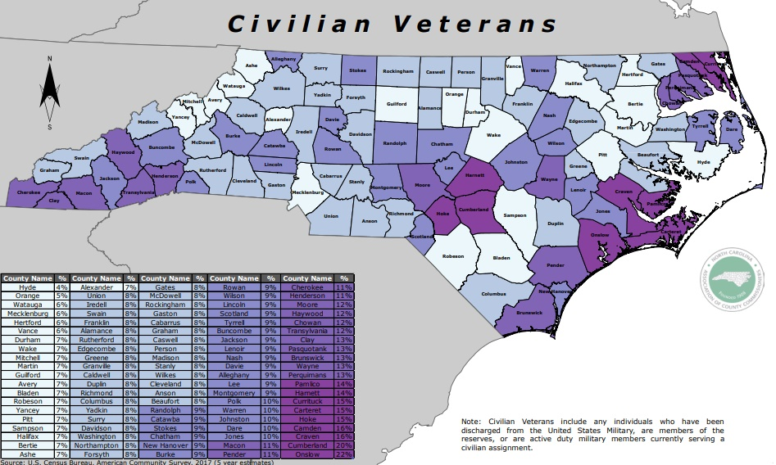

Civilian Veteran Population, 2017

Civilian Veteran Percentage of Labor Force, 2017

Estimating Future Workforce Demand
NC’s Southeast Region – Total Jobs
From 2014-2019 jobs increased 4.5 percent in the region. Although slower than the state or national rate, regional job growth outpaced regional population growth. The projection is for job growth to continue, although COVID-19 impacts are difficult to incorporate into the models.

A longer view shows the significant impact of the 2007 great recession on the region, and the subsequent bounce back.
When new end-of-year data is available, the recent downturn due to the pandemic will be reflected. The chart below shows actual and projected annual job change. While growth is projected over the next decade, the annual job growth rate is expected to slow with new data showing the need to replace jobs recently lost.
NC’s Southeast Region – Total Percentage Jobs Growth 2006 - 2030

Southeast Jobs 2019
End of the year data for 2019 shows the overall job market in the region. Government jobs, including the military, account for close to one-third of all jobs. Other significant sectors include Retail Trade, Health Care, Accommodation and Food Service, and Manufacturing.

NC’s Southeast Region – Non-Government Jobs by Sector 2006-2030
Government jobs have remained relatively stable and are not included on this chart to make other changes easier to see. Recent growth in Healthcare and Social Assistance, Accommodation and Food Service, Construction, and Professional, Scientific and Technical Services are all expected to continue over the next decade. After recent gains, Manufacturing job growth is expected to level off due in part to increased automation. Smaller gains are expected in several other sectors.

Largest Industries Compared to National Averages
The chart below compares regional employment by industry with the employment that would be expected in the region based on national averages. Government employment is approximately twice the national average and Retail Trade, Accommodation and Food Services, Manufacturing, and Agriculture all exceed the national average. Other industries such as Health Care, Construction, Administrative, Professional, Scientific and Technical Services, Transportation and Warehousing, Wholesale Trade, and Finance and Insurance are underrepresented in the region.

Some underrepresented industries have recently experienced the fastest growth.
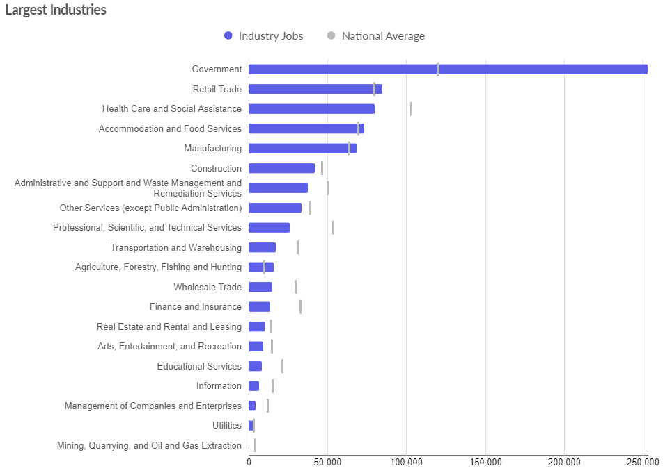

Top Growing Industries | Change in Jobs 14-19 | 2019 Earnings Per Worker
Accommodation and Food Services | 8,388 | $19,123
Construction | 7,404 | $52,846
Manufacturing | 4,535 | $60,600
Retail Trade | 4,413 | $32,322
Other Services | 3,341 | $27,213
Transportation and Warehousing | 2,879 | $55,785
Health Care and Social Assistance | 2,368 | $50,954
Professional, Scientific, and Tech | 2,162 | $72,067
Government | 1,304 | $65,310
Educational Services | 761 | $34,265
The industries that are growing offer jobs at annual earnings ranging from over $70,000 for Professional, Scientific, and Technical Services to under $20,000 for Accommodation and Food Services.

The chart below shows the average earnings in 2019 for all sectors.

Occupations
The workforce in every industry is comprised of many people doing different jobs. Individual occupations require specific skills. The occupations employing the largest numbers in the Southeast are shown in the chart below. Office and administrative support, sales, and food prep and service are the three largest occupations. Combined, they total over 226,000 jobs, about one third of all jobs.
Over the past ten years the national economy, and the economy of North Carolina’s Southeast region, have been experiencing change driven by globalization, technology, and demographics shifts in birth rates and longevity. Some occupations have been growing while others have contracted. The next three charts show the top 20 occupations by educational requirements and the net change in those occupations from 2009-2019. The first is for occupations with a minimum educational requirement of a high school diploma or less.
2009-2019 Net New Jobs-Occupations Needing High School or Less
20 Largest Occupation Groups in 2019 & Average Hourly Wage

Among the 20 largest occupations, only Police and Sheriff Patrol Officers lost jobs. Unfortunately, that occupation paid the highest wages among these occupations. Combined Food Workers added the most net new positions, close to 7,000, but had an average hourly wage below $10.00.

The next chart reflects the occupations that require specialized training in addition to a high school diploma, but not a college degree. Many of these occupations were identified by stakeholders as being the most difficult to fill in a tight labor market.
2009-2019 Occupations Needing Post High School, No Degree
20 Largest Occupation Groups in 2019 & Average Hourly Wage

Heavy Truck Drivers, Medical Assistants, Computer Support, HVAC Mechanics, and Health Techs added the most positions over the past ten years. Several of the occupations finished the decade with total jobs losses including Bookkeeping, LNPs, Telecom Equipment Installers, Teachers’ Assistants, and Aircraft Mechanics.

The third group features occupations that require an associate’s degree, bachelor’s degree or higher. The single occupation adding the most net new jobs was Logisticians, followed by Registered Nurses, and General Managers. Teachers of all types and Accountants saw the most net losses. These numbers reflect the net gain or loss, but do not show how turnover or retirements would impact the demand.

2009-2019 Occupations Needing AA or Higher
20 Largest Occupation Groups in 2019 & Average Hourly Wage

More important, to help insure a sufficient future workforce, is the ability to anticipate employers’ future needs. The next three charts project the 20 occupations that will require the most net new workers by minimum educational requirement. As before, the charts also show the average hourly wage for each occupation.
2019-2029 Occupations Needing High School or Less
20 Largest Growing Occupation Groups

As the chart below shows, demand for Heavy Truck Drivers, Medical Assistants, HVAC Mechanics, and Computer Support will continue.
2019-2029 Occupations Needing Post High School, No Degree
20 Largest Growing Occupation Groups

The final chart shows the growth in occupations that require an AA college degree or more. The need for new Registered Nurses (with an hourly wage just over $30) is the clearest take-away.
2019-2029 Occupations Needing AA or Higher
20 Largest Growing Occupation Groups

When looking at this data it is often surprising to see the lower number of jobs that require post-high school education. To visualize this relationship, below is a tree-map of the NC’s Southeast Region’s 40 largest occupation categories to better show the proportion and size of these job types.

40 Largest Occupation Categories by Entry-Level Educational Requirement, 2019

Skills in Demand
Occupation-specific skill training is not the only skill employers expect. Determining the most important skills for future work is a popular research topic although there is not a simple, universally agreed-upon list. Employers tell us that different jobs prioritize different skills. Often a specific job’s most important skill or skills are determined by the overall ability of the work team, not just by the individual task.
The following breakdown, created by Economic Leadership, helps to explain the “skills gap”, and the skills that North Carolina’s Southeast workers will need to successfully compete for better jobs in the future. Each tier builds upon the previous set of skills. By identifying specific skill deficiencies, specific actions can be taken to address the concerns.
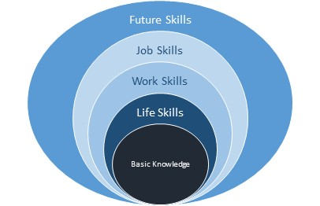
Basic Knowledge is the set of core academic competencies being taught by elementary, middle, and high schools. Local districts and schools make their own decisions about curriculum, instructional strategies, materials, and textbooks. From the employers’ perspective, an effective course of study would result in proficiency in reading comprehension, writing and, increasingly important, applied mathematics. Almost all jobs today, and in the future, will require these skills, and that the skill level be quantified by new assessment methods.
© Economic Leadership

Life Skills are made up of those personal attributes that are sometimes described as “soft skills.” They include motivation (initiative), responsibility, honesty, punctuality, personal accountability, adaptability, and conflict resolution. Often barriers to employment such as failing a drug test or having a criminal record are included in this category.
Work Skills are sometimes considered “soft skills” since many are viewed as personal traits. These skills are increasingly more important to employers, and they are also generally transferable from one job to the next. Employees with strong work skills have greater opportunities in a dynamic employment market. Today, most jobs demand that successful employees have teamwork, problem solving, flexibility, perseverance, and communication skills. Increasingly, innovation, creativity, leadership, selling and negotiation abilities are valued.
Job Skills are specific to an individual job and are reflected in the previous occupational charts. A Heavy Truck Driver or a Registered Nurse must receive specific training for the task. Higher education institutions will be the primary provider of this training, but increased exposure to sector skills can begin earlier, including in CTE classes in high school. Whether it is a degree or certificate, many employers are demanding more skills than the basic knowledge conferred by a high school diploma. For North Carolina’s Southeast, EMSI projects that over 40 percent of the estimated net new jobs will require post high school training. This is higher than the current requirements and shows that the workforce skill bar continues to rise.
NC’s Southeast Net New Jobs 2019 – 2029 by Education Requirement

The educational requirements needed to qualify for the region’s jobs in 2029 is reflected in the chart below. About 25 percent of all jobs will require an AA degree or more, and another 11 percent will require post-secondary training.

NC’s Southeast Projected Jobs in 2029 by Education Requirement

Finally, Future Skills are emerging as abilities that can add worth to the employee, especially in these rapidly changing economic times. Once, being able to use a computer was new. Today, the ability to use and interface with technology (including robots), manage multiple simultaneous priorities, comfortably absorb and apply data, and successfully interact with colleagues and customers of different backgrounds, are all highly valued. These skills ideally would be acquired during school years and augmented by ongoing education and on-the-job experience.
The demand side of the workforce equation continues to evolve and requires continuous monitoring through close contact and regular surveys of regional employers combined with on-going data collection and analysis.

Building a Regional Supply of Workers to Meet Demand
As stated earlier, the acquisition of workforce skills begins at birth and involves parents, teachers, and ultimately everyone that touches a person’s life. For this project, the focus is on the institutions that are primarily charged with delivering education and skill training to the region’s workforce.

Current Southeast Education and Training Resources

About CTE
The mission of Career and Technical Education (CTE) is to empower all students to be successful citizens, workers and leaders in a global economy. CTE gives purpose to learning by emphasizing real-world skills and practical knowledge. Programs in Career and Technical Education are designed to contribute to the broad educational achievement of students, including basic skills such as reading, writing, and mathematics, as well as their ability to work independently and as part of a team, think creatively, solve problems, and utilize technology.
These tools and experiences make school more relevant, and ensure students are ready for the real world. Whether students plan to further their education in community colleges, technical schools, four-year colleges and universities, receive on-the-job training, or pursue careers in the military, CTE can be the first step in a pathway toward productive employment and citizenship.
We are proud to have 931,801 Career and Technical Education participants. The 2018 CTE Concentrator Graduation rate of 99.2% is evidence of how CTE is learning that works for North Carolina.
NC Department of Public Instruction Web Site
Career and Technical Education
Career and Technical Education courses are provided in all 18 county and two city school systems in the Southeast region. At the national level, CTE is made up of 16 career clusters, each one related to a specific career pathway. Each state can shape their programs to meet their projected workforce needs.
The 16 CTE career clusters in North Carolina are:
Agriculture, Food, & Natural Resources
Architecture & Construction
Arts, Audio/Video Technology, & Communications
Business Management & Administration
Education & Training
Finance
Government & Public Administration
Health Science
Hospitality & Tourism
Human Services
Information Technology
Law, Public Safety, Corrections, & Security
Manufacturing
Marketing
Science, Technology, Engineering, & Mathematics
Transportation, Distribution, & Logistics

North Carolina’s Southeast Region has robust CTE programs with almost 50,000 earned credentials in the most recent year. Popular courses include office skills, construction, mechanical, medical, logistics, food processing, and public safety. A list of the courses resulting for the top ten credentials is provided for each of the region’s 20 school districts in the Appendix.

School System | Enrolled in CTE 2018-2019 | Earned Credentials 2018-2019 | Number of CTE Programs with Completions
Anson County Schools | 867 | 877 | 22
Bladen County Schools | 1,356 | 2,535 | 82
Brunswick County Schools | 3,875 | 2,589 | 67
Columbus County Schools | 1,379 | 2,070 | 44
Whiteville City Schools | 465 | 443 | 32
Craven County Schools | 2,933 | 2,109 | 57
Cumberland County Schools | 10,377 | 5,817 | 56
Duplin County Schools | 2,135 | 1,907 | 43
Hoke County Schools | 1,313 | 1,271 | 40
Lenoir County Public Schools | 1,714 | 951 | 42
Montgomery County Schools | 917 | 1,202 | 54
Moore County Schools | 2,603 | 3,679 | 68
New Hanover County Schools | 4,487 | 3,007 | 53
Onslow County Schools | 5,908 | 7,676 | 105
Pender County Schools | 2,327 | 4,021 | 64
Public Schools of Robeson Co | 5,404 | 2,541 | 37
Sampson County Schools | 1,916 | 477 | 13
Clinton City Schools | 580 | 262 | 9
Scotland County Schools | 873 | 1,522 | 62
Wayne County Public Schools | 3,983 | 4,050 | 69
NC's Southeast Total CTE Credentials | 55,412 | 49,006

While many of the jobs in the region do not require formal education after high school, a high school diploma is an important step toward a successful career. According to the Department of Public Instruction, high school graduation rates for students who were “Entering 9th Graders in 2015-16” and graduated in 2018-19 (or earlier) are shown in the table below. Eight of the 20 systems had graduation rates above the state average, and 12 were below the state average.

Higher Education
The region is home to 21 public and private universities and colleges that along with other degree and certificate granting institutions produced over 26,000 graduates this past year.
Graduations 2019
Anson College of Cosmetology | 2
Bladen Community College | 466
Brunswick Community College | 422
Cape Fear Community College | 1,894
Carolina College of Biblical Studies | 46
Coastal Carolina Community College | 1,518
College of Wilmington | 63
Craven Community College | 849
Fayetteville State University | 1,218
Fayetteville Technical Community College | 4,539
Grace College of Divinity | 26
James Sprunt Community College | 348
Lenoir Community College | 1,143
Methodist University | 510
Miller-Motte College-Fayetteville | 396
Miller-Motte College-Jacksonville | 364
Miller-Motte College-Wilmington | 444
Montgomery Community College | 376
Paul Mitchell the School-Fayetteville | 76
Robeson Community College | 582
Sampson Community College | 426
Sandhills Community College | 834
Southeastern Community College | 395
South Piedmont Community College | 538
St. Andrews University | 105
University of Mount Olive | 886
University of North Carolina at Pembroke | 1,229
University of North Carolina Wilmington | 4,745
Wayne Community College | 2,091
NC's SE Region TOTALS | 26,531
The North Carolina Community College System has been a national leader in workforce development and a significant economic development advantage for decades. Currently, the system’s Align4NCWorks promotes a more responsive and aligned workforce development system by strengthening partnerships among community colleges, business & industry, workforce development boards, public schools and economic development. According to the system’s web site, specific goals include:
- Increase and sustain employer engagement as part of an integrated, customer-centered workforce system.
- Connect students to quality careers and employers to quality employees.
- Ensure education and training address and validate skill and competency needs and attainment.
- Expand work-based learning opportunities.
- Improve career awareness and mapping.

- Increase opportunities for college access while keeping education and training affordable.
- Promote demand-driven and data-informed decision making and evaluation to more effectively meet workforce customer needs and enhance system accountability.
- Strengthen the foundations of success for workforce development.
Over the past four years there has been a steady increase in post-secondary education completers in the NC’s Southeast Region with certificate completers growing by 21 percent, associate degrees increasing by 4 percent, and bachelor’s degrees by almost 10 percent.

Top Certificates and Degree Subjects 2019
The top areas of educational focus represent 70 percent of the total certificates and degrees issued regionally in 2019 and align well with the previous job growth estimates.
- Health Professionals and Related 4,761
- Liberal Arts and Sciences 4,619
- Business, Management and Marketing 3,576
- Education 1,542
- Computer and Information Sciences 1,509
- Homeland Security, Law Enforcement, Fire Fighting 1,420
- Mechanic and Repair Technologies 1,180

Workforce Development Boards

According to the North Carolina Department of Commerce, local Workforce Development Boards are comprised of a “group of community leaders appointed by local elected officials and charged with planning and oversight responsibilities for workforce programs and services in their area.”
In North Carolina, the 23 local boards are responsible for the following:
- Developing local plans for the use of federally funded Workforce Innovation & Opportunity Act funds;
- Oversight of the local service delivery system;
- Coordinating activities with economic development entities and employers in their local areas.

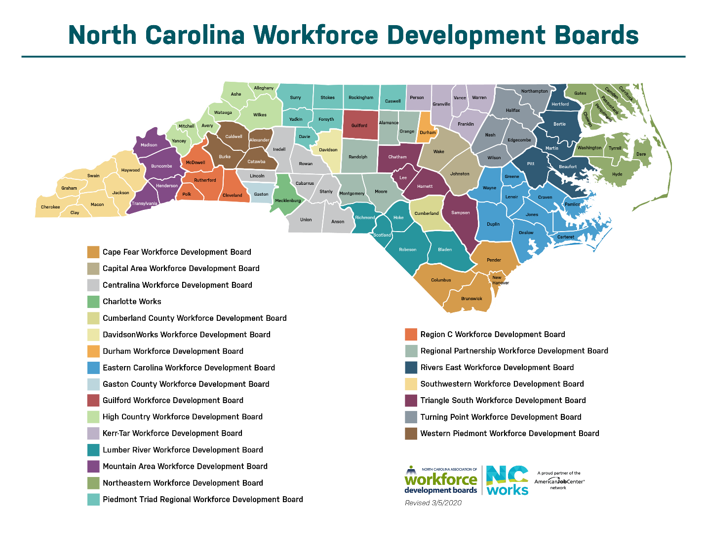
By federal law, “The majority of each board is represented by members of the local business community. In all, board membership includes individuals representing business and industry, economic development agencies, community-based organizations, education, organized labor, public assistance agencies and more.”
Seven different Workforce Development Boards (WDB) serve one or more of the 18 counties of North Carolina’s Southeast region.

Cape Fear WDB
Brunswick
Columbus
New Hanover
Pender
Centralina WDB
Anson
Cumberland WDB
Cumberland
Eastern Carolina
Craven
Duplin
Lenoir
Onslow
Wayne
Lumber River WDB
Bladen
Hoke
Robeson
Scotland
Regional Partnership WDB
Montgomery
Moore
Triangle South WDB
Sampson
Each Workforce Development Board provides a unique set of support and training opportunities that contribute to overall workforce preparedness.

ACT WorkKeys

ACT WorkKeys National Career Readiness Certificates – through July 2020

NC’s SE Region has 83,040 NCRC’s through July 2020, while North Carolina has 515,268 NCRC’s in the same time period.

Stakeholder Workforce Development Input
In interviews with stakeholders, workforce was the top competitive concern. The interviews began prior to the COVID-19 outbreak when unemployment was historically low. Many of the concerns expressed were about not having enough workers to fill current and future employer needs. The skill levels of workers was also a concern. From the interviews and focus groups, the following workforce themes emerged for the region and the organization.
Labor market data - especially about the current and future skill requirement of the region’s businesses – is not readily available and is not well known among parents, students, educators, and workforce development professionals.

Employment growth is constrained by specialized skill shortages in many industries including growth industries like healthcare, construction, and manufacturing but also in industries that are not experiencing net new growth. Turnover and retirements are creating crises even in industries where growth is slower.

Increased attention is needed to the quality and job alignment of the region’s Career and Technical Education offerings.

The attraction of new people to the region needs to be a part of the workforce development effort. Talent attraction initiatives and talent incentives have become popular nationally and should be considered in the region.

The region’s workforce readily commutes across county jurisdictions with employers viewing the labor shed in terms of drive times. Workforce efforts need to be regional, and increased cooperation among economic developers and other service providers is a prerequisite to success.

The workforce of each county in the region has different qualifications, so there needs to be a nuanced approach to marketing and recruitment to generate new job opportunities that align with local workforce skills.

All regional and local Business Retention and Expansion efforts need to include workforce quantity and quality solutions for the business.

The region’s Workforce Development Boards could be more impactful with increased business engagement, better marketing of services, common metrics to evaluate return-on-investment, and improved collaboration with a broader group of stakeholder organizations.

The region needs to collect, publish and champion more workforce best practices. Some of the suggestions included a focus on workforce experience through apprenticeships and OJTs, a regional Intern Database, and a push for newer, more attractive, modern career and training centers.

Finally, despite the many suggestions for workforce development improvement there was a clear concern that North Carolina’s Southeast is an organization with limited resources, and that meaningful involvement in workforce development would require significant effort and could detract from recruitment and advocacy priorities. Almost everyone interviewed believed that the organization should be a source of information, an advocate for best practices, and a convener. Almost no one recommended that the organization devote significant resources to workforce programs.

National Best Practices in Workforce Development
As workforce has become an ever-increasing competitive concern across the country, states and regions have experimented with many different program designs. This section highlights some of the state and regional programs that have been recognized as best practices. Based on the feedback from stakeholders, the best practices are grouped by themes most relevant to North Carolina’s Southeast Region.
Collaboration Between Economic Development and Workforce Development
Nationally: In a survey highlighted in a 2019 report by the Federal Reserve System, 97 percent of stakeholders in the Federal Reserve’s Cleveland region said that close alignment of the workforce development and economic development systems is crucial to their region’s future. However, 55 percent of respondents said that in reality the two are only “somewhat aligned,” with 24 percent saying, “not aligned” and just 21 percent “very aligned.” Participants said that the private sector is hesitant to engage with the public workforce system because they view it as “a social service rather than a business resource.” And in general, those active in either economic or workforce development “see combining efforts as an encroachment upon their territory.”
The Federal Reserve System’s report noted that there are some common ways in which areas are increasing alignment of the two systems. Practices cited most often as helpful include:
Sector-based training partnerships – 73%
Public-private partnerships – 58%
Sharing resources such as data, physical space, and staff – 50%
Financial collaborations – 38%.
Among the main challenges preventing better alignment are: 1) the lack of a lead organization; 2) gaps in communication, data, and information; 3) differences in goals and/or funding sources; and 4) lack of support services. Having a lead entity responsible for alignment can help solve other challenges, by creating more consistent communication and use of shared data, by having broad agreement on goals and objectives, and by tapping into public and private sector funds. The Allegheny Conference on Community Development is a successful lead organization for workforce and economic development in the Pittsburgh area, operating as a non-profit community leadership group since 1944.
Work-Based Learning, Career Paths & Career Awareness
Rhode Island: PrepareRI was launched in 2016, as a partnership of the state government, private industry, the K-12 public school system, universities, and non-profits. The initiative is based on the premise that all young people “will need some form of postsecondary credential and practical work experience to be successful.” Among PrepareRI’s near-term goals are: 1) all career pathway programs will be aligned to high-demand careers in Rhode Island, and 2) all students will have access to a work-based learning experience, such as an internship in a relevant field.
The PrepareRI Model
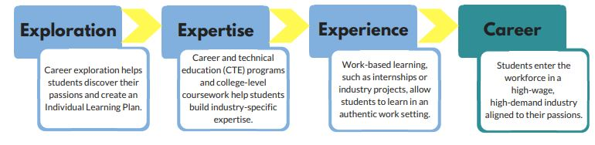
The PrepareRI Internship Program offers paid summer internships for high school juniors. Students are matched with internship opportunities by the non-profit Skills For Rhode Island’s Future, whose partners include the Greater Providence Chamber of Commerce. Interns are paid $11.25 per hour, can work up to 240 hours, and receive work readiness skills training.
West Virginia: The state’s Simulated Workplace initiative turns classrooms into student-run business environments. Student teams create their own businesses and learn punctuality, workplace safety, and technical skills. Team projects are evaluated onsite by regional business owners. Simulated Workplace was created in 2013, and by 2015 was used in over 500 classrooms impacting more than 13,000 students. Simulated Workplace is one reason why West Virginia was hailed in a 2017 New York Times article as “leading the way in transforming vocational education.” Thirty-seven percent of seniors in the state completed a technical education program in 2016, compared with 18 percent in 2010.
Alabama: School guidance counselors are generally spread too thin to offer useful career guidance, and usually lack the training to do so. As a result, separate career coaching programs are growing in importance. In Alabama, regional Career Coaches are responsible for networking with businesses in their region and preparing workforce demand reports, particularly for use in high school CTE programs. Career coaches also provide employability skills training and arrange job shadowing and industry tours. Alabama now has 93 career coaches based at the state’s workforce centers who are serving 366 schools.

Virginia: In rural southwest Virginia, United Way’s Ignite Program takes a “cradle to career” approach to talent pipeline development. Ignite brings career awareness tools to every middle school and high school in the area, including a) self-exploration and career planning software; b) classroom talks and regional employer tours; and c) a career expo for seventh graders. Ignite also provides a full range of skill development tools, such as project-based learning modules, and soft skills curriculum, and operation of a summer internship program.

Arkansas: In Bentonville, the Ignite Professional Studies program gives students “post-secondary options aligned to their passions and strengths” in their own community. Bentonville Ignite provides workplace experience and business mentors in eight career strands including Construction Management, Health Services, and Technology.
Skills Development
Pennsylvania: The state launched Manufacturing PA in 2017 to support workforce development in manufacturing, the state’s third-largest industry sector. Program components include Training-to-Career Grants made to community colleges, technical and trade schools that collaborate with two or more regional manufacturers. The goal of the grant program is to increase the “essential skill” attainment of entry-level applicants. In addition to training, eligible expenses include equipment purchases and internship placements.
Virginia: The state put $12.5 million into the first two years of the New Economy Workforce Credential Grant Program, which began in 2016. The New Economy grants fund training that leads to a credential in an occupation on the “Virginia Demand Occupation” list. The average age of participants is 36, and most have had no previous college experience. In 2018 the Virginia General Assembly allocated $19 million to the program for the next two years.
Kansas: The state’s Excel in CTE program started in 2012, providing tuition for high school students to take technical courses at the state’s technical and community colleges. In 2013 it was named one of the “Top Ten Innovations to Watch” by the Brookings Institution. Between 2013 and 2019 student participation increased by 124 percent, college credits by 138 percent, and credentials earned by 154 percent.

Sector-Based Strategies
Georgia: When the state Department of Economic Development met with businesses and economic developers about 10 years ago, they heard that the number one factor in most expansion and new location decisions was the availability of a skilled and educated workforce. In 2014, then Governor Nathan Deal established the High Demand Career Initiative (HDCI). HDCI convened the Department of Economic Development, the state’s university system, its technical college system, and more than 120 employers from around the state.
Georgia used $3 million from WIOA Governor’s Reserve Funds to offer capacity-building HDCI Sector Partnership Grants of up to $250,000 for each of 12 regions across the state. To apply, regions had to build a coalition with at least five employers in a key sector, postsecondary schools in the region, the K-12 school system, state workforce-related agencies, the chamber of commerce, and preferably non-profit organizations and other support service providers. Regions also needed to meet a 10 percent match requirement.
Within Georgia, a great example of a regional sector strategy is Floor360, which supports the carpet industry in northwest Georgia. This largely rural part of Georgia accounts for about 70 percent of the world’s carpet production. Updated manufacturing processes created the need for advanced skills in the workforce. In 2014 the region obtained a U.S. Economic Development Administration grant to implement the Northwest Georgia Regional Advanced Manufacturing Strategy. Among Floor360’s concrete successes is an expanded campus for Georgia Northwestern Technical College with a new flooring training center. State government contributed over $20 million for the project, and the industry donated most of the equipment. An inland port with rail access to the Port of Savannah has also been established in the region.
Kansas: The creation of a multi-region workforce plan for two key industry sectors in northeast Kansas is a noteworthy example of going beyond regional and even state boundaries to increase collaboration. KANSASWORKS Local Areas II and III agreed in 2017 on a plan to support the important Life Sciences (especially animal health) and Health Care sectors. It identified an animal health corridor that stretches from Manhattan, KS to Columbia, MO. Among the plan’s aims are to create a workforce strategy around the opening of the National Bio and Agro-Defense Facility in Manhattan, and to forge closer ties with the Kansas Hospital Association.

Apprenticeships
Alabama: One state heralded for its apprenticeship programs is Alabama. To expand the number and variety of apprenticeships, the state created an Alabama Office of Apprenticeship (AOA) in 2019. Some highlights of Alabama’s approach include:
Legislation creating the Alabama Industry-Recognized and Registered Apprenticeship Program (AIRRAP) was passed in 2019, ensuring that one agency – the AOA – will be accountable for both major types of apprenticeships across the state. Since 2016, Alabama provides employers an Apprenticeship Tax Credit, and has expanded the per-apprentice credit and the number of apprentices for which a business can claim the credit.
South Carolina: Another highly regarded state system for Registered Apprenticeships is Apprenticeship Carolina, operated by the South Carolina Technical College System. The system recently had over 34,000 apprentices in more than 1,000 federally registered programs, and over 200 youth apprenticeship programs. All 16 technical colleges participate, and all 46 counties of the state have participants.
Within South Carolina, the Charleston region and Trident Technical College are standouts for both adult and youth apprenticeships. Major employers such as Bosch, Boeing, and Volvo have found the programs valuable. Bosch notes that retention of employees who completed an apprenticeship is five times greater than for external candidates, and that the average tenure of a skilled trade employee at its Charleston facility is 17 years.
Colorado: The CareerWise Colorado initiative, started in 2016, has an ambitious goal for advancing youth apprenticeships: 20,000 youth apprenticeships within ten years. Like the Charleston, SC region, CareerWise Colorado is part of the national Partnership to Advance Youth Apprenticeship. CareerWise borrows from the Swiss apprenticeship model. Three-year apprenticeships start in the junior year of high school and are available in five major industry sectors. Funders include the Gates Foundation, JPMorgan Chase, the Walton Family Foundation, and United Healthcare.
North Carolina: Around the country, more community colleges are serving as the official sponsor of Registered Apprenticeships. Having a community college as the sponsor of record relieves employers of some of the administrative and regulatory burden. In North Carolina,
community colleges serving this role include Gaston College and Alamance Community College.

Talent Retention and Attraction
Wisconsin: The state has invested significant money, $6.8 million, in its THINKMAKEHAPPEN talent campaign. Strategies include targeting young professionals in nearby metropolitan areas like Chicago, reaching out to alumni of Wisconsin universities, and visiting U.S. military bases around the U.S., and the world, to meet military personnel leaving active duty and promote work opportunities for them in Wisconsin.
At the regional level, a group of small cities and businesses in Wisconsin’s Fox River Valley collaborate to recruit graduates of colleges and universities around the Midwest. The Fox Cities Regional Partnership annually hosts a three-day Talent Upload tour to introduce students with in-demand majors to the region’s culture, amenities, and career opportunities.
Arkansas: The Northwest Arkansas Council, a regional private sector led group, developed the Finding NWA program to help businesses deliver information on the region’s quality of life, recreation, and entertainment options to out-of-state job candidates. Northwest Arkansas also hosts a Young Professionals Summit annually, with a goal of retaining and developing young talent.
Missouri: The Springfield, MO Business Development Corporation won a 2017 award from the International Economic Development Council for its Talent Attraction Initiative. The Springfield organization has created an extensive video library including career-focused videos highlighting the depth and breadth of job opportunities in information technology, engineering, and medical careers. Another set of videos is aimed at attracting young professionals.
New Hampshire: The small Lakes Region of New Hampshire, about two hours north of Boston, has a very high median age. In 2013 the Belknap Economic Development Council began a campaign to attract young people, particularly natives who have left the area. The campaign uses social media, a revamped website with a “Meet Our Young Talent” section, and radio ads.
Increased Workforce Participation by Special Populations:
Ex-Offenders and Disconnected Youth
Ex-Offenders
A history of incarceration reduces an individual’s annual earnings by 40 percent. Only six percent of the prison population in America has any post-secondary degree, compared with about 37 percent of the general population. Increasingly, states, community colleges, and businesses are developing training, work experience, and support service programs to boost the prospects of workplace success by ex-offenders.
Indiana: The Hoosier Initiative for Re-Entry (HIRE) started in 2012 and is run by the state’s Department of Corrections and the Department of Workforce Development. The HIRE model prepares inmates with a felony conviction in three areas:
1. Hiring process skills, workplace readiness training, and financial literacy.
2. Outreach to area businesses for job placement.
3. Coordination with support organizations that can assist with clothing, housing, and transportation.
A mentor works with each HIRE participant for one year after an initial job placement. In a recent year, the HIRE program placed over 2,200 ex-offenders in jobs, with a three-month retention rate of 97 percent. Participants also have lower recidivism rates. In 2018 the Indiana HIRE program won an award from the National Association of State Workforce Agencies.
Texas: Lockhart Correctional Facility, a state prison for women located south of Austin, Texas, partnered with Austin Community College to begin an in-house Certified Production Technician program for inmates. Fourteen women graduated in the initial class in August 2019. Funding sources include Workforce Innovation & Opportunity Act (WIOA) funds and Workforce Solutions Rural Capital Area, a regional workforce board. This is the first time that Austin Community College has partnered with a prison in its region.
Washington: The Trades Related Apprenticeship Coaching (TRAC) program in the State of Washington helps prepare women for skilled trades work as a carpenter, iron worker, mason, or laborer. Participants must have a high school diploma or GED. Graduates of the 16-week, 460-hour program get preference for placement in union trade apprenticeships. TRAC also partners with non-profits to help women get the work tools and clothing they need. The program is small – with about 300 graduates since 1997 – but has been expanded to a second women’s prison in Washington. According to the state corrections department, graduates re-offend at a rate one-tenth that of other female offenders.
Disconnected Youth
Arkansas: YouthBuild in Little Rock targets young people 18 to 24 years old. Seventy-five percent of participants are high school dropouts, and 25 percent are lacking in basic skills. YouthBuild’s Education and Occupational Skills component operates for 32 weeks of the year, with content comprised of 50 percent in academics; 40 percent in occupational skills; and 10 percent in community service and leadership development. In addition to career pathways in construction, nursing, and commercial driving, YouthBuild has added paths for home health care and industrial technician certifications.

North Carolina’s Southeast Marketing Target Analysis
Opportunity in economic development marketing can be defined as the set of circumstances that makes it possible to interest potential companies to invest. Many techniques can be used to identify the best marketing opportunities for a region. Marketing funds are limited, precious and need to be used efficiently. This analysis is designed to identify marketing targets with the highest probability of success for North Carolina’s Southeast Region.
Current marketing materials describe the region as “a highly unique and competitive economic region because of its diversity of assets, including:

- International port (Wilmington, NC)
- Four of the largest military installations in the world
- One of the most productive agricultural bases in the nation as ranked by Farm Futures Magazine
- More than 21 institutions, including six top universities and fifteen community colleges.
- Three interstate highways.”

Opportunities for growth in the Southeast are a combination of (1) the expansion of existing Southeast firms or their supply networks, (2) the relocation of investment from somewhere else, domestic or international, to the region, or (3) new facilities to increase capacity and accommodate growth. Identifying the best marketing targets is therefore a combination of identifying companies in sectors that are expected to grow, companies that are part of existing regional firm supply chains, and companies in industries where the region might have a competitive advantage.

This analysis is being conducted during the COVID-19 pandemic, which over the past few months has dramatically reduced national and regional gross domestic product, and increased unemployment from historic lows to historic highs. The COVID-19 pandemic has brought a new level of uncertainty to future business growth. Industry trends are likely to be upended, with lasting damage to some industries, and others experiencing unpredicted growth. Incorporating the best post-pandemic thinking into this analysis is necessary, but many of the drivers of place-based business competitiveness will be the same post-pandemic.
Successful regions will still be analyzed by companies and site selection professionals based on the business climate, cost structure, labor quality and availability, infrastructure, and access to suppliers and customers that businesses need to prosper. Successful communities will have good shovel-ready sites and high-quality buildings ready for occupancy. The major changes from COVID-19 will be the impact on specific business sectors, the viability of individual companies and changes in supply chains and logistics. Reduced globalization and lower foreign direct investments are expected due to global trade tensions and the pandemic. Re-shoring or Near-shoring of critical manufacturing is likely.
COVID-19 aside, few would dispute that we have been experiencing rapid economic shifts and significant industry disruption. Technological advancements combined with consumer and lifestyle changes have resulted in the rise and fall of companies and entire industry sectors. Almost everyone predicts that the pace of change will continue to accelerate. Opportunistic economic development organizations will have their eyes on the horizon.
Over the past five years the national economy has experienced steady growth, adding over 11 million jobs. An initial examination of growing industry sectors nationally (by three-digit NAICS codes) reveals that while there has been strong overall growth from 2014-2019, it is decidedly uneven. The industries that have historically been important to North Carolina‘s Southeast reflect the differences. Nationally, textile mills, apparel production, and paper manufacturing have continued to shed jobs, while food and beverage manufacturing, transportation equipment, plastics and rubber, and wood products have grown, combined adding close to a half million net new jobs.
Industry | Net Job Gain 2014-2019
Transportation Equipment Manufacturing | 171,636
Food Manufacturing | 144,747
Beverage and Tobacco Manufacturing | 75,451
Plastics and Rubber Manufacturing | 59,698
Wood Product Manufacturing | 39,693

In addition to these Manufacturing sub-sectors our country has experienced significant job growth in Professional, Scientific and Technical Services (+1,251,622), Ambulatory Health Care (+1,032,370), and Warehouse and Storage (+468,951).
North Carolina’s strong economy produced significant job gains over the past five years. Strong gains in white collar sectors such as Professional, Scientific and Technical Services and Finance and Insurance continued to consolidate in the state’s largest urban areas. Yet growth in Manufacturing, Transportation and Warehousing, and Construction were more distributed across the state. The Southeast saw 20 percent growth in Construction jobs, 17 percent growth in Transportation and Warehousing, and outperformed the state with 7 percent growth in Manufacturing jobs.

While economically interconnected through shared labor pools, common infrastructure and educational assets, the region’s eighteen counties have distinct economic drivers. Over the past five years 15 of the 18 counties have experienced manufacturing jobs growth, but the specific industry producing the highest net new jobs in each county varies. In three counties it is Manufacturing, but for others it is Government, Health Care, Transportation and Warehousing or Construction.
To determine recommendations for targets to generate investor prospects we used a four-step process.
- Sector concentration and recent employment growth mapping
- Review of existing targets and expected trends
- Identifying sector requirements and local strengths
- Supply chain leakage analysis

Sector Concentration and Employment Growth Mapping
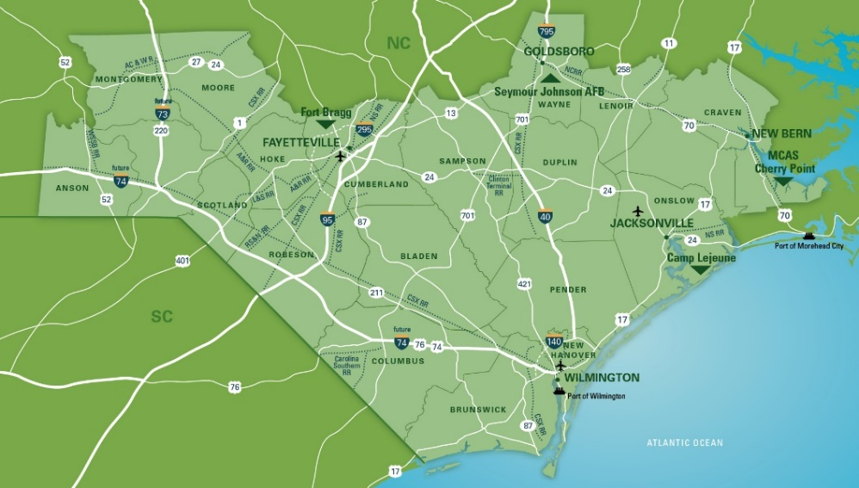
A closer examination of North Carolina’s Southeast counties reveals its current industry mix, recent job history, and projections for the next five years. The targeting focus will be on industries that serve a broader market and bring wealth from outside into the region. These industries typically represent about one third of a community’s jobs while the other two-thirds are generated from the indirect impacts of spending from the primary wealth generators. This analysis will not examine companies that primarily serve the local market.
To analyze North Carolina’s Southeast industries, we collected employment and wage data for over 680 six-digit NAICS code industries. These industries were then grouped into 53 standard industry groups, closely related to those used by the Harvard Business School Mapping Project (a full listing is included in the appendix section).
In the initial analysis, the concentration and recent employment growth of industries is used to determine their significance as potential marketing targets. Location quotients (LQs) are a measure of employment concentration. LQs are the level of an industry’s employment in the region compared to national employment levels. A location quotient of 1.00 or greater demonstrates a higher concentration than what would be expected based on national levels. This can reveal what industry groupings are most important to NC’s Southeast and the generation of money from outside of the region through exports. This type of analysis can also shed light on previous business evaluations of the region’s suitability and competitiveness for that specific industry.

Example Chart for Industry Mapping
As the quadrant map below shows, Location Quotients, when mapped alongside employment growth can show which industries are thriving or declining. The chart demonstrates where an industry is positioned, and how it corresponds to its LQ strength and growth. The position on the map does not alone determine what would be a good marketing target, but it does allow industries to be visually grouped and compared.
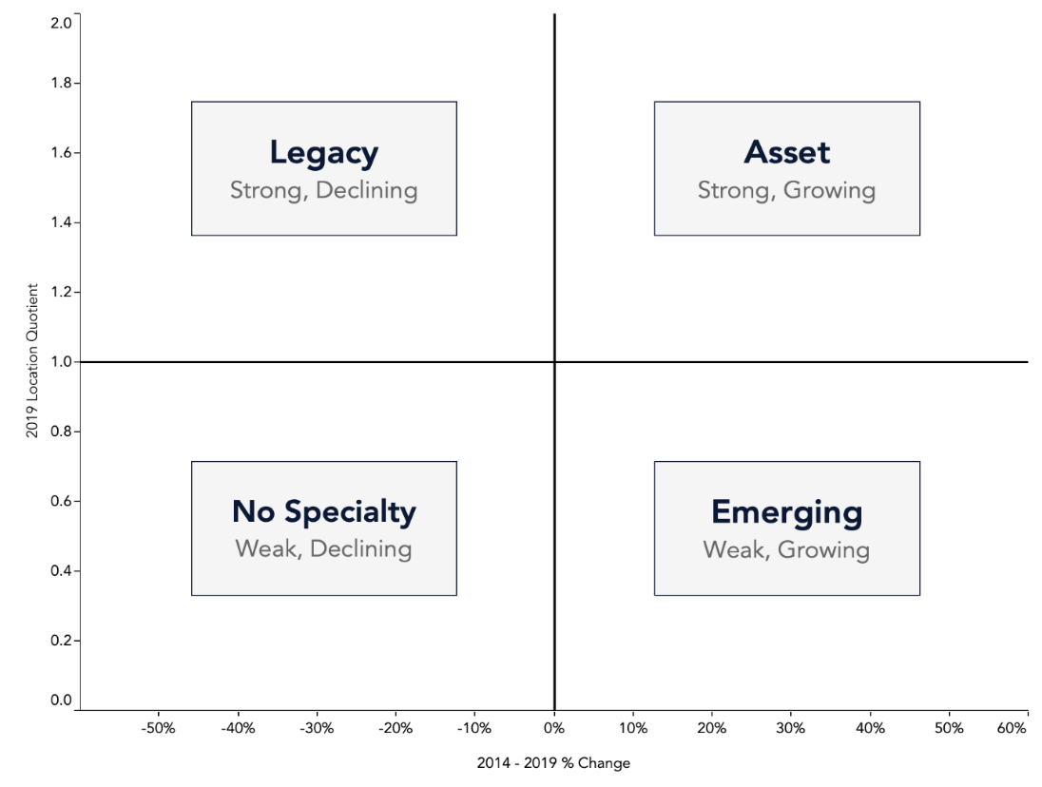
Industry mapping for NC’s Southeast for the past five years reveals a dynamic and diverse economy. While the military (federal government services) is by far the largest employer, 17 other industries are also more concentrated in NC’s Southeast than the national level. Nine of these 18 strength industries saw employment grow in the last five years, while the other half experienced a net decline in employment.
Textiles, agricultural inputs, and forestry are some of the important legacy industries in the region. They have traditionally been a key part of the region’s economy but have experienced consistent employment declines. Many factors have contributed, including globalization and automation. This does not diminish their economic importance to the region but does reduce the expectation of strong future job growth.
Many smaller employment industry groups have been growing in the region. Livestock processing was the most concentrated area with an LQ greater than 8.0. Livestock processing also had a strong employment growth rate of 20 percent in the last five years. Construction products and services ranked as an asset industry with one of the highest growth rates. Strong growth in power and communication line construction, as well as an uptick in industrial building construction, were contributors. Water Transportation was another emerging area; this industry added over 360 jobs in boat building and marine cargo handling. Tech, Distribution and E-commerce industries also had strong levels of growth.
North Carolina Southeast Industry Sector Map
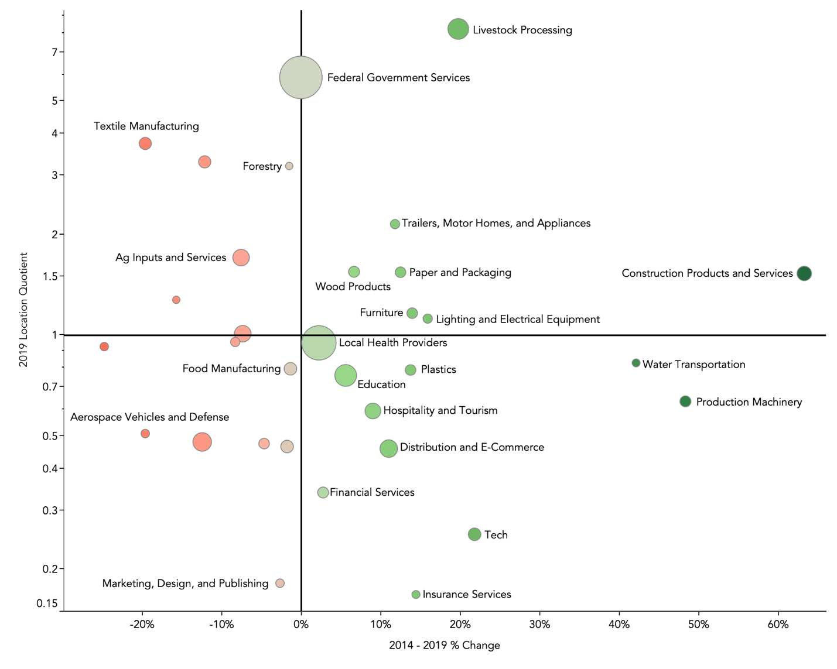
Note: The size of each industry bubble is determined by the size of 2019 employment levels. The color of each industry is determined by the employment growth from 2014 to 2019. Industry sectors with fewer than 1,000 workers were removed from the chart.
The federal government is, by far, the leading employer in the region. No other sector comes close to the military employment levels in NC’s Southeast. Average annual salaries are $70,000. Education and knowledge creation is another top employer, along with health providers, livestock processing, and business services. Of the top ten employing industries, six experienced a net employment increase in the last five years. As the following chart shows, average earnings per worker vary greatly by industry. Some top NC’s Southeast industries like Hospitality and Tourism, Agriculture, and Textiles have lower wages - none averaging more than $45,000 in annual earnings.
Top Industry Sector by Employment in NC Southeast
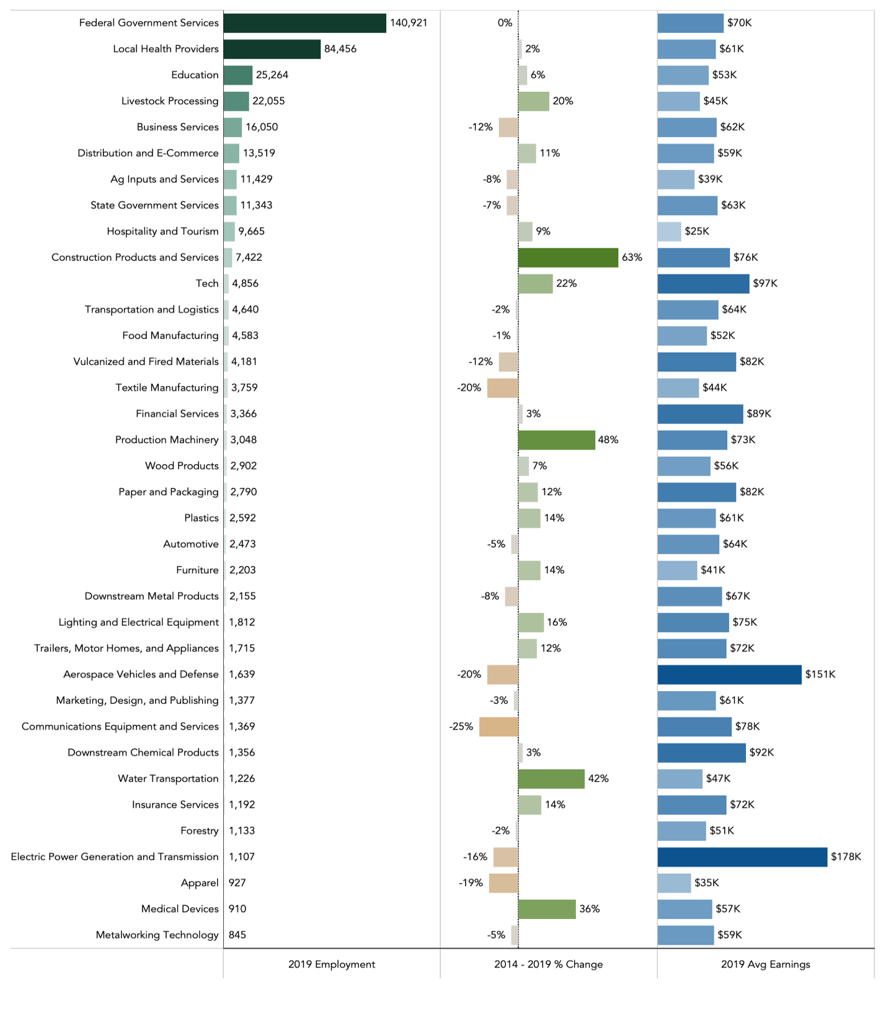
Looking at LQs and their rate of change, some of the lower employing industry sectors still have unique concentrations in the region. Forestry, for example, employs over 1,100 workers, but has a concentration over three times the national average. For some industries like apparel, the net job change was a loss, but this was consistent with the national trends and thus the LQ was unchanged.
Top Concentrated Industries, By Location Quotient, in
NC’s Southeast
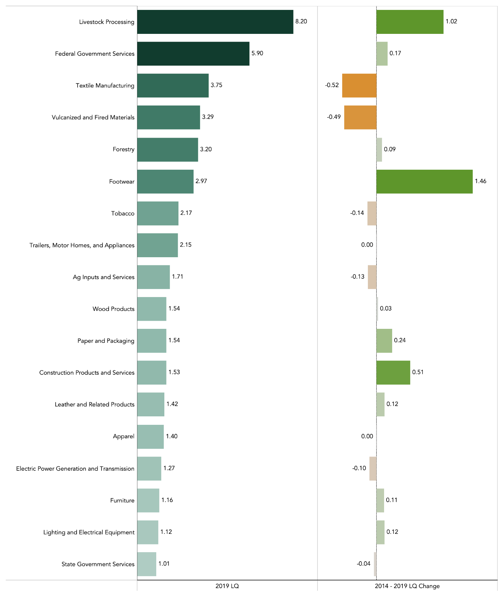
Fastest Growing Industries in NC Southeast
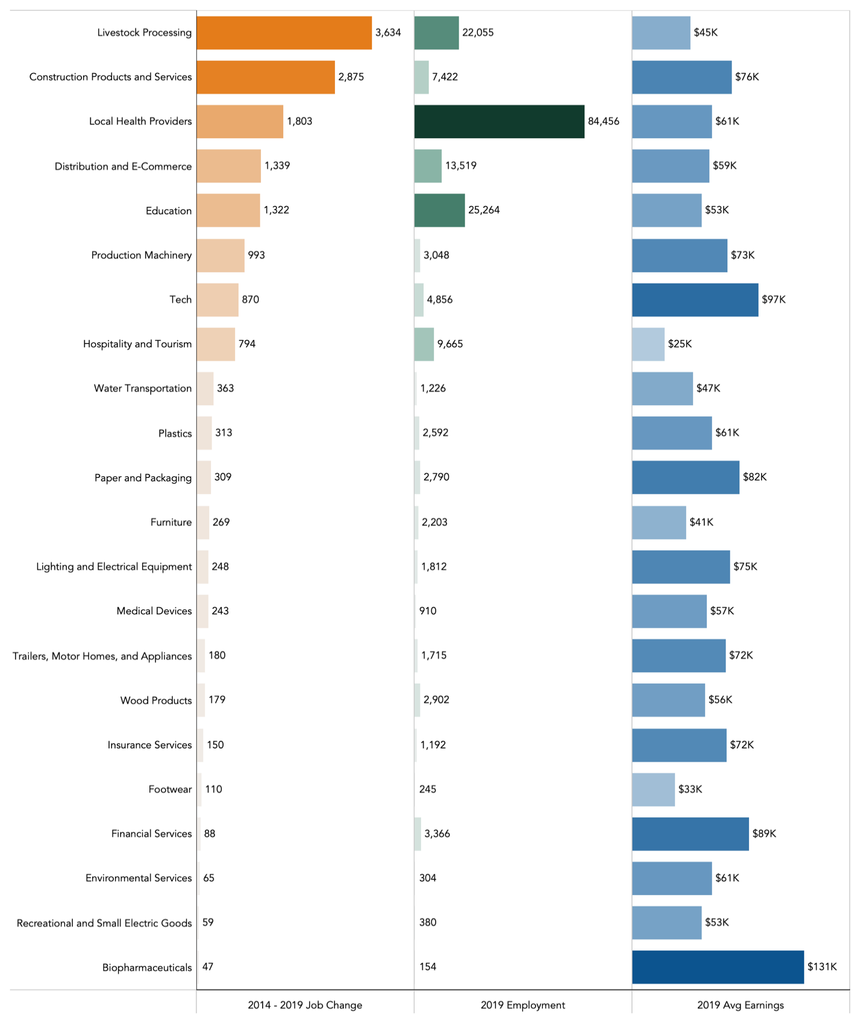

Looking at the raw change in job numbers, Livestock Processing added the greatest number of jobs in the last five years with over 3,630 jobs added. The industry is a top employer, and top concentrated industry sector, in the region. Average earnings are $45,000 a year. The next top job-adding industry was another asset sector for the region, Construction Products and Services, including building materials. Local Health Providers added 1,800 jobs to an already large workforce, an increase of two percent. Other notable sectors to examine are Production Machinery, Tech, and Paper and Packaging due to their solid gains and above average wages.
Tech is a broad sector that includes the manufacturing of tech products, such as computers, software, and precise devices, and subcomponents like semiconductors. In this analysis it also includes computer services that assist businesses such as systems design, server facilities management, and computer programming.
In NCTECH’s 2020 State of Technology report, North Carolina remains a top five state for technology job growth. While much of the growth is concentrated in Charlotte and the Research Triangle, the data suggests that many parts of the state, including areas of the Southeast region, have enjoyed recent growth. This analysis confirms those findings, and suggests that even more success is possible. NCTECH also projects that North Carolina will remain a top tech growth state over the next few years.
Using the slightly broader definition of technology established by NCTECH (87 specific classification codes), the Southeast’s technology sector added close to 1,700 net new jobs to the region between 2014 and 2019. Although basic IT (hardware, software, and communication) and the energy technology subsector were virtually unchanged, environmental tech companies added over 300 net new jobs. The big additions were in life sciences with an overall growth of 23 percent and a net job increase of over 1,300.

A Note About the Health Care Industry
Including health care in any primary industry analysis is debated among economists. Traditionally, it has been assumed that health care was an industry that served the local market and did not export or bring in additional money from outside the region. In many cases in the Southeast we believe that you can consider health care a significant primary industry; one that might bring in people from outlying, underserved places, pay high wages, and is a sector with strong national growth trends. Most officials see their regional hospitals as anchor institutions for the local economy. This was the case for the NC’s Southeast and why we chose to include health care in the initial analysis.
The Health Care industry employs over 84,450 workers in NC’s Southeast. This concentration of employment is five percent lower than the national average, or a LQ of 0.95. Since 2014, jobs have increased modestly, by two percent. Health Care’s growth and LQ that is just below average concentration, would rank it as an emerging industry area under our methodology for significant industries. The average earnings for a worker in the industry is $61,200 annually, about $9,000 lower than the national average (but likely offset by a lower cost of living in many of the NC’s Southeast counties). Registered nurses make up about 13 percent of this industry’s employment.
National research, and our stakeholder interviews, suggest that NC’s Southeast health care providers are facing many challenges, especially in more rural settings. Declining large employer private insurance, the rise of out-of-hospital ambulatory competition, shortages of specialty health care workers, North Carolina’s decision to not expand Medicaid, and the general lack of growth in rural America are all factors currently impacting NC’s Southeast hospitals.
The Kaiser Family Foundation summarized the research on the impact of not expanding Medicaid as follows.
“Studies demonstrate that Medicaid expansion has significantly improved hospital operating margins and financial performance. A study published in January 2018 found that Medicaid expansion was associated with improved hospital financial performance and significant reductions in the probability of hospital closure, especially in rural areas and areas with higher pre-ACA uninsured rates. Another analysis found that expansion’s effects on margins were strongest for small hospitals, for-profit and non-federal-government-operated hospitals, and hospitals located in non-metropolitan areas. A third study found larger expansion-related improvements in operating margins for public (compared to nonprofit or for-profit) hospitals and rural (compared to nonrural) hospitals.”

Expansion of Medicaid remains a complicated, divisive political decision. According to Chartis Center for Rural Health, 2019 was the worst year in over a decade for rural hospital closings. They report that one in four rural hospitals were at risk prior to the stresses accentuated by the COVID-19 pandemic. The near future for rural health care across the country faces strong headwinds.
The economic health of the Health Care industry is critical to the Southeast region’s future growth potential. Quality health care availability is critical for recruiting quality companies and talent to the region. Most workers list quality health care as a priority for the places they decide to live and work.
Looking to the future, growth models predict that aggregate employment in the NC’s Southeast, across all primary sectors, will increase by about 10,500 workers between now and 2024, resulting in many additional secondary or indirect and induced jobs. This will be led by over 3,020 new workers needed in the Health Care industry.
Health care occupations that will likely require the most net new workers, include the following.
Growth 2019-2024 Average Hourly Earnings
- Registered Nurses 654 $30.73
- Medical Assistants 259 $14.88
- Physician Assistants 113 $52.87
- Dental Assistant 106 $19.43
- Physical Therapists 104 $42.71

There will also be strong demand for new nursing assistants, physical therapist assistants, massage therapists, physicians and surgeons, nurse practitioners, respiratory specialist, speech-language pathologists, and clinical laboratory technicians.
Other asset sectors like the Federal Government, Construction, and Livestock Processing will also lead in job growth. Consistent growth is also expected for Tech, Distribution and E-commerce, Food Manufacturing, and Transportation & Logistics. Increased focus on, and marketing to, these industries could increase the projected employment growth. Legacy industries like Aerospace and Textiles will remain important, but are currently predicted to continue job declines in the next five years. The impacts of COVID-19 are projected to be negative on the Aerospace sector but could positively impact the specialty Textile sector, especially in subsectors of Textile Health and Safety Materials.

Predicted Employment Change in NC Southeast
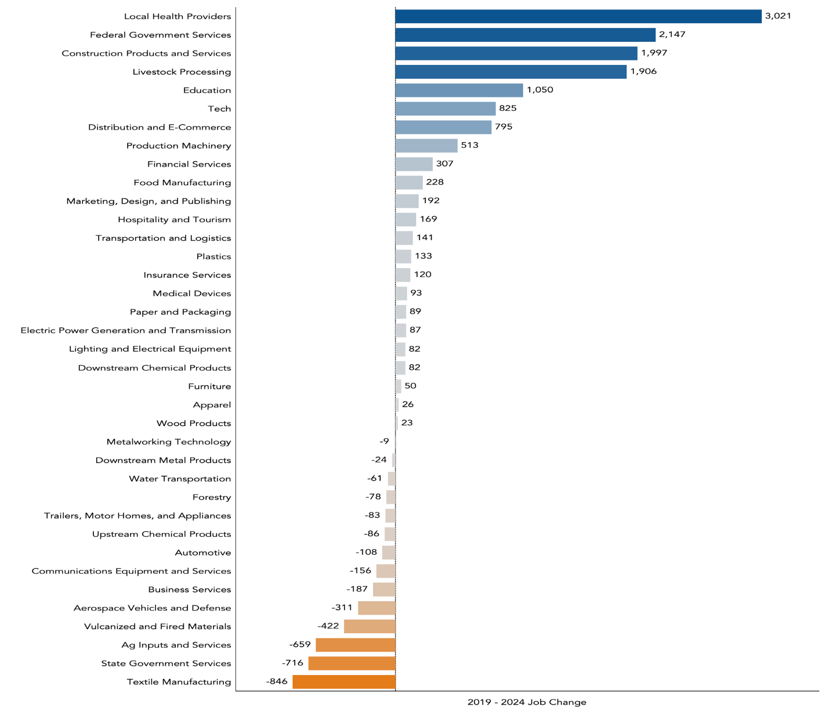

Sub-Regional Analysis
NC’s Southeast was also interested in analyzing specific microregions within the greater 18-county region to improve sub-regional marketing approaches.
The first microregion of interest was Wayne, Lenoir, and Craven counties. These counties are home to some of the military installments in the region and include the Global TransPark, where several aircraft manufacturers are located. As expected, Federal Government Services is the largest employing industry sector. There were several asset sectors in the microregion. Trailers, Motor Homes, and Appliances was the most unique industry to the region; this is driven largely by an Electrolux manufacturing facility. Livestock Processing is a major employer and has seen significant job growth in the last five years. There is also an asset concentration of Plastics. Plastics is a moderate employer with strong growth in the greater NC’s Southeast region.
Wayne, Lenoir, Craven Counties Industry Map
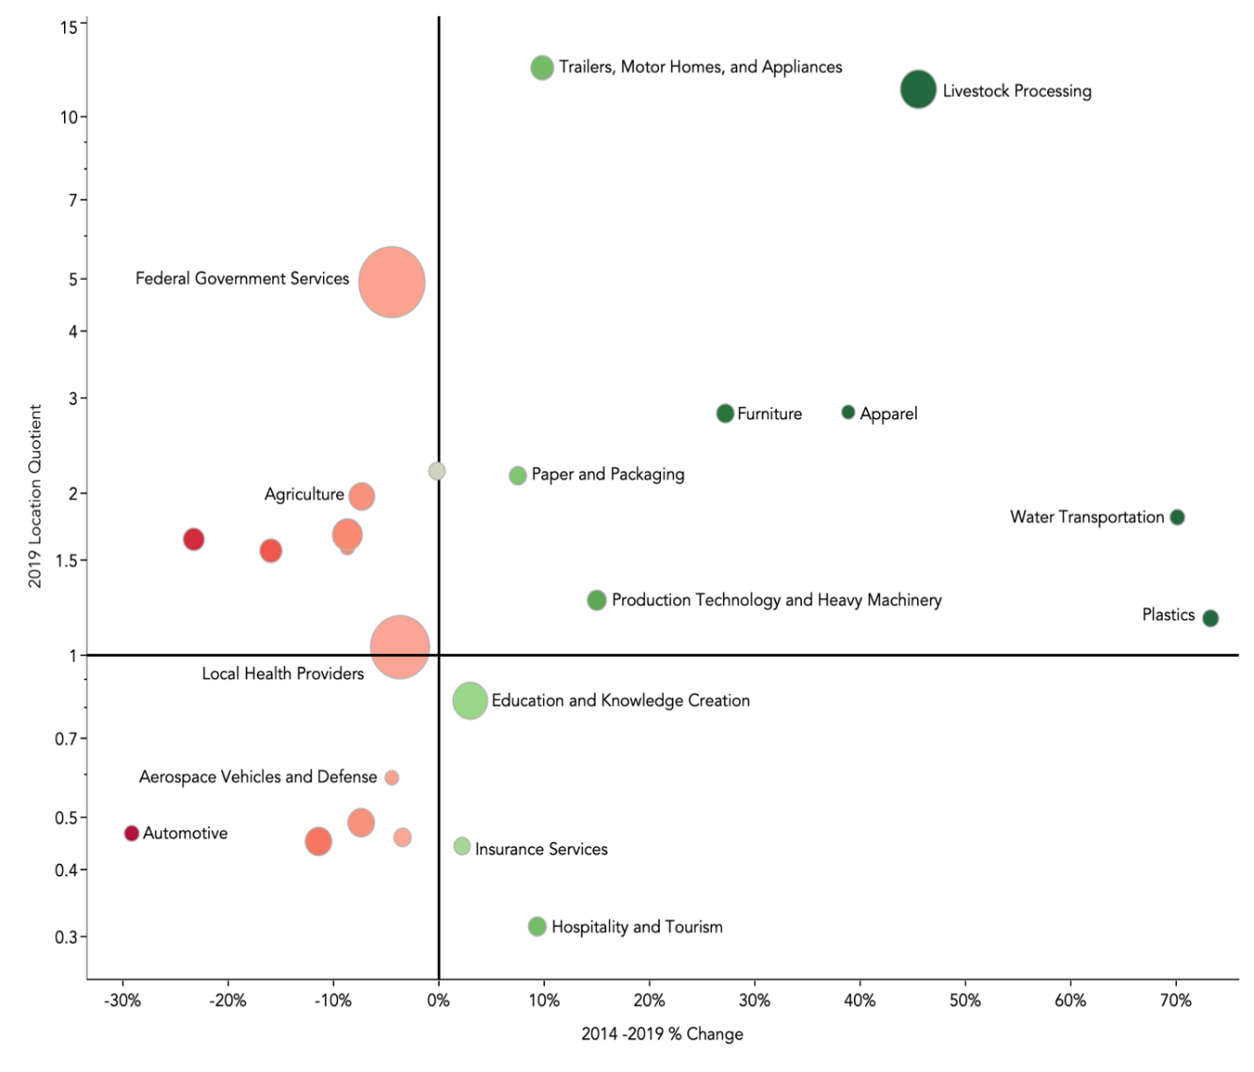

NC’s Southeast was also focused on the greater Wilmington area where significant population growth has occurred. This microregion includes New Hanover, Pender, Brunswick, and Columbus counties. When the sub-region industries are mapped, we see several high growth sectors including Construction Products and Services, Production Technology and Heavy Machinery, and Tech. Health Care and Education are the top employers, with major hospital systems serving the region, and UNC – Wilmington located in the region. Aerospace is unique to the microregion, but the sector has experienced job losses in the last five years. Although not specifically identified in this analysis, Marine Biology is a focus area for the region that remains important.
Greater Wilmington Industry Map
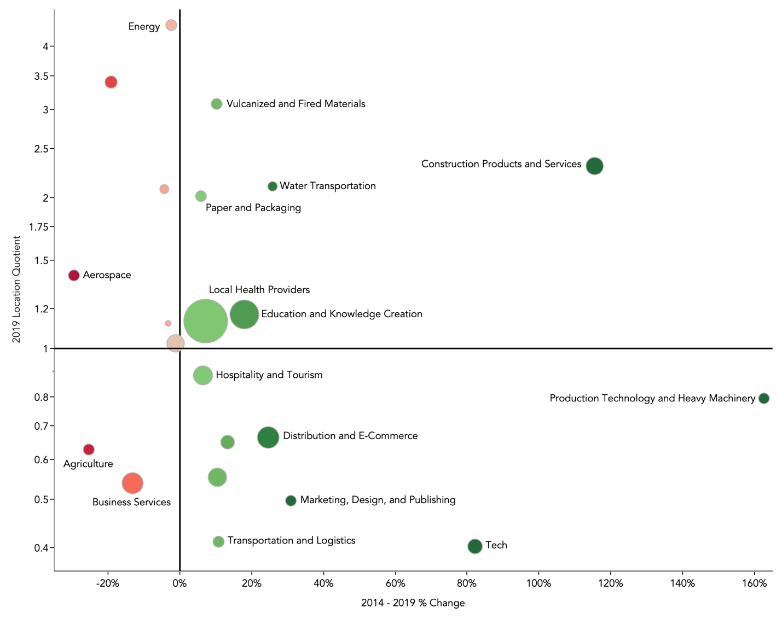

Industry Opportunities
Three areas - Federal Government Services, Health Care and Construction - are critical to the regional economy, but as sectors are not the best marketing targets. Federal Government Services is a broad, complex sector, largely outside of the control of local economic developers. The local military bases use and consume everything, from fighter aircrafts to computer systems to uniforms to chicken wings. Specific marketing targets for NC’s Southeast are better identified within their more specific sectors (Aerospace, Tech, Textiles, Food Processing). As one of the strongest and most important job and income generators, any shock to Federal Government Services would have massive rippling effects for the rest of the NC’s Southeast economy. We believe that NC’s Southeast should devote resources to supporting this sector, and strengthening the supply chain opportunities for regional companies, but not include it as a current marketing target.
The same thinking holds for the Health Care sector. Support for the health system and the region’s hospitals is critical to maintaining a competitive investment product, but marketing targets need to be more specific. Specialty health textiles, pharmaceuticals and medical devices are examples.
The Construction industry serves the local market, but it is clear that the Construction Products and Services sector serves a broader area. The sector is growing rapidly and needs to be supported. Our interviews suggest that the lack of skilled labor acts as a throttle on current industry growth. Attracting more young people into the skilled trades, and partnering with educational institutions to provide the specific training, could be an impactful strategy.
Based on the industry mapping portion of the overall analysis, there are also several additional industry assets that have unique strengths in the region. Some are suffering from employment declines but are still major goods and services exporters and contributors to the regional economy. Like Construction, many of these legacy industries may experience workforce issues as skilled workers age, making alignment between economic developers and workforce developers important.
Asset Industries That Show Opportunity for Future Growth in the Southeast
- Livestock Processing
- Construction Products and Services
- Vulcanized and Fired Materials
- Textile Manufacturing
- Forestry
- Wood Products
- Paper and Packaging
There are three emerging industries that deserve to be further explored because they have seen significant growth levels and are expected to continue in the future.

Emerging Industry Areas with Increasing Opportunity for the Southeast
- Distribution and E-Commerce
- Technology
- Production Technology and Machinery

NC’s Southeast Current Targets
Sector | Status | Employment | Past Job Change | Earnings | Future Job Change
Textile Manufacturing | Legacy | 3,760 | -20% | $44,000 | -23%
Apparel | Legacy | 930 | -19% | $35,000 | +3%
Footwear | Asset | 250 | +82% | $33,000 | +9%
Advanced Textiles | Legacy | 4,930 | -17% | $41,000 | -16%

Despite declining employment, textiles remain an important industry for the region. The port also provides a potential significant asset to the industry. A focus on specific advanced textiles, including those used for safety, protection and industrial uses could yield new success. Personal protection equipment (PPE) has become a national necessity in recent months, and increased production demand will probably remain high for years to come. As with agriculture and food, moving up the value-added production cycle to produce more specialized textiles can increase the earnings and output. North Carolina’s higher education assets are known globally for their expertise in both value-added agriculture and textiles, and can be a competitive advantage in attraction.
To move up the value chain in both food processing and textiles, the community colleges in the region are critical to provide existing workers with new technical skills.
Aviation and Aerospace
NC’s Southeast has a presence in aircraft manufacturing with GE Aviation and Spirit Aerosystems. These jobs offer the high earnings that are coveted by economic developers and workers alike. Although high-profile in the region, currently the level of jobs does not rise above the national average for a region of this size. Since major employment gains in the early 2000s, recent years have shown steady employment declines. There is potential for further private-sector development for this target industry if a company can be attracted, but the private industry is likely to experience employment and new production declines in the next few years due to COVID-19 impacts.

Through the early part of 2020 there was great optimism in the aviation and aerospace industry. According to a April 22, 2020 report from Businesswire the “Factors that were driving the aviation industry before the COVID-19 pandemic include increasing disposable income all across the globe, the introduction of low-fare airlines, increasing global economic activities, new travel trends, and many more. Moreover, replacement of aging commercial aircraft has also contributed significantly to the market growth.” Now global travel has largely ceased with a return to prior levels by major carriers unlikely anytime soon. Short, inexpensive tourism travel is expected to see major reductions. One area that could be impacted positively is a rise in the production of smaller private aircraft.
Sector | Status | Employment | Past Job Change | Earnings | Future Job Change
Aircraft Manufacturing | No Specialty | 1,610 | -20% | $150,000 | -19%
Air Transport | Emerging | 1,170 | 0% | $65,000 | +5%
Aviation and Aerospace | No Specialty | 2,780 | -13% | $114,000 | -10%

The Economic Development Partnership of North Carolina is likely to maintain Aerospace and Defense as one of their targeted industries. Partnering on statewide opportunities might be a better choice for NC’s Southeast allocation of marketing resources.
A continued focus on the military side of aviation is warranted. The direct and indirect impact of current and potential defense aviation resources in the region is significant. The Southeast needs to support the AeroDef sector with advocacy and supplier identification, attraction, and support.
Biotechnology
With several research universities, and the presence of PPD (a large global clinical trial pharmaceutical company in Wilmington), NC’s Southeast believes that the region has an opportunity to expand jobs in biotechnology. To create this target industry, we pulled the Research & Development sector out of the Education and Knowledge Creation sector and added in Biopharmaceuticals, Medical Devices, and Chemical Products. As NC’s Southeast is excited about bioenergy technology in the region, we also included the Biomass Energy sector. Notably earnings are very high in this sector, likely due to the high skills required for workers.
Past job growth has been strong throughout almost the entire target industry, and the future job growth is also predicted to be strong at five percent over the next five years.

Sector | Status | Employment | Past Job Change | Earnings | Future Job Change
Research & Development | Emerging | 3,000 | +14% | $113,000 | +5%
Biopharmaceuticals | Emerging | 150 | +44% | $131,000 | +24%
Chemical Products | Emerging | 2,080 | +1% | $94,000 | 0%
Medical Devices | Emerging | 910 | +36% | $57,000 | +10%
Biomass Energy | Legacy | 50 | -19% | $99,000 | 0%
Biotechnology | Emerging | 6,190 | +12% | $99,000 | +5%
EDPNC Targeted Industries
- Aerospace & Defense
- Automotive
- Food Processing & Manufacturing
- Information Technology
- Biotechnology & Pharmaceuticals
- Business & Financial Services
- Corporate Headquarters
- Furniture
- Outdoor Recreation
- Plastics and Chemicals
- Textiles

This is a sector where COVID-19 impacts will almost certainly increase opportunity. There is a high probability that the production of pharmaceuticals, biologicals, and medical devices and equipment will be aggressively reshored to the United States. According to the Food and Drug Administration, nearly three-quarters of the active ingredients for medicines sold in the U.S. are produced in other countries. Only 28 percent are domestic.
It is reasonable to expect that increased site selection activity in the United States has already begun. North Carolina is a major biotech and vaccine state and should have significant opportunity. Many regions in the state target this industry and NC’s Southeast will face stiff intrastate competition. Nevertheless, this is an opportunity worth the dedication of marketing resources.
Defense & Military
With the largest concentration of military personnel on the East Coast, NC’s Southeast military and defense assets are unique and major drivers of the economy. This target industry is expected to grow further with the FRC East capabilities to maintain F-35 fighter jets set to become fully operational in 2020. To measure this target industry, we segmented the Defense Industries from the Aerospace and Defense sector and added them to the Military sector from the Federal Government Services grouping. Employment in this large target industry is expected to stay stable over the next five years. The economic development opportunity for growth will

be recruiting private suppliers who support the military operations in the region.
North Carolina is, and will remain, a welcoming home for important military installations and personnel for many years to come. While tantalizing in scope and potential impact, success in attracting significant defense contractors and suppliers has proven difficult over the past decades. The Department of Defense has about 50,000 contractors each year, contracting for everything from jet aircraft to medical supplies to apparel. The defense industry could be viewed as an aggregate of many (most) other industries. Many factors impact DOD decisions and private sector decisions on where to locate facilities.
Sector | Status | Employment | Past Job Change | Earnings | Future Job Change
Defense | Emerging | 30 | +40% | $178,000 | -30%
Military | Legacy | 108,500 | -2% | $62,000 | +1%
Defense & Military | Legacy | 108,530 | -2% | $62,000 | +1%

As stated earlier, NC’s Southeast needs to devote resources to supporting the military bases and advocating for investments and actions that will strengthen their continued and hopefully expanded operations. We believe that the most efficient and effective marketing opportunities will occur within other sectors.
Energy
The traditional energy sector is strong with Duke Energy, Cooperatives, and ElectriCity Communities operating in the region. Earnings are high, but the industry employment levels have been reduced in the past few years. New growth could come from nontraditional energy generation. The region has ample solar resources, and some wind resources. The sector activity of Forestry and Animal Processing produces waste that can be converted into biomass. There is substantial development activity currently ramping up in the utilization of pork and poultry waste. Despite recent losses, projections suggest some future job growth.
Sector | Status | Employment | Past Job Change | Earnings | Future Job Change
Electric Power Generation and Transmission | Legacy | 1,110 | -16% | $178,000 | +8%

Alternative energy investment should continue in the region due to a good match between regional assets and new energy demands. We believe that there are limited marketing opportunities in this sector for NC’s Southeast. Energy availability, reliability and costs will remain important competitive factors, and the Southeast should devote some resources to support continued energy competitiveness.
Distribution & Logistics
The rise of online shopping and Amazon has made Distribution and E-commerce an emerging sector in almost every region we have studied in the past several years. The NC’s Southeast is no different, but also has unique assets in the form of the Wilmington deep water port. Jobs have been added in the past five years, and the COVID-19 impacts could raise the growth rate significantly from current projections. Recent regional activity has included joint manufacturing and distribution projects.

Sector | Status | Employment | Past Job Change | Earnings | Future Job Change
Distribution & E-Commerce | Emerging | 13,520 | +11% | $59,000 | +6%
Transportation & Logistics | No Specialty | 4,640 | -2% | $64,000 | +3%
Water Transportation | Emerging | 1,230 | +42% | $47,000 | -5%
Distribution & Logistics | Emerging | 19,390 | +9% | $60,000 | +5%

The Southeast’s transport infrastructure is a competitive advantage. As a growing sector, likely to grow faster due to COVID-19 impacts, this sector presents an opportunity for the region. The Logistics sector will experience rapid technological advancement in the coming years, with demands for trained employees and customized buildings.
Metal Working
Examining the data from the sector analysis, the region did not appear to have a significant advantage in the Metalworking sector. We expanded the analysis to include an even larger value chain for the metal products that often supply metalworking, as well as the production machinery sector that often uses metal to produce machinery. This greater value chain shows an emerging target industry with strong job growth, particularly from the Production Machinery sector.
Sector | Status | Employment | Past Job Change | Earnings | Future Job Change
Downstream Metal Products | No Specialty | 2,160 | -8% | $67,000 | -1%
Production Technology & Heavy Machinery | Emerging | 3,050 | +48% | $73,000 | +17%
Metalworking Technology | No Specialty | 840 | -5% | $59,000 | -1%
Metalworking | Emerging | 6,050 | +14% | $69,000 | +8%

Production Technology and Heavy Machinery has growth potential and offers a good marketing target. The marketing targets would be companies that produce machines and parts designed to produce end user, or downstream, goods in the industrial, agricultural, construction and commercial industries. Earnings are high, and we believe with a strong community college training partnership, this is a new area for growth.
If we apply the same mapping methodology to the current NC’s Southeast target industries, the results reveal mixed outcomes. Only one target industry truly registers as an asset: Agri-industry and Food Processing. There are three additional strongly emerging industries in the region: Biotechnology, Metalworking, and Distribution and Logistics. Aerospace, Textiles, and Energy have all seen significant net job loss in the past five years.
Based on the industry analysis, some industries that are assets are not current regional target industries. Vulcanized and Fired Materials, Construction Products and Services, as well as Forestry and Associated Products (wood products, furniture, paper and packaging) have a statistically unique presence in NC’s Southeast, and could be targeted. Tech is another emerging industry that could be included in the targeted industries.

NC Southeast Current Target Industries Map
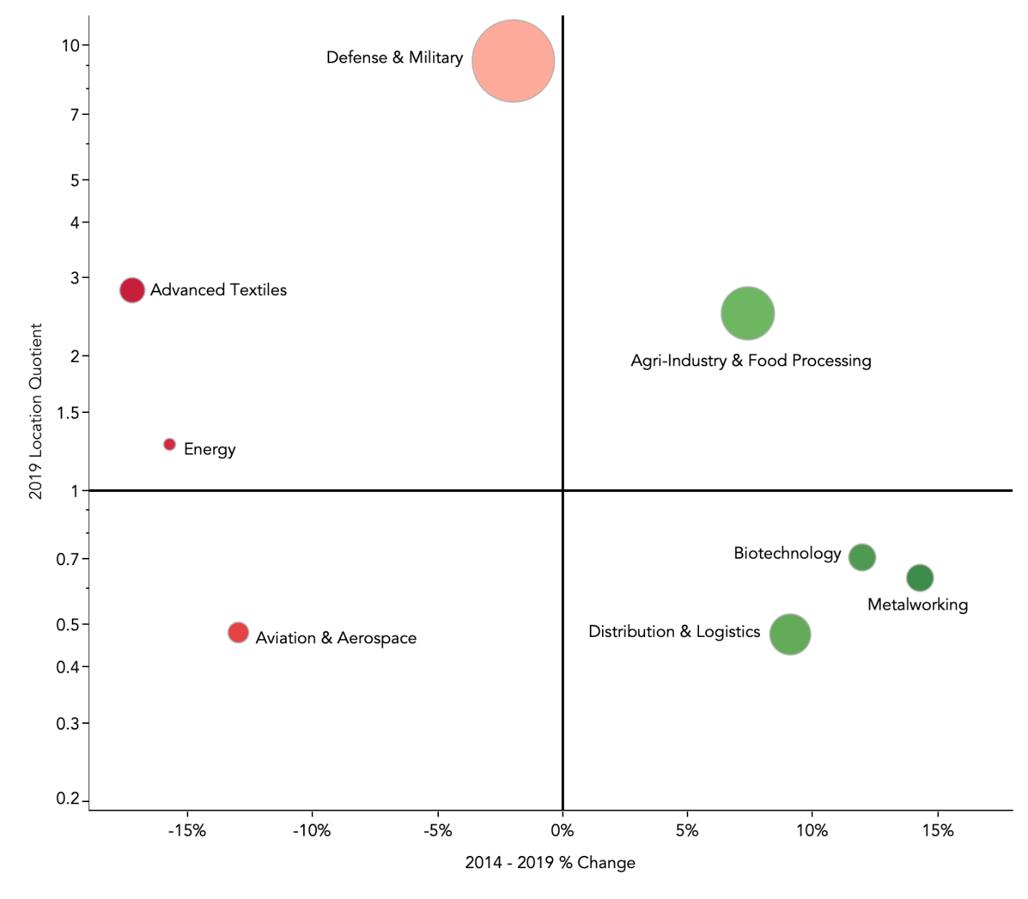

Matching Strengths to Industry Needs
The third level of assessment is the development of a matrix evaluating regional strengths in relationship to the various industry requirements. The NC’s Southeast benefits from the state’s highly competitive business climate. Most multifactor analyses rank the state among the top 10 best states for business, and the most recent site selector survey named North Carolina as the state that had improved its business climate the most in recent years. Other factors that rank high on Area Developments 34th Survey released earlier this year include a low corporate tax rate, low union profile, and energy costs, which are all strengths of the state. (See list below)
The other key factors in the ranks include highway accessibility, availability of skilled labor, local training capacity, quality of life, occupancy costs, the availability of ready buildings and sites, and proximity to markets and suppliers. The 18 counties of NC’s Southeast have almost 800,000 workers in the labor force with about one-third having a college degree (AA, bachelor’s, or advanced degree).
The region has greater diversity than the nation and is home to a significantly higher percentage of veterans. The education pipeline is fueled by over 21 institutions including six four-year institutions and 15 community colleges that produce over 25,000 graduates annually. The pipeline has grown by over 20 percent in the past five years. One negative is the region’s ability to sustain its labor force quantity. Some companies will be concerned by data that show population decline in more than half of the region’s counties over the past five years.
Transportation infrastructure is also a regional strength with several interstates and service from rail, the Port of Wilmington and numerous airports. There are also many available high-quality buildings and sites scattered throughout the region. Our analysis shows different levels of competitiveness from county to county based on access to infrastructure, availability of buildings and sites, and labor force quantity and skills. Currently the region needs more high-quality buildings. If the buildings available can be improved, and the workforce continues to improve its overall training, the region could be an excellent home for any of the industries discussed.

North Carolina’s Southeast Supply Chain Analysis
Building from the research of the asset industries of NC’s Southeast, our fourth analysis dives deeper into the supply chains of top traded sectors to help identify effective targets for economic development marketing. Examining what goods and services are imported to the region shows where money is leaking outside of the region and offers potential recruitment opportunities. If an anchor industry is having to import heavily from another industry in its supply chain, this could be a recruitment opportunity to bring more supply chain companies to the region and keep money within the community. It helps bring new companies to your area while simultaneously reducing costs for your existing companies. This type of approach is enhanced by a strong Business Retention and Expansion program where regional and local economic developers are in constant discussions with their anchor companies.
To generate specific target industries, we evaluated data based on the sector analysis. The supply chains of the most relevant asset and emerging sectors from the analysis were evaluated. This analysis looks at the supply chain requirements and spending of these top sectors, as well as the supply chain for all sectors in NC’s Southeast.
Data from EMSI’s input/output model for the year 2019 breaks down the amount of purchases the sector buys from other industries (six-digit NAICS code level). This spending is broken down by spending that is met within region, and out of the region. The sectors with the highest value of out-of-region, or imported, purchases represent the largest leakage and therefore opportunities for regional economic developers.

Supply Chain Purchases for Top Sectors

The Federal Government Services sector has the largest supply chain in the region at an annual value of $42 billion. Only 15 percent of that demand is sourced within the NC’s Southeast region, meaning $35 billion in military spending leaks out of the region to other areas. The next largest supply chain is Livestock Processing with almost $6 billion in spending. For Livestock Processing, about 37 percent is met in-region. The percentage sourced within the region ranges from 15 percent with Federal Government Services to 55 percent for Aerospace and Defense. Across all examined sectors, the supply chain has a value of $74 billion. About 26 percent of these needs are sourced within NC’s Southeast, meaning $55 billion leaks outside of the region. Keeping any greater portion of this spending in NC’s Southeast could represent a significant positive economic impact to the area.

Supply Chain Value by Sector
Sector | Total Value of Supply Chain (million$) | % Sourced Within Region | Value of Imported Purchases  (million$)
Federal Government Services | $41,528 | 15% | $35,473
Livestock Processing | $5,846 | 37% | $3,656
Food Manufacturing | $1,467 | 26% | $1,082
Distribution and E-Commerce | $1,377 | 44% | $777
Paper and Packaging | $1,068 | 28% | $767
Construction Products and Services | $817 | 31% | $565
Vulcanized and Fired Materials | $755 | 30% | $529
Production Technology and Heavy Machinery | $587 | 26% | $433
Wood Products | $473 | 39% | $287
Aerospace and Defense | $432 | 55% | $196
Textile Manufacturing | $423 | 23% | $326
Electric Power Generation and Transmission | $414 | 37% | $263
Tech | $287 | 45% | $159
Forestry | $98 | 49% | $50
All Sectors | $74,273 | 26% | $54,805

The sectors with the top three supply chains were evaluated further to see which specific industries they import purchases from outside the region.
Federal Government Services
The Federal Government Services sector is dominated specifically by the military in NC’s Southeast. The military imports over a billion dollars from each of the top six supplying industries. The highest in-region purchasing percentage was 20 percent, with many industries falling below that level. The top supplier by far in the military is Aircraft Manufacturing. Only six percent of this need is met within NC’s Southeast. Since this sector is national in scope, opportunities to attract a supplier or have an existing company fulfill the demand are not likely.
Other needs that could be met within the region are Computer Systems Design Services, Engineering, Ship Building and Repair, and Research & Development. Helping regional companies secure military contracts, or recruiting military suppliers to the region, offer potential gains for NC’s Southeast.

Top Supply Chain Needs for Federal Government Services
Purchases From | In-region Purchases  (million$) | % In-region Purchases | Imported Purchases  (million$) | % Imported Purchases
Aircraft Manufacturing | $144 | 6% | $2,418 | 94%
Petroleum Refineries | $2 | 0% | $1,539 | 100%
Computer Systems Design Services | $96 | 7% | $1,256 | 93%
Engineering Services | $143 | 11% | $1,221 | 89%
Data Processing, Hosting, and Related Services | $34 | 3% | $1,188 | 97%
Ship Building and Repairing | $1 | 0% | $1,016 | 100%
Search, Detection, Navigation, Guidance, Aeronautical, and Nautical System and Instrument Manufacturing | $6 | 1% | $883 | 99%
Research and Development in the Physical, Engineering, and Life Sciences (except Nanotechnology and Biotechnology) | $26 | 4% | $676 | 96%
Guided Missile and Space Vehicle Manufacturing | $0 | 0% | $646 | 100%
Administrative Management and General Management Consulting Services | $112 | 20% | $460 | 80%
Custom Computer Program Services | $64 | 12% | $460 | 88%
Other Electronic Parts and Equipment Merchant Wholesalers | $25 | 6% | $414 | 94%
Software Publishers | $31 | 7% | $410 | 93%

Livestock Processing
Livestock Processing sources more of its purchases in region, in general, compared to the military. However, opportunities for greater connections exist. Processers source 69 percent of their animals from outside the region, while the region is one of the top animal production areas. Other top suppliers are Transportation and Logistics industries like trucking and warehousing.

Top Supply Chain Needs for Livestock Processing
Purchases From | In-region Purchases  (million$) | % In-region Purchases | Imported Purchases  (million$) | % Imported Purchases
Animal Production | $929 | 31% | $2,069 | 69%
Meat Processed from Carcasses | $38 | 12% | $289 | 88%
Corporate, Subsidiary, and Regional Managing Offices | $11 | 4% | $256 | 96%
General Freight Trucking, Long-Distance, Truckload | $79 | 49% | $84 | 51%
General Freight Trucking, Long-Distance, Less Than Truckload | $15 | 23% | $51 | 77%
General Freight Trucking, Local | $36 | 42% | $51 | 58%
Corrugated and Solid Fiber Box Manufacturing | $4 | 7% | $49 | 93%
General Line Grocery Merchant Wholesalers | $10 | 17% | $48 | 83%
Other Grocery and Related Products Merchant Wholesalers | $12 | 21% | $46 | 79%
Specialized Freight (except Used Goods) Trucking, Local | $16 | 32% | $34 | 68%
General Warehousing and Storage | $11 | 27% | $30 | 73%

Food Manufacturing
The next most valuable supply chain is the Food Manufacturing sector. Again, Animal Production is only sourced 26 percent within the region. Crop Production is the top supplier and is sourced in-region at 33 percent. Given the NC’s Southeast agriculture presence this value could be higher. Many food processing companies outsource their corporate offices to other areas.

Top Supply Chain Needs for Food Manufacturing
Purchases From | In-region Purchases  (million$) | % In-region Purchases | Imported Purchases  (million$) | % Imported Purchases
Crop Production | $105 | 33% | $212 | 67%
Soybean and Other Oilseed Processing | $53 | 32% | $111 | 68%
Corporate, Subsidiary, and Regional Managing Offices | $2 | 4% | $56 | 96%
Distilleries | $1 | 2% | $37 | 98%
Flour Milling | $0 | 0% | $28 | 100%
Animal Production | $10 | 26% | $28 | 74%
Other Grocery and Related Products Merchant Wholesalers | $8 | 25% | $25 | 75%
General Line Grocery Merchant Wholesalers | $10 | 30% | $23 | 70%
Fats and Oils Refining and Blending | $0 | 0% | $20 | 100%
Rail Transportation | $7 | 27% | $20 | 73%

All Industries
While the previous industries represent the largest supply chains of the top sectors, there are many other important industries in the region. To round out the analysis, we looked at the sourcing needed by all industries. While a supplier company is most likely to be drawn by one of the top existing companies, it can be beneficial to show the full extent of potential from all industries in NC’s Southeast.
Given the large military presence in the region, many of the top military supply needs show up in the total list as well, reiterating that securing more local military suppliers would be the best way to capture leakage. Many of the top needs are Tech related industries. The industry analysis revealed growth in the Tech sector in NC’s Southeast.

Top Supply Chain Needs for All Traded Industries
Purchases From | In-region Purchases  (million$) | % In-region Purchases | Imported Purchases  (million$) | % Imported Purchases
Aircraft Manufacturing | $155 | 6% | $2,445 | 94%
Animal Production | $1,095 | 33% | $2,257 | 67%
Petroleum Refineries | $4 | 0% | $2,048 | 100%
Computer Systems Design Services | $125 | 8% | $1,391 | 92%
Engineering Services | $200 | 13% | $1,328 | 87%
Data Processing, Hosting, and Related Services | $58 | 4% | $1,325 | 96%
Corporate, Subsidiary, and Regional Managing Offices | $46 | 4% | $1,174 | 96%
Ship Building and Repairing | $1 | 0% | $1,019 | 100%
Search, Detection, Navigation, Guidance, Aeronautical, and Nautical System and Instrument Manufacturing | $6 | 1% | $910 | 99%
Research and Development in the Physical, Engineering, and Life Sciences (except Nanotechnology and Biotech) | $31 | 4% | $681 | 96%
Guided Missile and Space Vehicle Manufacturing | $0 | 0% | $650 | 100%
Administrative Management and General Management Consulting Services | $234 | 30% | $545 | 70%
Custom Computer Programming Services | $84 | 14% | $517 | 86%
Other Electronic Parts and Equipment Merchant Wholesalers | $27 | 5% | $478 | 95%
Electrical Apparatus and Equipment, Wiring Supplies, and Related Equipment Merchant Wholesalers | $30 | 6% | $467 | 94%
Software Publishers | $68 | 13% | $453 | 87%
Internet Publishing and Broadcasting and Web Search Portals | $15 | 3% | $415 | 97%
Research and Development in Biotechnology (except Nanobiotechnology) | $112 | 24% | $366 | 76%
Meat Processed from Carcasses | $44 | 11% | $359 | 89%
Direct Property and Casualty Insurance Carriers | $63 | 15% | $352 | 85%
Crop Production | $206 | 37% | $349 | 63%

Reducing Leakage
This analysis reveals that the military supply chain represents the highest value, and biggest lever, on reducing leakage in NC’s Southeast. The state of North Carolina is also interested in expanding the number of local companies that secure defense contracts. Currently, only about 12 percent of North Carolina companies have defense contracts. Researchers at RTI International and NC Department of Commerce recently released a study focused on growing the state’s defense and homeland security economy. The report found the main barriers to more success are:

- Lack of awareness of relevant opportunities,
- Difficulties navigating government requirements and the contracting process, and
- Greater financial opportunities in the private market.

The report lists four major recommendations on improving local defense contracts including improving networking and collaboration, providing contracting assistance, remove barriers of entry, and agency outreach. The group responsible for this report is the Defense Alliance of North Carolina. Partnering with this organization to implement these recommendations on the ground in NC’s Southeast could be productive to secure more contracts. Considering that this a high priority for the state, there may be resource assistance that can be provided for these efforts.
Another effort that can be taken from this information is ensuring that local companies are aware of local suppliers and making these connections. For example, there may be a local company spending money on a web developer who lives in California while there is an existing website development company five miles down the road. Usually these missed connections happen because of lack of awareness; other times the supplier may need assistance getting their operations up to par with the demands of the buyer.
In NC’s Southeast, Animal and Crop Production are both top traded industries, yet $685 million and $796 million were exported from the region in 2019, respectively. They are both top inputs required for industries in the NC’s Southeast, but only 33 percent and 37 percent are sourced locally. This allows for almost $2.6 billion to leak from the region. If we address the gaps where a local animal producer could be meeting a local buyer’s needs, this could help keep money in the region and help bolster the Food Processing and Agricultural Inputs and Services sectors.

Conclusions and Recommendations
No analysis provides an easy answer to the question of which industries North Carolina’s Southeast should target. In addition to the fruits of the regional effort, new interest in the region will be generated from many sources including the marketing efforts of the state and NCPED, the individual county offices, allies, and the existing businesses. Based on the research and input from stakeholders, and our team, we make the following recommendations, beginning with the NC’s Southeast eight current targeted industries.
Current Targeted Industries Recommendation Expanded Explanations
Advanced Textiles | Maintain as Target | Focus on advanced textiles in the health and safety sector & target value-added manufacturers. NC’s history, workforce and research capacity is a competitive advantage.
Agri-Industry & Food Processing | Maintain as Target | Focus marketing on value-added and more on the processing component - growth is expected to be strong
Aviation & Aerospace | Support (not marketing target) | The private components of the sector will face near-term reductions due to COVID-19. It remains important and may warrant additional marketing in future years. The Defense aviation presence warrants support and advocacy
Biotechnology | Narrow Focus | Redefine target as med-tech and focus on medical devices and the near-shoring of pharma and pharma components
Defense & Military | Support & Advocacy (not marketing target) | Increase support to build existing business supply chain opportunities but reduce marketing
Distribution & Logistics | Maintain as Target | E-Commerce opportunities are likely to expand, and recent growth has been strong
Energy | Support & Advocacy (not marketing target) | Energy remains important, but marketing opportunities (outside alternative energy) will be limited
Metal Working | Re-Focus | Redefine as production technology and heavy machinery

The recommendations are to devote staff resources to support the Defense and Construction and Building Products sectors through BRE and supply chain activities, support the Health Care sector through influence leadership, and to respond to new energy opportunities that present themselves.
We recommend that North Carolina’s Southeast target Advanced Textiles with a focus on health and safety, Value-Added Agriculture and Food Processing, Medical Technology with a focus on medical devices, Distribution and Logistics, and Production Technology and Heavy Machinery to generate clients for the broad region. Despite projections that the Agriculture and Food Processing sector will continue to see job contraction, it is an industry that is critical to the economy of many of the counties in the region. The other four recommendations are all industries expecting strong growth over the next five years. Construction and building products are also expected to grow and if additional marketing funding becomes available, dedicated efforts could yield results.
We also see opportunities in the broader Technology sector for the Wilmington subregion especially in Life Science, Plastics in the Wayne, Lenoir, and Craven counties subregion, and targeted recruitment in manufacturing and research to the Golf sector for Moore County.
We further recommend that the region reduce resources to market to the Aviation and Aerospace, Defense and Military, and Energy sectors.
Finally, we recommend that North Carolina’s Southeast focus on existing company supply chains to expand their marketing reach.

Top Industry Groupings Descriptions
Livestock Processing
Establishments that process meat from livestock are included in this sector. Livestock wholesaling companies are also included in the livestock processing sector.
Industries included:
- Animal Slaughtering
- Meat Byproduct and Carcasses Processing
- Poultry Processing
- Air Handling Equipment
- Livestock Merchants Wholesalers

Top Company in NC’s Southeast: Butterball

Construction Products and Services
Industries involved in this sector include those that manufacture inputs that are used in residential, commercial, and industrial construction such as cement, asphalt, pipes, heat exchangers, etc. The sector also includes engineering services for heavy construction. Industries that construct for other businesses including industrial construction and pipeline construction are also included.
Industries included:
- Non-Residential Construction
- Water, Sewage, and Other Systems
- Construction Products
- Construction Components
- Construction Materials

Top Company in NC’s Southeast: Rush Construction
Vulcanized and Fired Materials
In this sector, manufacturers use extremely high temperatures to process earthen substances like clay, rubber, and sand into goods such as brick, glass, and tires.
Industries included:
- Clay Products and Refractories
- Glass Products
- Rubber Products
- Tire manufacturing

Top Company in NC’s Southeast: Goodyear Tires
Textile Manufacturing
This sector focuses on the mills that produce finished fabrics for clothing, carpets, and other household goods. It also includes the manufacturers of the fibers used by mills.
Industries included:
- Yarn and Thread Mills
- Fabric Mills
- Textile and Fabric Finishing
- Knitting Mills
- Household Textile Products
- Other Textile Products
- Fibers

Top Company in NC’s Southeast: Kayser Roth Corporation
Forestry
Companies in this sector are involved in the growing and/or harvesting of trees. Support activities are also included. As a legacy sector, however, predicted job loss and an industry ripe for automation present specific challenges.
Industries included:
- Logging
- Timber Tract
- Forest Nurseries
- Forestry Support Activities

Top Company in NC’s Southeast: Weyerhaeuser
Wood Products
Given the strong historical presence of forestry in the region, establishments that could help process the timber also became prevalent in the industry. Movements to source and manufacturer locally, similarly to food, are starting in the furniture and woodworking sphere. The natural forests in the region offer a unique advantage for wood manufacturing companies.
Industries included:
- Wood Processing
- Wood Components and Products
- Prefabricated Wood Building

Top Company in NC’s Southeast: West Fraser Sawmill
Paper and Packaging
Within this sector are manufacturers of paper, paper mills, and the manufacturing of packaging products.
Industries included:
- Paper Mills
- Packaging
- Paper Products

Top Company in NC’s Southeast: Pactiv
Distribution and Electronic Commerce
Traditional wholesalers and electronic merchants are the companies included in this sector. These companies’ primary functions are buying, warehousing, and distributing goods. Goods range across a variety of materials and uses. Also included in the sector are companies that support wholesalers.
Industries included:
- Warehousing and Storage
- Electronic and Catalog Shopping
- Wholesale Trade Agents and Brokers
- Packaging and Labeling Services
- Wholesalers
- Rental and Leasing

Top Company in NC’s Southeast: Atlantic Packaging Corp
Tech
This sector, slightly adapted from US Cluster Mapping, is also known as Information Technology and Analytical Instruments. This sector includes the manufacturing of tech products such as computers, software, and precise devices. It also includes the makers of subcomponents like semiconductors. In this variation, it includes computer services that help businesses such as systems design, server facilities management, and computer programming.
Industries included:
- Electronic Components
- Computers and Peripherals
- Semiconductors
- Software Publishers
- Software Reproducing
- Process and Laboratory Instruments
- Medical Apparatus
- Audio and Video Equipment
- Computer Business Services

Top Company in NC’s Southeast: Cisco Systems
Production Technology and Heavy Machinery
In this sector, companies produce machines and parts designed for the production of end user, or downstream, goods. Often these products are used by other manufacturers to deliver to industrial, agricultural, construction and commercial industries.
Industries included:
- Industrial Machinery
- Agricultural Machinery
- Construction Machinery
- Air Handling Equipment
- Commercial and Service Industry Machinery
- Moving and Material Handling Equipment
- Process Equipment and Components

Top Company in NC’s Southeast: Railroad Friction Products Corp

Regional Data Comparisons
Economic development is a competition between places. The winners add jobs, wealth, companies, and residents. As was mentioned in the first section about future trends, there is an expanded role for data analytics in the site selection process. It is no longer enough to know what your regional assets are, you must understand how they compare to your competitors. Effective economic development organizations promote the areas where they have a competitive advantage and improve the regional product where there are deficiencies.
No two regions are alike, and no two clients equally value the same assets. Maintaining a data base of both the Southeast Region, and likely competitors, allows for quick response to opportunities, but also allows for ongoing strategic improvement. The table below shows some basic information about the 18-County region and about the Fayetteville and Wilmington Metropolitan Statistical Areas.
 | NC's Southeast 18 County Region | Fayetteville NC MSA | Wilmington NC MSA
Population (2019) | 1,836,745 | 524,202 | 299,510
Population Percentage Growth (2014-2019) | 2.9% | 2.6% | 10.2%
Employment (2019) | 802,319 | 218,643 | 145,097
Employment Percentage Growth (2014-2019) | 4.5% | 2.8% | 14.4%
Employment to Population Ratio (2019) | 43.7% | 41.7% | 48.4%
Average Earnings per Job (2019) | $51,100 | $55,758 | $53,490
Cost of Living (U.S. = 100) | 93.6 | 91.0 | 94.4
Gross Regional Product Per Capita (2019) | $46,152 | $48,798 | $50,750
Exports Per Capita (2019) | $81,340 | $111,064 | $48,412
Educational Attainment - AA degree and above (2019) | 33.1% | 32.8% | 45.7%
Largest Industry (number of jobs in region) (2019) | Government | Government | Government
Top Growing Industry (2014-2019) Number of Net New Jobs | Accom. & Food Service | Construction | Construction
Postsecondary Graduates (2019) | 26,498 | 8,549 | 7,118
Educational Pipeline Growth (2014-2019) | 15% | 8% | 10%

The table below shows how the Wilmington MSA compares on specific data points to similar sized southern MSAs.
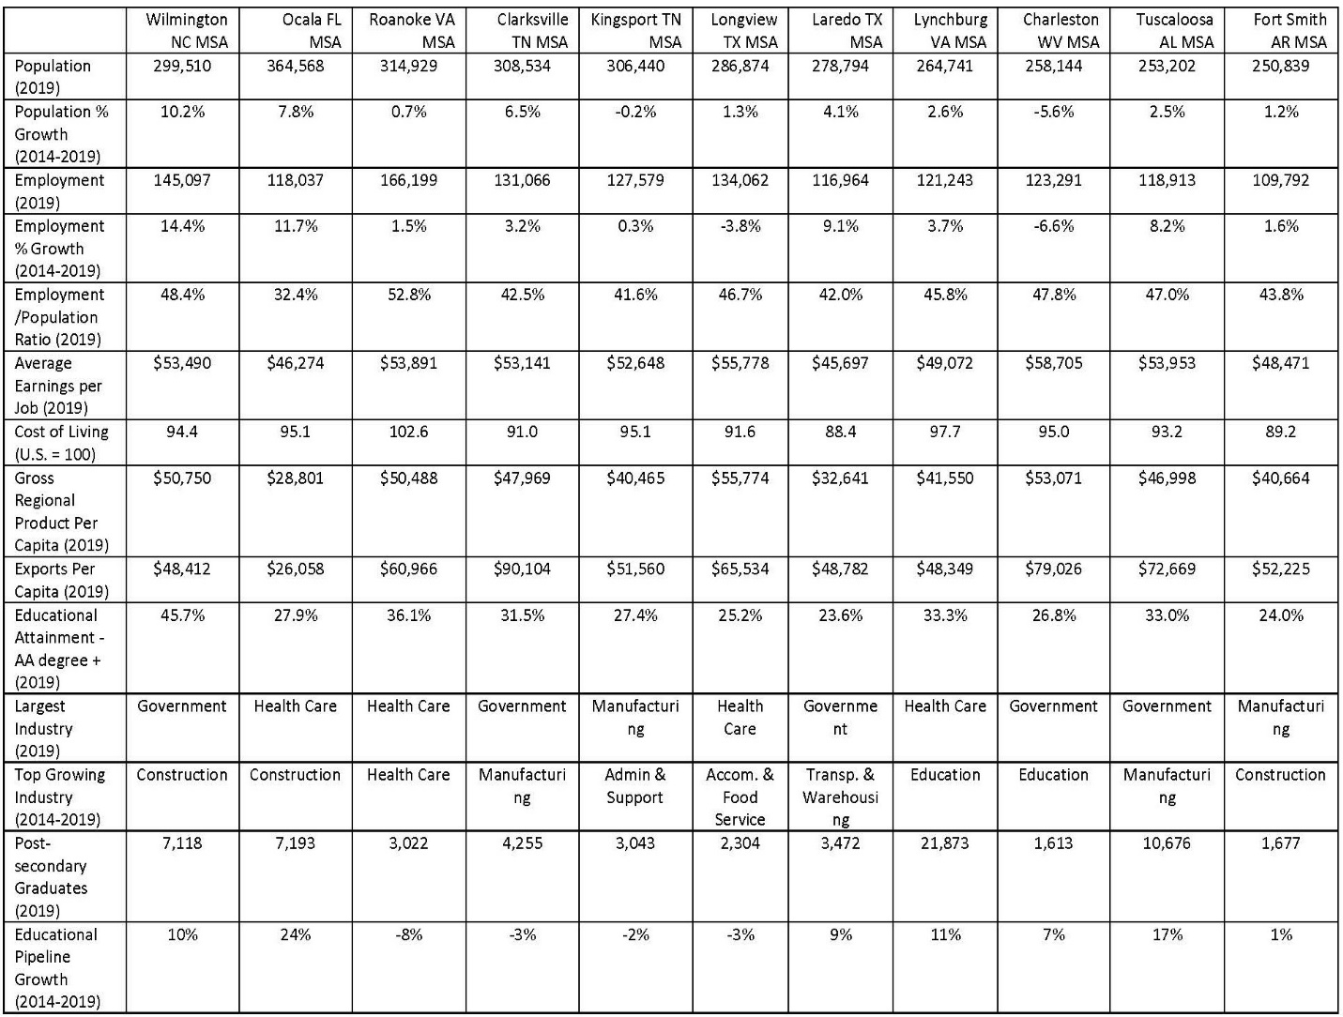

The next chart provides similar data for the Fayetteville MSA. In each case some of the data shows information for build marketing materials and messages, while other points might provide the basis for improved product work.
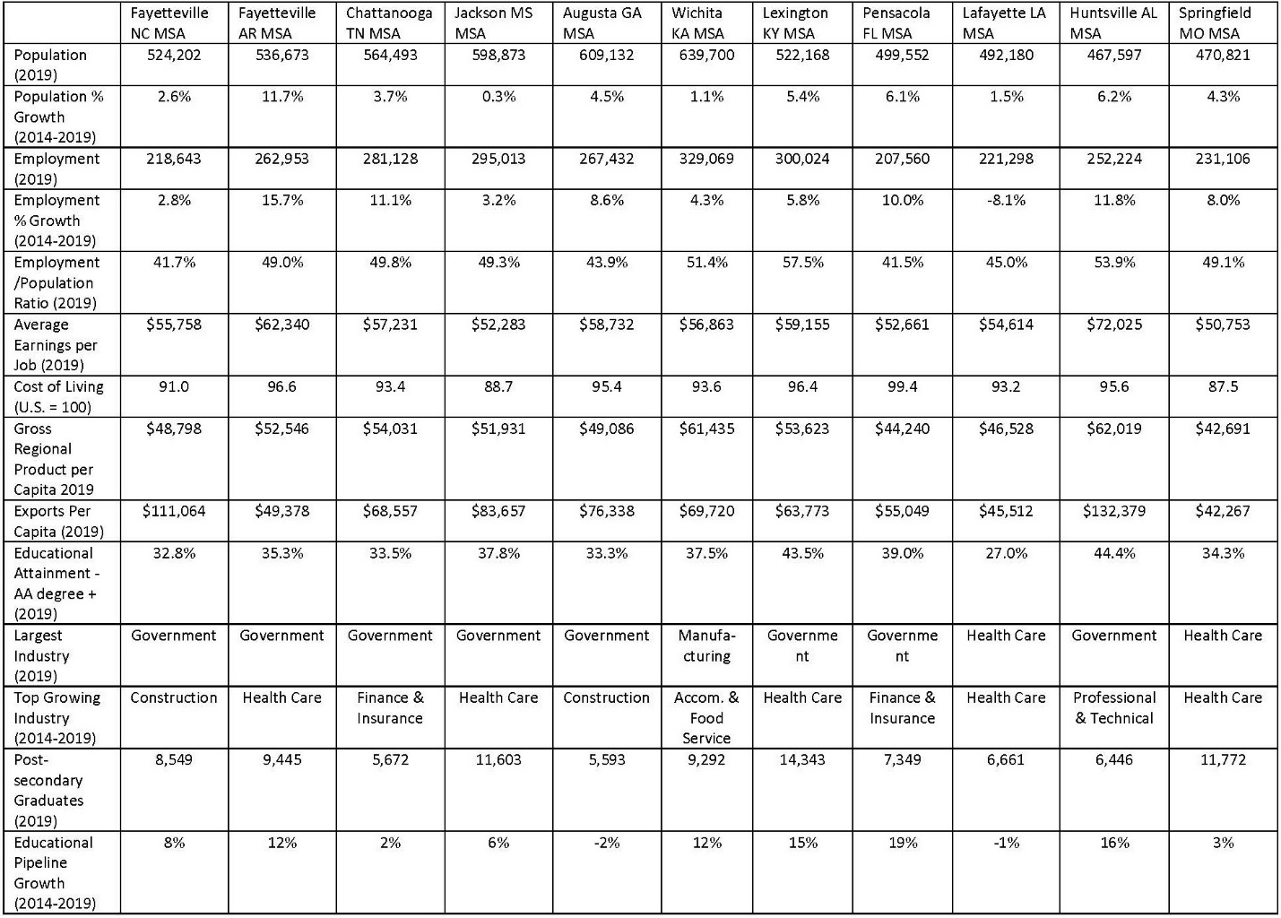

Best Practices Examples to Strengthen Competitiveness in North Carolina’s Southeast Rural Places - Six Focus Areas

As was shown earlier some parts of North Carolina’s Southeast have experienced population decline and struggled more for economic development success. Nationally rural places have been challenged over the past 30 years. As the chart below from Wendall Cox, in Newgeography, shows since 2010, places under 100,000 residents have lost over 700,000 residents while places whose population is between 100,000 and one million have grown.
Many organizations including the North Carolina Department of Commerce, the Golden LEAF Foundation, and The North Carolina Rural Center focus on improving the economic prosperity in rural North Carolina, including many of the counties in the Southeast. North Carolina’s Southeast region plays an important role to attract new investment to these communities but can also share best practices and align activities with other groups to increase efficiency and synergies.
The NC Rural Center’s mission is to develop, promote, and implement sound economic strategies to improve the quality of life of rural North Carolinians. We serve the state’s 80 rural counties, with a special focus on individuals with low to moderate incomes and communities with limited resources.

Domestic Migration by MSA 2010-2019
What follows is a national review of some of the best practices to increase rural competitiveness in six specific strategic areas. We provided footnotes in the section so that additional information would be easy to find. The footnotes are included in the Appendix.
1. Prioritize Population Growth, Talent Retention and Attraction
Employers consistently report that finding enough employees with the right skills is their greatest challenge. Improving the economic opportunities in rural and small-town parts of the Southeast region begins with efforts to better retain, attract, and train talent.
Retention:
Research suggests that the best talent and population strategy is to retain young people from small cities, towns, and rural areas. Businesses are extending career awareness efforts from high schools into middle schools, and they recommend starting earlier than that. They are getting more directly involved in high school classrooms to identify, target, and “sponsor” young people with work experience and scholarships to technical or four-year college. They view this one-on-one relationship building with young residents as crucial for retaining them. By developing deeper roots early some portion will see local opportunity and stay.

A related effort is a “bring them back” strategy to target North Carolina natives at the stage in life when they are most likely to return to small town North Carolina: young couples who are starting a family or have young children. These are 30 to 35-year-olds in nearby metro areas such as Charlotte, Raleigh and Atlanta. One incentive that is common for young people and young families to consider returning to their hometowns is a student loan repayment or forgiveness program. Several community foundations in Michigan have banded together to create the Come Home program, targeted at recent college graduates in a STEAM field.
Another retention strategy is to market locally available jobs to out-commuters. In western Wisconsin, Momentum West’s Regional Talent Initiative targets residents commuting to the Minneapolis-St. Paul area by highlighting good local jobs and a better work-life balance.
Attraction:
To attract talent, North Carolina’s Southeast could expand a business model that has frequently been used in the agriculture sector: cooperative or employee ownership models. Talented young people might be more willing to commit to careers in smaller, rural areas when they have a stake in ownership. Even on a small scale, cooperative ownership can help keep small towns viable. When the local grocery store closed in Walsh, Colorado, townspeople bought it, renovated it, and reopened it. Colorado’s Governor stated that employee ownership models are a “best practice in capitalism that leads to better long-term economic growth.” Canada, which boasts 8,000 cooperatives employing more than 100,000 people, is putting more money into supporting development of cooperative business ownership.
The lifestyle of small town, and rural North Carolina, will not appeal to everyone, but business interviews suggest that the best strategy is to market quality of life positives such as natural beauty, outdoor recreation, affordability, safety, and being a good place to raise a family. A regional asset-based strategy that emphasizes place-making and improving amenities is likely to be successful in attracting those that respond to rural Southeast North Carolina’s appeal. Covid-19 may broaden the number of young people that would see value in a rural lifestyle.
Wisconsin is one state that has aggressively promoted rural growth. The former mining town of Hurley, WI has adopted a ‘community gardening’ model of improvement, focusing on outdoor recreation, trails, and kayaking to create an environment where “people would want to live and launch businesses.” In the Richland County area of southwest Wisconsin, the Southwest Partners non-profit organization led the development of the Pine River Trails Project, creating a Pine River corridor that offers “exceptional kayaking, canoeing, tubing, hiking, biking, mountain biking, snowshoeing, camping, and cross-country skilling.”
Rural areas can have more success by packaging the assets of several towns and cities across a region, and marketing them together. Based on EMSI’s recent Talent Attraction Scorecard, researchers believe that “bundles of amenities” in many places – “renovated old buildings, coffee shops and good restaurants, music venues, and not least of all, more affordable homes” – have closed the “amenity gap” between superstar big cities and other places.
Immigrant labor has been historically important for industries such as agriculture and manufacturing. Data supports the contention that immigrants relate to strong economic performance in rural areas. Though not necessarily a cause-and-effect relationship, a 2015 study links greater percentages of foreign-born residents in non-metro counties with higher per capita income, lower unemployment rates, and lower poverty in those communities. A 2018 study of over 2,700 rural places notes that “immigrants are often reversing or mitigating rural population decline,” and that their incomes and tax payments help support public schools and services for retirees. Also, a higher percentage of immigrants were of working age (nearly 80 percent) compared with the U.S.-born population (60 percent).
Many small towns have been proactive in welcoming foreign-born residents and sponsoring immigrant families. The small city of Worthington, Minnesota hosts an International Festival, now in its 28th year. About one-third of Worthington’s population was born overseas, coming from many different nations. The city’s population has grown 17 percent since 2000, and the labor force has grown even faster. Foreign-born residents appreciate the same attributes as native-born citizens: low crime rate, low cost of living, and a short commute. After “decades of experience,” Worthington is seen as a “model of inclusiveness.”
Elsewhere, the meatpacking towns of Lexington and Madison, Nebraska have focused on parent engagement and ESL classes in their school districts, leading to high school graduation rates that are “consistently…above the state average of 90 percent.” A public-private partnership in Lexington is also addressing a housing shortage, which will be discussed later in this report.
Canada’s federal government and provincial governments have aggressively instituted programs to court immigration in rural Canada. These programs have helped change the percentage of immigrants settling outside of major metro areas from 10 percent in 1997 to 40 percent in 2017. Initiatives include:
- The Atlantic Immigration Pilot in four maritime provinces, to help employers hire foreign skilled workers and international college graduates. The program has seen over 2,500 applicants in its first three years. It gives applicants a pathway to permanent residency.
- The Rural and Northern Immigration Pilot, to address a 23 percent decline in potential workers in rural Canada along with a 40 percent increase in potential retirees. In June 2019, an initial group of 11 communities started testing strategies to attract and retain newcomers who can meet the greatest labor needs.
- An Agri-Food Permanent Residence Pilot announced in 2019 to support workforce capacity in agriculture and food processing.

Education and Training:
Educational offerings and school facilities can be keys to community success. When the town of Monticello, Maine (population 750) had to close its elementary school due to lack of funds, students had to travel an additional 14 miles to school, and residents worried that Monticello would become a “ghost town.” Across America, regions and states are innovating in education and training programs to address goals such as:
- Attracting young families to move to and stay in smaller cities and towns;
- Increasing awareness of in-region careers among students, parents, teachers, and administrators;
- Increasing the workplace readiness of young people and adult workers;
- Improving customized training to help businesses succeed.

Around the United States:
- The Simulated Workplace program transforms CTE classrooms in West Virginia high schools into authentic workplace environments. The initiative, less than a decade old, has helped the state to lead the way in “transforming vocational education.” In 2016, 37 percent of seniors in the state completed a CTE program, up from 18 percent in 2010.
- Realizing that current school counselors are too few and not focused on career readiness, Arkansas is expanding its College and Career Coach program. The program supports students from the 7th to 12th grade and incorporates new metrics such as work-based learning and credential attainment. Coaches help with career planning and arranging workplace experiences.
- In 2018, Greene County, Iowa voters passed a historic $21.5 million bond issue (getting 69 percent of the vote) to create a regional career academy to be staffed by Iowa Central Community College. The “bold” proposal saw county supervisors step up with $5 million in financing as well, using tax increment financing (TIF) from wind turbine farms in the county. Strands of study at the academy will be in computer software, advanced manufacturing, the culinary arts, and precision agriculture.
The carrot in this proposal was the Future Ready Iowa initiative from software company Pillar Technology and its Iowa-native executive, Linc Kroeger. Pillar’s ‘Rural Forge’ mini tech hub opened in Greene County last year, planning to employ 30 people at salaries in the $55,000 to $75,000 range.
- Conexus Indiana is a non-profit created in 2017 with business, government, and foundation partners. Conexus’ talent programs include Catapult Indiana to teach adults the basic work skills needed for manufacturing jobs. The four week, 160-hour work-and-learn program has had more than 3,000 completers and is offered in small towns such as Greensburg (population 12,000).
- Last year, Virginia allocated $7 million to launch a new, customized workforce recruitment and training program, based on the highly regarded Quick Start in Georgia and FastStart in Louisiana. Training will be provided through the state’s community college system. The head of Virginia’s economic development partnership says that these training programs are “particularly powerful for the smaller metro and rural regions, where companies are worried about finding enough quality talent.”

- In northwestern Wisconsin, the Gold Collar Careers website is targeted at middle and high school students, parents, and teachers to help them understand manufacturing career opportunities in their own region. Gold Collar Careers was started by the Manufacturing Works volunteer group. The website advertises a 100 percent placement rate for post-secondary program completers, 25 percent higher average incomes, and job security.
2. Continue to Aggressively Expand Rural Broadband
High-speed internet service has become as essential to commerce as electricity, water and sewer. Students in rural Southeast North Carolina school districts operate in the same modern interconnected world as students in Raleigh’s suburbs or downtown Charlotte.
There appears to be no magic bullet solution for extending broadband to all rural areas. The technology will likely need to be a mix of buried fiber and wireless. Because of the economics of serving low-density areas, public and private sector participation will both be needed. It will also require involvement at the federal, state, and local levels.
National Broadband Initiatives:
The FCC’s Universal Service Fund is a major source of funds for expanding telecommunications. Early in 2020, the FCC unveiled its new Rural Digital Opportunity Fund (RDOF), providing $20 billion for telecom companies to compete for service extension projects. The first RDOF auction is scheduled for October 2020.

USDA Rural Development has been increasing broadband loan and grant programs. In the fall of 2019, a rural Wisconsin telecom provider received $8 million in loans for fiber upgrades in two small communities. Late last year, the USDA’s new ReConnect Pilot Program announced its first round of investments. Alabama received a major share – over $62 million in a combination of grants and loans for four sizable projects.
North Carolina’s Broadband Infrastructure Office has a team of four technical assistance experts to help communities develop projects. Tennessee’s Broadband Accessibility Grant Program provides up to 50 percent of last-mile project costs, up to $2 million per project. Starting in 2016, West Virginia has diverted some of its Community Development Block Grant (CDBG) funds from traditional water & sewer projects to broadband expansion.
3. Expand Support & Champion Innovation for Legacy Industries and Entrepreneurs
Legacy sectors such as farming and manufacturing remain important to rural North Carolina’s economy, but each face major challenges What can the Southeast do? There are examples of innovative ways to build upon the scale and strength of legacy industries.
Promote Additional Exporting:
Many of the region’s manufacturers and food producers are small to medium-sized, and few of those tap into international markets. Support from NCPED and the US Department of Commerce can be directed to firms with an interest.
Promote Cooperative Business Ownership:
As noted in the Talent Attraction section, cooperative ownership models have a long history in agriculture, and could be promoted to help businesses scale, as well as attract, a new generation of business leadership. Young people might be more motivated to work in farming and manufacturing if they see a clear path to ownership.
Invest More in Manufacturing Workforce Training:
South Carolina launched the ManufirstSC program in 2018 to allow adults without manufacturing work experience to earn a basic skills certificate. This is similar to the Catapult Indiana adult skill training noted earlier in the Education and Training section. The 62-hour ManufirstSC program had about 1,000 completions in its first year, and over 100 firms recognize the certificate. The curriculum was based on training initially developed for Volvo Car USA, and addresses a need particularly for “rural residents who’d had limited access to manufacturing jobs.”
Be a Clearinghouse for Flexible Employment Models:
Another promising workforce innovation is greater employee sharing. With dire shortages in the skilled trades, many manufacturers need electricians, welders, plumbers, and other maintenance personnel. However, employers might not need all of these skilled tradespeople on a full-time basis. Sharing of skilled workers among several companies can keep these workers in rural areas and maximize their earning potential while firms share the costs.

New Business Development:
Even though small towns in some states have a higher number of new businesses per capita, and the business survival rate is better in rural areas, stakeholders that were interviewed felt that spurring new business development in rural areas is a difficult challenge in today’s environment. It would involve bucking the long-term trend of declining business dynamism in America, and startups would need to find quality employees in a very tight labor market. The general consensus among interviewees was, ‘Our existing bigger businesses can’t find or keep good workers, how are new businesses going to find people?’
Despite the challenges, we believe that smaller towns in the Southeast can be an appealing place for the true entrepreneur: the individual, couple, or family wanting to start a business. Smaller cities and towns can increase their attractiveness to startups through the same asset-based approach used in talent attraction and retention – improving downtowns, schools, trails and recreation, culture and the arts. It is a strategy focused on “what a community has, rather than what it doesn’t have.”
Beyond that, entrepreneurism benefits from a range of support services that can be provided at the local, regional, and/or state levels. These services include access to capital, business training classes, networking and mentoring. Recent immigrants in particular, who typically start businesses at higher rates, can benefit from small business training and understanding regulations. Below are entrepreneurship development examples from across America.
- In 2002, Ohio Third Frontier was started to provide early-stage investment capital to support technology innovation throughout the state. To date, Ohio Third Frontier has invested over $2 billion, with funding through voter-approved bond issues. During its first 10 years it was credited with supporting 600 businesses, adding 60,000 jobs to the state, and leveraging more than $5 billion in private investment.
- Within Ohio, an early investment through the Third Frontier was made in the Youngstown Business Incubator (YBI), located in the struggling industrial city of 65,000. YBI portfolio company Turning Technologies was named the fastest-growing company in the U.S. by Inc. Magazine in 2007, and in 2014 YBI was named the best university-affiliated business incubator in the world. YBI currently occupies five historic buildings in downtown Youngtown and has 75 firms in its portfolio.
- Some localities are working with microlenders to provide small business loans. Rochester, NY partnered with Kiva, the world’s largest crowdfunded microlender, to offer loans up to $10,000, to be repaid in one to three years at no interest. Entrepreneurs must gather a number of $25 commitments from family and friends before their business pitch is broadcast through Kiva.
- In northwest Wisconsin, the Wisconsin Rural Enterprise Fund (WREF) makes equity investments in startup companies, especially those with the potential to create higher-skill, higher-wage jobs. Since it started in 2002, WREF has made over $2,000,000 in investments ranging from $35,000 to $200,000 each. Investors include economic development organizations, cities, and electric cooperatives. WREF is managed by the Wisconsin Business Innovation Corporation, an offshoot of the Northwest Regional Planning Commission.
4. Develop New Housing Strategies and Financing for Small Towns
The lack of housing choices can be a deterrent in individual and family location decisions. Small cities, towns, and employers are looking for ways to spur anything new in the housing market: new apartments, new single-family homes, and young buyers to purchase them. Here are some innovative ideas from around the country.
- Nearly 75 percent of Duluth, Minnesota’s housing is at least 46 years old. Duluth is hoping that giving away small parcels of land to developers or builders who design a “good, achievable idea that can provide affordable housing” will be a “micro-solution” for the city’s housing shortage. The city is starting with 13 sites in the Rebuild Duluth program and is requiring applications with realistic timelines and budgets, but not imposing any income restrictions or affordability requirements.
Duluth has also made zoning changes recently to allow narrower homes with smaller setbacks. It hopes that these changes, along with free land, might “create a model that works” for infill development. One builder believes that it will at least “have a positive impact on upfront costs” to make small projects in smaller cities more feasible. The initial round of 13 free land awards will be announced in the spring of 2020.
- Housing shortages created tensions in the growing, multi-cultural meatpacking town of Lexington, Nebraska (population 10,000). To address this, local employer Tyson Foods and city leadership agreed in 2013 to collaborate to build 900 new housing units by 2030. Tyson will reimburse the city’s housing authority for land purchases. Two hundred new units were completed as of 2018.
- Grant County is a central Indiana county of about 66,500 people, located between Indianapolis and Fort Wayne, and near college towns like Muncie. Grant has adopted two programs to attract new residents. Since 2012, the Grant For Grads initiative has helped about 60 college graduates to buy or rent within the county. It provides home buyers up to $5,000 for down payment or closing costs, and renters a 20 percent rent reduction up to a total of $2,500. Grant For Grads is a creation of the county’s Economic Growth Council and the county’s Affordable Housing & Community Development Corporation.
Grant County, IN also offers the Grant’s Got Talent relocation assistance program for people accepting a job within the county. It provides up to $7,500 in down payment assistance for college graduates (associate degree or higher) taking a full-time job in one of three targeted fields and moving into the community.
- Similar to the county program in Indiana, the statewide Ohio Housing Finance Agency has a Grants for Grads initiative offering 2.5 percent to five percent down payment assistance for those who graduated with at least an associate degree in the past 48 months. Recipients must take free homebuyer education classes, and the down payment assistance is forgiven if the homeowner remains in Ohio for five years.
5. Strengthen Rural Healthcare
This report has several sections that address healthcare. It is that important to the region’s future. For the past 30 years researchers have been writing about the series of factors that have converged to threaten rural health care services. Competition for health professionals from better-financed urban providers, the shift to outpatient facilities, and slow or negative patient growth have combined to create a crisis across much of rural America.
The most high-profile impacts of rural population loss on healthcare have been the closing of hospitals and other reductions in available medical services. In America, more hospitals have closed than opened each year since 2011. Data collected by the Rural Health Research Program indicates that 41 percent of rural hospitals have a negative operating profit margin. Other research by Navigant, looking across 12 Midwestern states, concluded that 18 percent of rural hospitals in those states were at high risk of closing. A recent study found that when a community loses its only hospital, per capita income falls about four percent and the unemployment rate rises by 1.6 percent.
Medical Facility Solutions:
- Due to declining and aging populations, fewer rural hospitals are able to provide a full range of services, such as obstetrics. Hospitals such as one in Iowa Falls, Iowa (population 5,000) are addressing this with “share care” agreements in which patients receive routine prenatal care locally and are transferred to larger hospitals for late-term care and delivery. Other agreements have small town facilities hosting specialists from larger hospitals on a weekly or monthly basis to bring specialized outpatient care to rural areas.
- Communities are tapping a wide variety of funding sources to create the next generation of facilities aligned with current rural healthcare needs. The new medical campus in Rock Rapids, Iowa has space for same-day primary care appointments, telehealth services, visiting specialists, and a therapy gym. The $29 million facility opened in 2019 and was funded through community donations, hospital association funding, and a USDA loan. Other pilot projects are positioning rural hospitals “at the center of healthy communities,” with various providers on-site to offer outpatient services, behavioral health, and meals programs.
- Partnerships between health systems and local communities are closing care gaps in rural areas. In McCook, Nebraska, Bryan Health is working with local fire departments to schedule paramedic visits to high-risk patients in their homes after discharge from the local hospital. These home checks ensure that the home environment is safe and conducive to recovery, and paramedics deliver some follow-up care.
- School-based health centers are being improved to deliver care to children, and more rural communities are delivering mental health services in schools as well.
- Proposed federal legislation would free rural hospitals from the requirement to maintain inpatient beds. Under the new Medicare classification of a Rural Emergency Hospital, small facilities could focus on emergency care, primary care, and outpatient services. The Rural Emergency Acute Care Hospital (REACH) Act was last introduced in 2017 but died in committee.

Attracting and Retaining Healthcare Professionals:
Getting medical professionals (including mental health professionals) – especially younger ones – to come to and stay in rural areas is a particular challenge. This includes doctors, physician assistants, nurse practitioners, and nurses. At the least, it requires the same place-making needed to attract anyone. As one healthcare executive noted, necessary amenities include good broadband and cell phone service, and businesses that add to the quality of life. Places that cannot attract medical professionals will have a harder time appealing to other families, all of whom want quality healthcare nearby.
Most states have at least one incentive program aimed at increasing the number of doctors and other medical staff in rural and other hard-to-serve areas. However, uneven funding means that many programs are inactive in any given year. The most common effort is to entice foreign physicians to make a three year commitment in a rural area through a J-1 Visa waiver program. But numerous states have additional incentives:
- Oregon’s Rural Practitioner Tax Credit Program offers personal income tax credits for doctors, nurses, optometrists, and others – even volunteer EMS personnel are eligible. Oregon also subsidizes medical malpractice insurance premiums for doctors and nurse practitioners working in rural parts of the state.
- The University of Missouri School of Medicine has had a Rural Track Pipeline program for 20 years. The Rural Track Pipeline includes scholarships for students from rural areas, clinical rotations at rural hospitals, and a week-long immersion program to introduce students to small town life.
- Through the West Virginia Rural Health Service Program, third and fourth year medical students at one of the state’s medical schools can receive up to $25,000 in scholarship money in exchange for agreeing to practice in a rural part of the state for at least 2 years after completing residency.

- Western Montana’s Student Rural Clinical Rotations Program provides travel reimbursement money for medical students to do clinical rotations in rural areas.

Research by Economic Leadership indicates that these programs can be effective in attracting and retaining health professionals. Some best practices that we have found:
1. Money talks! Cash-based incentives are effective, though they must be significant enough to make a difference (usually at least $10,000 per year for multiple years).
2. Targeting those with rural or small-town backgrounds is usually more effective.
3. Mid-level health professionals (such as physician assistants and nurse practitioners) may be more likely to stay in rural areas.
4. Spreading payments out over several years gives more time for the recipient to become attached to the community, and thus more likely to stay.
6. Support Rural Leaders and Incent Regional Cooperation
North Carolina’s 100 counties and over 530 incorporated municipalities can make regional coordination and action difficult. Too often, local leaders view neighboring communities as competitors, when in reality few small towns and cities have all the assets they need to succeed and could benefit greatly from collaboration. Increasingly, states are realizing that economic development is primarily a regional undertaking. Fortunately, there are a number of good examples of regional cooperation in rural areas of the United States, including North Carolina’s Southeast.
- Alabama has unveiled a Rural Development Initiative to include a custom economic development strategy in each of five regions across the state. Each region will get assistance in crafting a strategic plan addressing infrastructure, workforce, education, and other priorities, with the goal of capitalizing on “existing assets and infrastructure.”
Steering committee members for the Rural Development Initiative include major players Alabama Power, RegionsBank, Blue Cross and Blue Shield of Alabama, the state Department of Commerce, and the Economic Development Association of Alabama (EDAA). The group is chaired by a former speaker of the state’s House of Representatives. In addition, both the Department of Commerce and EDAA have hired a rural development specialist, and the state had its first Rural Economic Development Conference in January 2020.
- As promoted by the National League of Cities, improving rural-urban linkages can benefit both areas. NLC reports that rural areas connected to a larger hub have higher incomes, lower median ages, higher population growth, and greater educational attainment than rural areas that are more isolated. A particular strategy is to look at industry clusters in a broader way, considering rural areas and nearby metro areas together. The greater Sacramento, California region has seen success with its regional food and agriculture cluster, and for the GO Virginia initiative discussed below, one rural region is positioning itself to take advantage of supply chain needs for clusters in seven nearby metro areas.
GO Virginia was started by business leaders in 2015 to spur regional private-sector growth with the state government serving as a “catalyst and partner.” Each of the nine regions across Virginia has a business-led Regional Council that submits collaborative economic development proposals to a state-level board. Initial funding of $28 million from the Virginia General Assembly included money for each region to create a Growth & Diversification Plan.
Thus far, 74 projects have been approved with a total allocation of $38 million. A recent example is $300,000 for an area in southwest Virginia covering 13 counties and five independent cities. The non-profit Valleys Innovation Council received the grant to create a Regional Entrepreneurship Initiative focused on high-growth sectors such as health care, advanced manufacturing, and cybersecurity.
- In the northwestern corner of South Carolina, the Upstate SC Alliance was formed in 2000 to give its 10 counties opportunities “we wouldn’t be able to capture on our own.” The Alliance pools resources “for workforce, transportation, utilities, healthcare, and quality of life.” The public-private Alliance has about 170 business and government investors.
- Since most areas do not have a regional government with any power, a new study by The Aspen Institute suggests finding different organizations that can act as Rural Development Hubs. These are often community foundations, community development financial institutions (CDFIs), community colleges, or four year colleges. These “place-rooted organizations” can help to bridge local silos and attract other investors. Other strengths of a good Rural Development Hub include the willingness to task risks and make long-term commitments to a region.
- Regional branding and marketing for rural tourism is increasingly popular. Rural areas can succeed when they put together a “destination mix” with five components: 1) attractions; 2) infrastructure; 3) accommodations; 4) transportation; and 5) hospitality training. Examples include:
The Mississippi Blues Trail along U.S. Highway 61;
The Crooked Road, Virginia’s music heritage trail, including 19 counties, four cities, and 54 towns along a 300-mile trail;
Kentucky’s Bourbon Trail, with 18 distilleries to visit on the original trail and 19 more on the Craft Tour;
Old West Country in southwestern New Mexico, home of the nation’s first official wilderness area.
- Regional cooperation should include leadership development. Since 2016 the North Carolina Rural Center has offered the Homegrown Leaders program to help emerging leaders understand data and trends, community economic development, collaboration skills; and how to access resources. Peer-learning networks are another important component. In Nebraska, the Building Entrepreneurial Communities Act offers grants for two or more communities collaborating on capacity-building efforts including leadership development.

Final Thoughts

North Carolina’s Southeast region enjoys many competitive advantages. The North Carolina business climate is always ranked among the best in the country. The region’s roadways, rail, airports, and seaports provide excellent support to the region’s businesses. Universities, community colleges and other training facilities have the capacity and focus to build the workforce skills the region needs. The region’s military bases, major private businesses and hospitals are anchor institutions critical to future success.

Even with these assets sustained success is a challenge. Change is disruptive, and competition is fierce. Remaining competitive requires business and government leadership working together to promote the region and its assets and to continue to improve the region’s product. Targeted marketing, improved broadband, sustained high-quality healthcare, skilled workers, and a focus on the future are all necessary. North Carolina’s Southeast plays a critical role and must balance available resources, investor expectations and results.

Appendix 1: Workforce Analysis
Workforce Summary – North Carolina’s Southeast (18-Counties)
Population (2019) 1,836,745
Population Growth 2014-2019 52,528
Projected Population Growth 2019-2024 44,325
Total Employment (2019) 802,319
Job Growth 2014-2019 34,893
Projected Job Growth 2019-2024 26,623
Average Earners Per Job $51,100
Labor Force (2019) 765,706
Cost of Living 93.6
% of Workforce with a High School Diploma 85.6%
% of Workforce with a Bachelors Degree of Higher 23.2%

Top Growth Industries
- Accommodation and Food Services
- Construction
- Manufacturing
- Retail Trade
- Other Services

Largest Industries
- Government
- Retail Trade
- Health Care and Social Assistance
- Accommodation and Food Services
- Manufacturing

Top Growth Occupations
- Food Preparation and Serving
- Transportation and Material Moving
- Business and Financial Operations
- Construction and Extraction
- Healthcare Practitioners and Technical

Largest Occupations
- Office and Administrative Support
- Sales and Related
- Food Preparation and Serving
- Transportation and Material Moving
- Production

Workforce Summary – Anson County, North Carolina
Population (2019) 24,641
Population Growth 2014-2019 (-1,333)
Projected Population Growth 2019-2024 (-605)
Total Employment (2019) 8,236
Job Growth 2014-2019 (-352)
Projected Job Growth 2019-2024 233
Average Earners Per Job $43,055
Labor Force (2019) 10,925
Cost of Living 95.0
% of Workforce with a High School Diploma 78.7%
% of Workforce with a Bachelors Degree of Higher 8.7%

Top Growth Industries
- Transportation & Warehousing
- Construction
- Agriculture, Forestry, Fishing, Hunting
- Manufacturing
- Management of Companies

Largest Industries
- Government
- Manufacturing
- Retail Trade
- Health Care & Social Assistance
- Transportation & Warehousing

Largest Occupations
- Production
- Transportation and Material Moving
- Office and Administrative Support
- Sales and Related
- Education Instruction & Library

Top Growth Occupations
- Transportation and Material Moving
- Construction and Extraction
- Farming, Fishing & Forestry
- Management
- Healthcare Support

Workforce Summary – Bladen County, North Carolina
Population (2019) 33,003
Population Growth 2014-2019 (-1,383)
Projected Population Growth 2019-2024 (-729)
Total Employment (2019) 14,867
Job Growth 2014-2019 1,166
Projected Job Growth 2019-2024 621
Average Earners Per Job $44,198
Labor Force (2019) 14,782
Cost of Living 94.8
% of Workforce with a High School Diploma 78.9%
% of Workforce with a Bachelors Degree of Higher 13.5%

Top Growth Industries
- Manufacturing
- Support & Waste Management
- Accommodation & Food Service
- Construction
- Educational Services

Largest Industries
- Manufacturing
- Government
- Agriculture, Forestry, Fishing, Hunting
- Support & Waste Management
- Retail Trade

Largest Occupations
- Production
- Transportation and Material Moving
- Building & Grounds Maintenance
- Office & Administrative Support
- Sales and Related

Top Growth Occupations
- Building & Grounds Maintenance
- Production
- Transportation and Material Moving
- Construction and Extraction
- Installation, Maintenance & Repair

Workforce Summary – Brunswick County, North Carolina
Population (2019) 140,170
Population Growth 2014-2019 21,862
Projected Population Growth 2019-2024 14,797
Total Employment (2019) 38,705
Job Growth 2014-2019 4,627
Projected Job Growth 2019-2024 3,325
Average Earners Per Job $47,573
Labor Force (2019) 53,137
Cost of Living 91.0
% of Workforce with a High School Diploma 88.8%
% of Workforce with a Bachelors Degree of Higher 27.7%

Top Growth Industries
- Retail Trade
- Accommodation and Food Services
- Construction
- Government
- Health Care & Social Assistance

Largest Industries
- Government
- Retail Trade
- Accommodation and Food Services
- Health Care & Social Assistance
- Construction

Largest Occupations
- Food Preparation and Serving
- Sales and Related
- Office and Administrative Support
- Transportation and Material Moving
- Construction and Extraction

Top Growth Occupations
- Food Preparation and Serving
- Transportation and Material Moving
- Construction and Extraction
- Educational Instruction and Library
- Sales and Related

Workforce Summary – Columbus County, North Carolina
Population (2019) 55,419
Population Growth 2014-2019 (-1,458)
Projected Population Growth 2019-2024 (-977)
Total Employment (2019) 17,420
Job Growth 2014-2019 (-460)
Projected Job Growth 2019-2024 105
Average Earners Per Job $42,596
Labor Force (2019) 23,137
Cost of Living 90.9
% of Workforce with a High School Diploma 78.6%
% of Workforce with a Bachelors Degree of Higher 13.0%

Top Growth Industries
- Construction
- Accommodation and Food Services
- Management of Companies
- Professional, Scientific and Technical Services
- Transportation and Warehousing

Largest Industries
- Government
- Health Care and Social Assistance
- Retail Trade
- Manufacturing
- Support & Waste Management

Largest Occupations
- Office and Administrative Support
- Sales and Related
- Production
- Transportation and Material Moving
- Food Preparation and Serving

Top Growth Occupations
- Construction and Extraction
- Food Preparation and Serving
- Architecture and Engineering
- Business and Financial Operations
- Computer and Mathematical

Workforce Summary – Craven County, North Carolina
Population (2019) 102,668
Population Growth 2014-2019 (-1,413)
Projected Population Growth 2019-2024 (-104)
Total Employment (2019) 50,961
Job Growth 2014-2019 719
Projected Job Growth 2019-2024 242
Average Earners Per Job $54,969
Labor Force (2019) 41,904
Cost of Living 96.9
% of Workforce with a High School Diploma 87.9%
% of Workforce with a Bachelors Degree of Higher 25.4%

Top Growth Industries
- Manufacturing
- Retail Trade
- Accommodation and Food Services
- Other Services
- Construction

Largest Industries
- Government
- Retail Trade
- Health Care and Social assistance
- Accommodation and Food Services
- Manufacturing

Largest Occupations
- Office and Administrative Support
- Sales and Related
- Food Preparation and Serving
- Transportation and Material Moving
- Military-only

Top Growth Occupations
- Business and Financial Operations
- Food Preparation and Serving
- Healthcare Practitioners and Technical
- Architecture and Engineering
- Installation, Maintenance and Repair

Workforce Summary – Cumberland County, North Carolina
Population (2019) 332,466
Population Growth 2014-2019 70
Projected Population Growth 2019-2024 1,083
Total Employment (2019) 178,379
Job Growth 2014-2019 1,676
Projected Job Growth 2019-2024 2,023
Average Earners Per Job $58,590
Labor Force (2019)
128,172
Cost of Living 93.6
% of Workforce with a High School Diploma 90.0%
% of Workforce with a Bachelors Degree of Higher 23.4%

Top Growth Industries
- Construction
- Accommodation and Food Services
- Health Care and Social Assistance
- Retail Trade
- Other Services

Largest Industries
- Government
- Retail Trade
- Accommodation and Food Services
- Health Care and Social Assistance
- Other Services

Top Growth Occupations
- Business and Financial Operations
- Food Preparation and Serving
- Healthcare Practitioners and Technical
- Construction and Extraction
- Transportation and Material Moving

Largest Occupations
- Military-only
- Office and Administrative Support
- Sales and Related
- Food Preparation and Serving
- Transportation and Material Moving

Workforce Summary – Duplin County, North Carolina
Population (2019) 58,873
Population Growth 2014-2019 (-568)
Projected Population Growth 2019-2024 157
Total Employment (2019) 22,087
Job Growth 2014-2019 (-1,249)
Projected Job Growth 2019-2024 (-366)
Average Earners Per Job $43,558
Labor Force (2019) 25,974
Cost of Living 93.1
% of Workforce with a High School Diploma 73.5%
% of Workforce with a Bachelors Degree of Higher 11.3%

Top Growth Industries
- Manufacturing
- Government
- Construction
- Transportation and Warehousing

Largest Industries
- Manufacturing
- Government
- Agriculture, Forestry, Fishing, Hunting
- Retail Trade
- Health Care and Social assistance

Largest Occupations
- Production
- Transportation and Material Moving
- Office and Administrative Support
- Management
- Farming, Fishing and Forestry

Top Growth Occupations
- Transportation and Material Moving
- Production
- Construction and Extraction
- Community and Social Service
- Installation, Maintenance and Repair

Workforce Summary – Hoke County, North Carolina
Population (2019) 55,620
Population Growth 2014-2019 4,032
Projected Population Growth 2019-2024 3,261
Total Employment (2019) 10,310
Job Growth 2014-2019 1,339
Projected Job Growth 2019-2024 840
Average Earners Per Job $42,798
Labor Force (2019) 20,265
Cost of Living 89.1
% of Workforce with a High School Diploma 85.7%
% of Workforce with a Bachelors Degree of Higher 17.6%

Largest Industries
- Government
- Manufacturing
- Health Care and Social Assistance
- Retail Trade
- Construction

Top Growth Industries
- Government
- Manufacturing
- Heath Care and Social Assistance
- Construction
- Transportation and Warehousing

Largest Occupations
- Production
- Educational Instruction and Library
- Office and Administrative Support
- Transportation and Material Moving
- Sales and Related

Top Growth Occupations
- Office and Administrative Support
- Transportation and Material Moving
- Heathcare Practitioners & Technical
- Production
- Protective Service

Workforce Summary – Lenoir County, North Carolina
Population (2019) 55,570
Population Growth 2014-2019 (-2,692)
Projected Population Growth 2019-2024 (-1,833)
Total Employment (2019) 31,079
Job Growth 2014-2019 951
Projected Job Growth 2019-2024 543
Average Earners Per Job $47,346
Labor Force (2019) 28,070
Cost of Living 97.0
% of Workforce with a High School Diploma 78.4%
% of Workforce with a Bachelors Degree of Higher 13.3%

Top Growth Industries
- Manufacturing
- Construction
- Transportation and Warehousing
- Professional, Scientific & Technical Services
- Other Services

Largest Industries
- Manufacturing
- Government
- Health Care and Social Assistance
- Retail Trade
- Construction

Largest Occupations
- Production
- Office and Administrative Support
- Transportation and Material Moving
- Sales and Related
- Food Preparation and Serving
Top Growth Occupations
- Production
- Transportation and Material Moving
- Construction and Extraction
- Installation, Maintenance & Repair
- Educational Instruction and Library

Workforce Summary – Montgomery County, North Carolina
Population (2019) 27,261
Population Growth 2014-2019 (-29)
Projected Population Growth 2019-2024 (-95)
Total Employment (2019) 10,333
Job Growth 2014-2019 283
Projected Job Growth 2019-2024 202
Average Earners Per Job $45,081
Labor Force (2019) 11,489
Cost of Living 95.8
% of Workforce with a High School Diploma 77.8%
% of Workforce with a Bachelors Degree of Higher 13.4%

Top Growth Industries
- Manufacturing
- Support and Waste Management
- Construction
- Finance and Insurance
- Other Services

Largest Industries
- Manufacturing
- Government
- Health Care and Social Assistance
- Retail Trade
- Construction

Largest Occupations
- Production
- Transportation and Material Moving
- Office and Administrative Support
- Sales and Related
- Healthcare Practitioners & Technical

Top Growth Occupations
- Healthcare Practitioners and Technical
- Production
- Sales and Related
- Healthcare Support
- Construction and Extraction

Workforce Summary – Moore County, North Carolina
Population (2019) 100,012
Population Growth 2014-2019 7,188
Projected Population Growth 2019-2024 5,349
Total Employment (2019) 41,263
Job Growth 2014-2019 4,209
Projected Job Growth 2019-2024 3,040
Average Earners Per Job $47,712
Labor Force (2019) 42,403
Cost of Living 97.1
% of Workforce with a High School Diploma 90.7%
% of Workforce with a Bachelors Degree of Higher 35.3%

Top Growth Industries
- Health Care and Social Assistance
- Accommodation and Food Services
- Retail Trade
- Other Services
- Construction

Largest Industries
- Health Care and Social Assistance
- Accommodation and Food Services
- Government
- Retail Trade
- Construction

Largest Occupations
- Office and Administrative Support
- Food Preparation and Serving
- Healthcare Practitioners and Technical
- Sales and Related
- Healthcare Support

Top Growth Occupations
- Food Preparation and Serving
- Healthcare Practitioners and Technical
- Personal Care and Service
- Sales and Related
- Healthcare Support

Workforce Summary – New Hanover County, North Carolina
Population (2019) 235,984
Population Growth 2014-2019 19,987
Projected Population Growth 2019-2024 14,008
Total Employment (2019) 129,682
Job Growth 2014-2019 15,906
Projected Job Growth 2019-2024 9,388
Average Earners Per Job $54,753
Labor Force (2019) 125,535
Cost of Living 97.8
% of Workforce with a High School Diploma 91.3%
% of Workforce with a Bachelors Degree of Higher 39.1%

Top Growth Industries
- Construction
- Accommodation and Food Services
- Government
- Professional, Scientific & Technical Services
- Health Care and Social Assistance

Largest Industries
- Government
- Accommodation and Food Services
- Retail Trade
- Health Care and Social Assistance
- Construction

Largest Occupations
- Food Preparation and Serving
- Office and Administrative Support
- Sales and Related
- Healthcare Practitioners and Technical
- Transportation and Material Moving

Top Growth Occupations
- Food Preparation and Serving
- Construction and Extraction
- Management
- Healthcare Practitioners and Technical
- Transportation and Material Moving

Workforce Summary – Onslow County, North Carolina
Population (2019) 198,805
Population Growth 2014-2019 6,974
Projected Population Growth 2019-2024 6,715
Total Employment (2019) 102,494
Job Growth 2014-2019 3,584
Projected Job Growth 2019-2024 3,312
Average Earners Per Job $50,106
Labor Force (2019) 65,958
Cost of Living 97.7
% of Workforce with a High School Diploma 91.5%
% of Workforce with a Bachelors Degree of Higher 20.1%

Top Growth Industries
- Government
- Accommodation and Food Services
- Professional, Scientific & Technical Services
- Other Services
- Retail Trade

Largest Industries
- Government
- Retail Trade
- Accommodation and Food Services
- Support and Waste Management
- Health Care and Social Assistance

Largest Occupations
- Military-only
- Office and Administrative Support
- Food Preparation and Serving
- Sales and Related
- Transportation and Material Moving

Top Growth Occupations
- Business and Financial Operations
- Transportation and Material Moving
- Food Preparation and Serving
- Installation, Maintenance and Repair
- Office and Administrative Support

Workforce Summary – Pender County - North Carolina
Population (2019) 63,527
Population Growth 2014-2019 7,619
Projected Population Growth 2019-2024 5,401
Total Employment (2019) 15,405
Job Growth 2014-2019 2,388
Projected Job Growth 2019-2024 1,710
Average Earners Per Job $42,852
Labor Force (2019) 29,345
Cost of Living 91.0
% of Workforce with a High School Diploma 86.6%
% of Workforce with a Bachelors Degree of Higher 25.2%

Top Growth Industries
- Retail Trade
- Accommodation and Food Services
- Wholesale Trade
- Construction
- Other Services

Largest Industries
- Government
- Retail Trade
- Accommodation and Food Services
- Construction
- Health Care and Social assistance

Largest Occupations
- Food Preparation and Serving
- Sales and Related
- Office and Administrative Support
- Construction and Extraction
- Transportation and Material Moving

Top Growth Occupations
- Sales and Related
- Food Preparation and Serving
- Transportation and Material Moving
- Construction and Extraction
- Office and Administrative Support

Workforce Summary – Robeson County, North Carolina
Population (2019) 131,467
Population Growth 2014-2019 (-3,471)
Projected Population Growth 2019-2024 (-1,636)
Total Employment (2019) 44,370
Job Growth 2014-2019 715
Projected Job Growth 2019-2024 692
Average Earners Per Job $42,554
Labor Force (2019) 50,730
Cost of Living 87.8
% of Workforce with a High School Diploma 75.8%
% of Workforce with a Bachelors Degree of Higher 13.0%

Top Growth Industries
- Manufacturing
- Support and Waste Management
- Accommodation and Food Services
- Professional, Scientific & Technical Services
- Other Services

Largest Industries
- Government
- Health Care and Social Assistance
- Manufacturing
- Retail Trade
- Accommodation and Food Services

Largest Occupations
- Production
- Office and Administrative Support
- Sales and Related
- Transportation and Material Moving
- Food Preparation and Serving

Top Growth Occupations
- Production
- Transportation and Material Moving
- Food Preparation and Serving
- Building and Grounds Cleaning and Maintenance
- Educational Instruction and Library

Workforce Summary – Sampson County, North Carolina
Population (2019) 63,599
Population Growth 2014-2019 (-219)
Projected Population Growth 2019-2024 249
Total Employment (2019) 22,206
Job Growth 2014-2019 (-188)
Projected Job Growth 2019-2024 280
Average Earners Per Job $44,955
Labor Force (2019) 30,058
Cost of Living 93.8
% of Workforce with a High School Diploma 67.6%
% of Workforce with a Bachelors Degree of Higher 13.2%

Top Growth Industries
- Construction
- Retail Trade
- Educational Services
- Transportation and Warehousing
- Manufacturing

Largest Industries
- Government
- Agriculture, Forestry, Fishing, Hunting
- Manufacturing
- Retail Trade
- Health Care and Social Assistance

Largest Occupations
- Production
- Farming, Fishing and Forestry
- Office and Administrative Support
- Transportation and Material Moving
- Management

Top Growth Occupations
- Construction and Extraction
- Transportation and Material Moving
- Installation, Maintenance & Repair
- Protective Service
- Sales and Related

Workforce Summary – Scotland County, North Carolina
Population (2019) 34,661
Population Growth 2014-2019 (-1,003)
Projected Population Growth 2019-2024 (-747)
Total Employment (2019) 13,310
Job Growth 2014-2019 290
Projected Job Growth 2019-2024 186
Average Earners Per Job $45,032
Labor Force (2019) 11,607
Cost of Living 89.5
% of Workforce with a High School Diploma 78.4%
% of Workforce with a Bachelors Degree of Higher 16.0%
Top Growth Industries
- Manufacturing
- Health Care and Social Assistance
- Accommodation and Food Services
- Retail Trade
- Construction

Largest Industries
- Government
- Manufacturing
- Health Care and Social Assistance
- Retail Trade
- Accommodation and Food Services

Largest Occupations
- Production
- Office and Administrative Support
- Sales and Related
- Transportation and Material Moving
- Food Preparation and Serving

Top Growth Occupations
- Healthcare Support
- Production
- Transportation and Material Moving
- Management
- Educational Instruction and Library

Workforce Summary – Wayne County, North Carolina
Population (2019) 122,999
Population Growth 2014-2019 (-1,634)
Projected Population Growth 2019-2024 (-964)
Total Employment (2019) 51,212
Job Growth 2014-2019 (-710)
Projected Job Growth 2019-2024 246
Average Earners Per Job $47,440
Labor Force (2019) 52,215
Cost of Living 93.7
% of Workforce with a High School Diploma 82.1%
% of Workforce with a Bachelors Degree of Higher 18.4%
Top Growth Industries
- Accommodation and Food Services
- Transportation and Warehousing
- Construction
- Retail Trade
- Support and Waste Management

Largest Industries
- Government
- Health Care and Social assistance
- Retail Trade
- Manufacturing
- Accommodation and Food Services

Largest Occupations
- Sales and Related
- Office and Administrative Support
- Food Preparation and Serving
- Transportation and Material Moving
- Production

Top Growth Occupations
- Food Preparation and Serving
- Construction and Extraction
- Building and Grounds Cleaning and Maintenance
- Business and Financial Operations
- Transportation and Material Moving

Appendix 2: Regional Education and Training Programs
4-Year Colleges and Universities
Fayetteville State University  PROGRAMS | TOTAL degrees and certificates 2019 | All certificates 2019 | AA Degree 2019 | BA Degree 2019 | Master's Degree 2019 | Doctor's Degree 2019
BUSINESS, MANAGEMENT, MARKETING, AND RELATED SUPPORT SERVICES | 246 | 0 | 0 | 141 | 105 | 0
HEALTH PROFESSIONS AND RELATED PROGRAMS | 210 | 0 | 0 | 210 | 0 | 0
HOMELAND SECURITY, LAW ENFORCEMENT, FIREFIGHTING AND RELATED PROTECTIVE SERVICES | 172 | 0 | 0 | 163 | 9 | 0
PSYCHOLOGY | 161 | 0 | 0 | 149 | 12 | 0
PUBLIC ADMINISTRATION AND SOCIAL SERVICE PROFESSIONS | 104 | 0 | 0 | 65 | 39 | 0
SOCIAL SCIENCES | 71 | 0 | 0 | 64 | 7 | 0
BIOLOGICAL AND BIOMEDICAL SCIENCES | 61 | 0 | 0 | 61 | 0 | 0
EDUCATION | 57 | 0 | 0 | 29 | 19 | 9
LIBERAL ARTS AND SCIENCES, GENERAL STUDIES AND HUMANITIES | 49 | 0 | 0 | 49 | 0 | 0
COMPUTER AND INFORMATION SCIENCES AND SUPPORT SERVICES | 20 | 0 | 0 | 20 | 0 | 0
COMMUNICATION, JOURNALISM, AND RELATED PROGRAMS | 19 | 0 | 0 | 19 | 0 | 0
VISUAL AND PERFORMING ARTS | 17 | 0 | 0 | 17 | 0 | 0
ENGLISH LANGUAGE AND LITERATURE/LETTERS | 11 | 0 | 0 | 11 | 0 | 0
MATHEMATICS AND STATISTICS | 8 | 0 | 0 | 8 | 0 | 0
HISTORY | 5 | 0 | 0 | 5 | 0 | 0
PHYSICAL SCIENCES | 4 | 0 | 0 | 4 | 0 | 0
FOREIGN LANGUAGES, LITERATURES, AND LINGUISTICS | 2 | 0 | 0 | 2 | 0 | 0
MILITARY TECHNOLOGIES AND APPLIED SCIENCES | 1 | 1 | 0 | 0 | 0 | 0
TOTAL | 1,218 | 1 | 0 | 1,017 | 191 | 9

Methodist University  PROGRAMS | TOTAL degrees and certificates 2019 | All certificates 2019 | AA Degree 2019 | BA Degree 2019 | Master's Degree 2019 | Doctor's Degree 2019
BUSINESS, MANAGEMENT, MARKETING, AND RELATED SUPPORT SERVICES | 151 | 2 | 0 | 135 | 14 | 0
HEALTH PROFESSIONS AND RELATED PROGRAMS | 139 | 0 | 0 | 58 | 38 | 43
HOMELAND SECURITY, LAW ENFORCEMENT, FIREFIGHTING AND RELATED PROTECTIVE SERVICES | 64 | 0 | 0 | 45 | 19 | 0
PARKS, RECREATION, LEISURE, AND FITNESS STUDIES | 33 | 0 | 0 | 33 | 0 | 0
BIOLOGICAL AND BIOMEDICAL SCIENCES | 23 | 0 | 0 | 23 | 0 | 0
EDUCATION | 16 | 2 | 0 | 7 | 7 | 0
PUBLIC ADMINISTRATION AND SOCIAL SERVICE PROFESSIONS | 14 | 0 | 0 | 14 | 0 | 0
COMPUTER AND INFORMATION SCIENCES AND SUPPORT SERVICES | 13 | 0 | 0 | 13 | 0 | 0
PSYCHOLOGY | 12 | 0 | 0 | 12 | 0 | 0
ENGINEERING TECHNOLOGIES AND ENGINEERING-RELATED FIELDS | 10 | 0 | 0 | 10 | 0 | 0
SOCIAL SCIENCES | 10 | 0 | 0 | 10 | 0 | 0
COMMUNICATION, JOURNALISM, AND RELATED PROGRAMS | 8 | 0 | 0 | 8 | 0 | 0
VISUAL AND PERFORMING ARTS | 8 | 0 | 0 | 8 | 0 | 0
HISTORY | 2 | 0 | 0 | 2 | 0 | 0
MATHEMATICS AND STATISTICS | 2 | 0 | 0 | 2 | 0 | 0
PHYSICAL SCIENCES | 2 | 0 | 0 | 2 | 0 | 0
ENGLISH LANGUAGE AND LITERATURE/LETTERS | 1 | 0 | 1 | 0 | 0 | 0
FOREIGN LANGUAGES, LITERATURES, AND LINGUISTICS | 1 | 0 | 0 | 1 | 0 | 0
LIBERAL ARTS AND SCIENCES, GENERAL STUDIES AND HUMANITIES | 1 | 0 | 1 | 0 | 0 | 0
TOTAL | 510 | 4 | 2 | 383 | 78 | 43

St. Andrews University  PROGRAMS | TOTAL degrees and certificates 2019 | All certificates 2019 | AA Degree 2019 | BA Degree 2019 | Master's Degree 2019 | Doctor's Degree 2019
BUSINESS, MANAGEMENT, MARKETING, AND RELATED SUPPORT SERVICES | 42 | 0 | 0 | 30 | 12 | 0
EDUCATION | 22 | 0 | 0 | 22 | 0 | 0
BIOLOGICAL AND BIOMEDICAL SCIENCES | 10 | 0 | 0 | 10 | 0 | 0
PSYCHOLOGY | 8 | 0 | 0 | 8 | 0 | 0
PARKS, RECREATION, LEISURE, AND FITNESS STUDIES | 7 | 0 | 0 | 7 | 0 | 0
COMMUNICATION, JOURNALISM, AND RELATED PROGRAMS | 6 | 0 | 0 | 6 | 0 | 0
HOMELAND SECURITY, LAW ENFORCEMENT, FIREFIGHTING AND RELATED PROTECTIVE SERVICES | 3 | 0 | 0 | 3 | 0 | 0
ENGLISH LANGUAGE AND LITERATURE/LETTERS | 2 | 0 | 0 | 2 | 0 | 0
HISTORY | 2 | 0 | 0 | 2 | 0 | 0
AGRICULTURE, AGRICULTURE OPERATIONS, AND RELATED SCIENCES | 1 | 0 | 0 | 1 | 0 | 0
MULTI/INTERDISCIPLINARY STUDIES | 1 | 0 | 0 | 1 | 0 | 0
PHILOSOPHY AND RELIGIOUS STUDIES | 1 | 0 | 0 | 1 | 0 | 0
TOTAL | 105 | 0 | 0 | 93 | 12 | 0

University of Mount Olive  PROGRAMS | TOTAL degrees and certificates 2019 | All certificates 2019 | AA Degree 2019 | BA Degree 2019 | Master's Degree 2019 | Doctor's Degree 2019
BUSINESS, MANAGEMENT, MARKETING, AND RELATED SUPPORT SERVICES | 272 | 0 | 0 | 181 | 91 | 0
HEALTH PROFESSIONS AND RELATED PROGRAMS | 168 | 0 | 54 | 109 | 5 | 0
LIBERAL ARTS AND SCIENCES, GENERAL STUDIES AND HUMANITIES | 115 | 0 | 115 | 0 | 0 | 0
EDUCATION | 111 | 0 | 0 | 90 | 21 | 0
HOMELAND SECURITY, LAW ENFORCEMENT, FIREFIGHTING AND RELATED PROTECTIVE SERVICES | 64 | 0 | 0 | 64 | 0 | 0
AGRICULTURE, AGRICULTURE OPERATIONS, AND RELATED SCIENCES | 44 | 0 | 4 | 40 | 0 | 0
PARKS, RECREATION, LEISURE, AND FITNESS STUDIES | 36 | 0 | 0 | 36 | 0 | 0
BIOLOGICAL AND BIOMEDICAL SCIENCES | 18 | 0 | 0 | 18 | 0 | 0
PSYCHOLOGY | 16 | 0 | 0 | 16 | 0 | 0
ENGLISH LANGUAGE AND LITERATURE/LETTERS | 10 | 6 | 0 | 4 | 0 | 0
VISUAL AND PERFORMING ARTS | 10 | 0 | 0 | 10 | 0 | 0
COMPUTER AND INFORMATION SCIENCES AND SUPPORT SERVICES | 6 | 0 | 0 | 6 | 0 | 0
PHILOSOPHY AND RELIGIOUS STUDIES | 5 | 0 | 0 | 5 | 0 | 0
HISTORY | 4 | 0 | 0 | 4 | 0 | 0
MATHEMATICS AND STATISTICS | 2 | 0 | 0 | 2 | 0 | 0
PHYSICAL SCIENCES | 2 | 0 | 0 | 2 | 0 | 0
THEOLOGY AND RELIGIOUS VOCATIONS | 2 | 0 | 0 | 2 | 0 | 0
COMMUNICATION, JOURNALISM, AND RELATED PROGRAMS | 1 | 0 | 0 | 1 | 0 | 0
TOTAL | 886 | 6 | 173 | 590 | 117 | 0

University of North Carolina at Pembroke  PROGRAMS | TOTAL degrees and certificates 2019 | All certificates 2019 | AA Degree 2019 | BA Degree 2019 | Master's Degree 2019 | Doctor's Degree 2019
BUSINESS, MANAGEMENT, MARKETING, AND RELATED SUPPORT SERVICES | 170 | 0 | 0 | 122 | 48 | 0
EDUCATION | 167 | 0 | 0 | 64 | 103 | 0
BIOLOGICAL AND BIOMEDICAL SCIENCES | 128 | 0 | 0 | 128 | 0 | 0
PUBLIC ADMINISTRATION AND SOCIAL SERVICE PROFESSIONS | 120 | 0 | 0 | 47 | 73 | 0
SOCIAL SCIENCES | 120 | 0 | 0 | 120 | 0 | 0
HOMELAND SECURITY, LAW ENFORCEMENT, FIREFIGHTING AND RELATED PROTECTIVE SERVICES | 113 | 0 | 0 | 113 | 0 | 0
PARKS, RECREATION, LEISURE, AND FITNESS STUDIES | 98 | 0 | 0 | 98 | 0 | 0
HEALTH PROFESSIONS AND RELATED PROGRAMS | 65 | 0 | 0 | 50 | 15 | 0
COMMUNICATION, JOURNALISM, AND RELATED PROGRAMS | 44 | 0 | 0 | 44 | 0 | 0
PSYCHOLOGY | 41 | 0 | 0 | 41 | 0 | 0
PHYSICAL SCIENCES | 30 | 0 | 0 | 30 | 0 | 0
COMPUTER AND INFORMATION SCIENCES AND SUPPORT SERVICES | 29 | 0 | 0 | 29 | 0 | 0
VISUAL AND PERFORMING ARTS | 28 | 0 | 0 | 28 | 0 | 0
MULTI/INTERDISCIPLINARY STUDIES | 23 | 0 | 0 | 23 | 0 | 0
HISTORY | 15 | 0 | 0 | 15 | 0 | 0
NATURAL RESOURCES AND CONSERVATION | 12 | 0 | 0 | 12 | 0 | 0
ENGLISH LANGUAGE AND LITERATURE/LETTERS | 6 | 0 | 0 | 6 | 0 | 0
FOREIGN LANGUAGES, LITERATURES, AND LINGUISTICS | 6 | 0 | 0 | 6 | 0 | 0
AREA, ETHNIC, CULTURAL, GENDER, AND GROUP STUDIES | 5 | 0 | 0 | 5 | 0 | 0
MATHEMATICS AND STATISTICS | 5 | 0 | 0 | 5 | 0 | 0
PHILOSOPHY AND RELIGIOUS STUDIES | 4 | 0 | 0 | 4 | 0 | 0
TOTAL | 1,229 | 0 | 0 | 990 | 239 | 0

University of North Carolina Wilmington  PROGRAMS | TOTAL degrees and certificates 2019 | All certificates 2019 | AA Degree 2019 | BA Degree 2019 | Master's Degree 2019 | Doctor's Degree 2019
HEALTH PROFESSIONS AND RELATED PROGRAMS | 1,148 | 7 | 0 | 990 | 142 | 9
BUSINESS, MANAGEMENT, MARKETING, AND RELATED SUPPORT SERVICES | 877 | 0 | 0 | 753 | 124 | 0
EDUCATION | 366 | 0 | 0 | 183 | 166 | 17
BIOLOGICAL AND BIOMEDICAL SCIENCES | 265 | 0 | 0 | 255 | 8 | 2
SOCIAL SCIENCES | 261 | 5 | 0 | 248 | 8 | 0
PSYCHOLOGY | 258 | 0 | 0 | 239 | 19 | 0
COMMUNICATION, JOURNALISM, AND RELATED PROGRAMS | 202 | 0 | 0 | 202 | 0 | 0
PUBLIC ADMINISTRATION AND SOCIAL SERVICE PROFESSIONS | 168 | 2 | 0 | 79 | 87 | 0
PARKS, RECREATION, LEISURE, AND FITNESS STUDIES | 162 | 0 | 0 | 162 | 0 | 0
VISUAL AND PERFORMING ARTS | 159 | 0 | 0 | 159 | 0 | 0
ENGLISH LANGUAGE AND LITERATURE/LETTERS | 143 | 0 | 0 | 119 | 24 | 0
NATURAL RESOURCES AND CONSERVATION | 138 | 0 | 0 | 118 | 20 | 0
PHYSICAL SCIENCES | 138 | 0 | 0 | 94 | 44 | 0
COMPUTER AND INFORMATION SCIENCES AND SUPPORT SERVICES | 137 | 0 | 0 | 112 | 25 | 0
MULTI/INTERDISCIPLINARY STUDIES | 91 | 0 | 0 | 66 | 25 | 0
MATHEMATICS AND STATISTICS | 67 | 0 | 0 | 55 | 12 | 0
HISTORY | 63 | 0 | 0 | 44 | 19 | 0
FOREIGN LANGUAGES, LITERATURES, AND LINGUISTICS | 56 | 0 | 0 | 51 | 5 | 0
PHILOSOPHY AND RELIGIOUS STUDIES | 25 | 0 | 0 | 25 | 0 | 0
HOMELAND SECURITY, LAW ENFORCEMENT, FIREFIGHTING AND RELATED PROTECTIVE SERVICES | 14 | 14 | 0 | 0 | 0 | 0
LIBERAL ARTS AND SCIENCES, GENERAL STUDIES AND HUMANITIES | 7 | 0 | 0 | 0 | 7 | 0
TOTAL | 4,745 | 28 | 0 | 3,954 | 735 | 28

Carolina College of Biblical Studies  PROGRAMS | TOTAL degrees and certificates 2019 | All certificates 2019 | AA Degree 2019 | BA Degree 2019 | Master's Degree 2019 | Doctor's Degree 2019
THEOLOGY AND RELIGIOUS VOCATIONS | 46 | 0 | 27 | 19 | 0 | 0
TOTAL | 46 | 0 | 27 | 19 | 0 | 0

Grace College of Divinity  PROGRAMS | TOTAL degrees and certificates 2019 | All certificates 2019 | AA Degree 2019 | BA Degree 2019 | Master's Degree 2019 | Doctor's Degree 2019
THEOLOGY AND RELIGIOUS VOCATIONS | 14 | 6 | 3 | 5 | 0 | 0
PHILOSOPHY AND RELIGIOUS STUDIES | 12 | 4 | 6 | 1 | 1 | 0
TOTAL | 26 | 10 | 9 | 6 | 1 | 0

Miller-Motte Wilmington  PROGRAMS | TOTAL degrees and certificates 2019 | All certificates 2019 | AA Degree 2019 | BA Degree 2019 | Master's Degree 2019 | Doctor's Degree 2019
HEALTH PROFESSIONS AND RELATED PROGRAMS | 272 | 147 | 94 | 31 | 0 | 0
BUSINESS, MANAGEMENT, MARKETING, AND RELATED SUPPORT SERVICES | 74 | 0 | 57 | 17 | 0 | 0
HOMELAND SECURITY, LAW ENFORCEMENT, FIREFIGHTING AND RELATED PROTECTIVE SERVICES | 51 | 0 | 39 | 12 | 0 | 0
PERSONAL AND CULINARY SERVICES | 27 | 27 | 0 | 0 | 0 | 0
COMPUTER AND INFORMATION SCIENCES AND SUPPORT SERVICES | 13 | 0 | 13 | 0 | 0 | 0
LEGAL PROFESSIONS AND STUDIES | 7 | 0 | 7 | 0 | 0 | 0
TOTAL | 444 | 174 | 210 | 60 | 0 | 0

Public Community Colleges
Bladen Community College  PROGRAMS | TOTAL degrees and certificates 2019 | All certificates 2019 | AA Degree 2019 | BA Degree 2019 | Master's Degree 2019 | Doctor's Degree 2019
LIBERAL ARTS AND SCIENCES, GENERAL STUDIES AND HUMANITIES | 126 | 0 | 126 | 0 | 0 | 0
HEALTH PROFESSIONS AND RELATED PROGRAMS | 108 | 47 | 61 | 0 | 0 | 0
PRECISION PRODUCTION | 62 | 54 | 8 | 0 | 0 | 0
COMPUTER AND INFORMATION SCIENCES AND SUPPORT SERVICES | 44 | 36 | 8 | 0 | 0 | 0
BUSINESS, MANAGEMENT, MARKETING, AND RELATED SUPPORT SERVICES | 35 | 31 | 4 | 0 | 0 | 0
EDUCATION | 28 | 22 | 6 | 0 | 0 | 0
CONSTRUCTION TRADES | 22 | 20 | 2 | 0 | 0 | 0
PERSONAL AND CULINARY SERVICES | 16 | 12 | 4 | 0 | 0 | 0
HOMELAND SECURITY, LAW ENFORCEMENT, FIREFIGHTING AND RELATED PROTECTIVE SERVICES | 15 | 10 | 5 | 0 | 0 | 0
FAMILY AND CONSUMER SCIENCES/HUMAN SCIENCES | 6 | 6 | 0 | 0 | 0 | 0
ENGINEERING TECHNOLOGIES AND ENGINEERING-RELATED FIELDS | 4 | 4 | 0 | 0 | 0 | 0
TOTAL | 466 | 242 | 224 | 0 | 0 | 0

Brunswick Community College  PROGRAMS | TOTAL degrees and certificates 2019 | All certificates 2019 | AA Degree 2019 | BA Degree 2019 | Master's Degree 2019 | Doctor's Degree 2019
LIBERAL ARTS AND SCIENCES, GENERAL STUDIES AND HUMANITIES | 175 | 0 | 175 | 0 | 0 | 0
HEALTH PROFESSIONS AND RELATED PROGRAMS | 76 | 37 | 39 | 0 | 0 | 0
AGRICULTURE, AGRICULTURE OPERATIONS, AND RELATED SCIENCES | 44 | 28 | 16 | 0 | 0 | 0
BUSINESS, MANAGEMENT, MARKETING, AND RELATED SUPPORT SERVICES | 24 | 20 | 4 | 0 | 0 | 0
HOMELAND SECURITY, LAW ENFORCEMENT, FIREFIGHTING AND RELATED PROTECTIVE SERVICES | 23 | 23 | 0 | 0 | 0 | 0
PRECISION PRODUCTION | 15 | 15 | 0 | 0 | 0 | 0
PERSONAL AND CULINARY SERVICES | 13 | 11 | 2 | 0 | 0 | 0
PARKS, RECREATION, LEISURE, AND FITNESS STUDIES | 11 | 9 | 2 | 0 | 0 | 0
EDUCATION | 10 | 8 | 2 | 0 | 0 | 0
BIOLOGICAL AND BIOMEDICAL SCIENCES | 8 | 3 | 5 | 0 | 0 | 0
COMPUTER AND INFORMATION SCIENCES AND SUPPORT SERVICES | 8 | 3 | 5 | 0 | 0 | 0
ENGINEERING TECHNOLOGIES AND ENGINEERING-RELATED FIELDS | 7 | 5 | 2 | 0 | 0 | 0
ENGINEERING | 4 | 0 | 4 | 0 | 0 | 0
FAMILY AND CONSUMER SCIENCES/HUMAN SCIENCES | 4 | 4 | 0 | 0 | 0 | 0
TOTAL | 422 | 166 | 256 | 0 | 0 | 0

Cape Fear Community College  PROGRAMS | TOTAL degrees and certificates 2019 | All certificates 2019 | AA Degree 2019 | BA Degree 2019 | Master's Degree 2019 | Doctor's Degree 2019
LIBERAL ARTS AND SCIENCES, GENERAL STUDIES AND HUMANITIES | 839 | 0 | 839 | 0 | 0 | 0
HEALTH PROFESSIONS AND RELATED PROGRAMS | 251 | 74 | 177 | 0 | 0 | 0
HOMELAND SECURITY, LAW ENFORCEMENT, FIREFIGHTING AND RELATED PROTECTIVE SERVICES | 100 | 73 | 27 | 0 | 0 | 0
PERSONAL AND CULINARY SERVICES | 94 | 76 | 18 | 0 | 0 | 0
COMPUTER AND INFORMATION SCIENCES AND SUPPORT SERVICES | 92 | 58 | 34 | 0 | 0 | 0
BUSINESS, MANAGEMENT, MARKETING, AND RELATED SUPPORT SERVICES | 76 | 32 | 44 | 0 | 0 | 0
ENGINEERING TECHNOLOGIES AND ENGINEERING-RELATED FIELDS | 71 | 39 | 32 | 0 | 0 | 0
PRECISION PRODUCTION | 65 | 54 | 11 | 0 | 0 | 0
MECHANIC AND REPAIR TECHNOLOGIES/TECHNICIANS | 64 | 46 | 18 | 0 | 0 | 0
TRANSPORTATION AND MATERIALS MOVING | 64 | 64 | 0 | 0 | 0 | 0
CONSTRUCTION TRADES | 48 | 20 | 28 | 0 | 0 | 0
VISUAL AND PERFORMING ARTS | 35 | 5 | 30 | 0 | 0 | 0
NATURAL RESOURCES AND CONSERVATION | 28 | 0 | 28 | 0 | 0 | 0
LEGAL PROFESSIONS AND STUDIES | 22 | 16 | 6 | 0 | 0 | 0
AGRICULTURE, AGRICULTURE OPERATIONS, AND RELATED SCIENCES | 14 | 14 | 0 | 0 | 0 | 0
FOREIGN LANGUAGES, LITERATURES, AND LINGUISTICS | 13 | 0 | 13 | 0 | 0 | 0
SCIENCE TECHNOLOGIES/TECHNICIANS | 8 | 0 | 8 | 0 | 0 | 0
EDUCATION | 6 | 0 | 6 | 0 | 0 | 0
ENGINEERING | 4 | 0 | 4 | 0 | 0 | 0
TOTAL | 1,894 | 571 | 1,323 | 0 | 0 | 0

Coastal Carolina Community College  PROGRAMS | TOTAL degrees and certificates 2019 | All certificates 2019 | AA Degree 2019 | BA Degree 2019 | Master's Degree 2019 | Doctor's Degree 2019
LIBERAL ARTS AND SCIENCES, GENERAL STUDIES AND HUMANITIES | 479 | 0 | 479 | 0 | 0 | 0
MECHANIC AND REPAIR TECHNOLOGIES/TECHNICIANS | 228 | 219 | 9 | 0 | 0 | 0
HEALTH PROFESSIONS AND RELATED PROGRAMS | 213 | 127 | 86 | 0 | 0 | 0
HOMELAND SECURITY, LAW ENFORCEMENT, FIREFIGHTING AND RELATED PROTECTIVE SERVICES | 116 | 87 | 29 | 0 | 0 | 0
PERSONAL AND CULINARY SERVICES | 87 | 84 | 3 | 0 | 0 | 0
COMPUTER AND INFORMATION SCIENCES AND SUPPORT SERVICES | 75 | 48 | 27 | 0 | 0 | 0
BUSINESS, MANAGEMENT, MARKETING, AND RELATED SUPPORT SERVICES | 73 | 51 | 22 | 0 | 0 | 0
ENGINEERING TECHNOLOGIES AND ENGINEERING-RELATED FIELDS | 63 | 49 | 14 | 0 | 0 | 0
LEGAL PROFESSIONS AND STUDIES | 54 | 47 | 7 | 0 | 0 | 0
CONSTRUCTION TRADES | 41 | 41 | 0 | 0 | 0 | 0
PRECISION PRODUCTION | 31 | 31 | 0 | 0 | 0 | 0
EDUCATION | 25 | 18 | 7 | 0 | 0 | 0
PARKS, RECREATION, LEISURE, AND FITNESS STUDIES | 25 | 15 | 10 | 0 | 0 | 0
ENGINEERING | 6 | 0 | 6 | 0 | 0 | 0
FAMILY AND CONSUMER SCIENCES/HUMAN SCIENCES | 2 | 2 | 0 | 0 | 0 | 0
TOTAL | 1,518 | 819 | 699 | 0 | 0 | 0

Craven Community College  PROGRAMS | TOTAL degrees and certificates 2019 | All certificates 2019 | AA Degree 2019 | BA Degree 2019 | Master's Degree 2019 | Doctor's Degree 2019
LIBERAL ARTS AND SCIENCES, GENERAL STUDIES AND HUMANITIES | 412 | 0 | 412 | 0 | 0 | 0
HEALTH PROFESSIONS AND RELATED PROGRAMS | 130 | 35 | 95 | 0 | 0 | 0
MECHANIC AND REPAIR TECHNOLOGIES/TECHNICIANS | 61 | 44 | 17 | 0 | 0 | 0
COMPUTER AND INFORMATION SCIENCES AND SUPPORT SERVICES | 49 | 27 | 22 | 0 | 0 | 0
PRECISION PRODUCTION | 43 | 21 | 22 | 0 | 0 | 0
BUSINESS, MANAGEMENT, MARKETING, AND RELATED SUPPORT SERVICES | 39 | 21 | 18 | 0 | 0 | 0
HOMELAND SECURITY, LAW ENFORCEMENT, FIREFIGHTING AND RELATED PROTECTIVE SERVICES | 38 | 33 | 5 | 0 | 0 | 0
ENGINEERING TECHNOLOGIES AND ENGINEERING-RELATED FIELDS | 29 | 18 | 11 | 0 | 0 | 0
PERSONAL AND CULINARY SERVICES | 23 | 23 | 0 | 0 | 0 | 0
EDUCATION | 18 | 12 | 6 | 0 | 0 | 0
ENGINEERING | 7 | 0 | 7 | 0 | 0 | 0
TOTAL | 849 | 234 | 615 | 0 | 0 | 0

Fayetteville Technical Community College  PROGRAMS | TOTAL degrees and certificates 2019 | All certificates 2019 | AA Degree 2019 | BA Degree 2019 | Master's Degree 2019 | Doctor's Degree 2019
LIBERAL ARTS AND SCIENCES, GENERAL STUDIES AND HUMANITIES | 928 | 0 | 928 | 0 | 0 | 0
BUSINESS, MANAGEMENT, MARKETING, AND RELATED SUPPORT SERVICES | 798 | 617 | 181 | 0 | 0 | 0
COMPUTER AND INFORMATION SCIENCES AND SUPPORT SERVICES | 525 | 431 | 94 | 0 | 0 | 0
HEALTH PROFESSIONS AND RELATED PROGRAMS | 477 | 242 | 235 | 0 | 0 | 0
EDUCATION | 382 | 295 | 87 | 0 | 0 | 0
MECHANIC AND REPAIR TECHNOLOGIES/TECHNICIANS | 378 | 302 | 76 | 0 | 0 | 0
HOMELAND SECURITY, LAW ENFORCEMENT, FIREFIGHTING AND RELATED PROTECTIVE SERVICES | 312 | 218 | 94 | 0 | 0 | 0
PERSONAL AND CULINARY SERVICES | 228 | 157 | 71 | 0 | 0 | 0
VISUAL AND PERFORMING ARTS | 136 | 107 | 29 | 0 | 0 | 0
CONSTRUCTION TRADES | 93 | 62 | 31 | 0 | 0 | 0
FAMILY AND CONSUMER SCIENCES/HUMAN SCIENCES | 78 | 78 | 0 | 0 | 0 | 0
ENGINEERING TECHNOLOGIES AND ENGINEERING-RELATED FIELDS | 74 | 37 | 37 | 0 | 0 | 0
PRECISION PRODUCTION | 55 | 51 | 4 | 0 | 0 | 0
PARKS, RECREATION, LEISURE, AND FITNESS STUDIES | 26 | 22 | 4 | 0 | 0 | 0
AGRICULTURE, AGRICULTURE OPERATIONS, AND RELATED SCIENCES | 24 | 15 | 9 | 0 | 0 | 0
LEGAL PROFESSIONS AND STUDIES | 18 | 5 | 13 | 0 | 0 | 0
MILITARY TECHNOLOGIES AND APPLIED SCIENCES | 6 | 3 | 3 | 0 | 0 | 0
PUBLIC ADMINISTRATION AND SOCIAL SERVICE PROFESSIONS | 1 | 1 | 0 | 0 | 0 | 0
TOTAL | 4,539 | 2,643 | 1,896 | 0 | 0 | 0

James Sprunt Community College  PROGRAMS | TOTAL degrees and certificates 2019 | All certificates 2019 | AA Degree 2019 | BA Degree 2019 | Master's Degree 2019 | Doctor's Degree 2019
LIBERAL ARTS AND SCIENCES, GENERAL STUDIES AND HUMANITIES | 100 | 13 | 87 | 0 | 0 | 0
BUSINESS, MANAGEMENT, MARKETING, AND RELATED SUPPORT SERVICES | 72 | 54 | 18 | 0 | 0 | 0
COMPUTER AND INFORMATION SCIENCES AND SUPPORT SERVICES | 46 | 30 | 16 | 0 | 0 | 0
EDUCATION | 25 | 8 | 17 | 0 | 0 | 0
MECHANIC AND REPAIR TECHNOLOGIES/TECHNICIANS | 21 | 17 | 4 | 0 | 0 | 0
HEALTH PROFESSIONS AND RELATED PROGRAMS | 20 | 6 | 14 | 0 | 0 | 0
PRECISION PRODUCTION | 16 | 16 | 0 | 0 | 0 | 0
CONSTRUCTION TRADES | 12 | 12 | 0 | 0 | 0 | 0
PERSONAL AND CULINARY SERVICES | 11 | 3 | 8 | 0 | 0 | 0
HOMELAND SECURITY, LAW ENFORCEMENT, FIREFIGHTING AND RELATED PROTECTIVE SERVICES | 10 | 9 | 1 | 0 | 0 | 0
VISUAL AND PERFORMING ARTS | 7 | 1 | 6 | 0 | 0 | 0
AGRICULTURE, AGRICULTURE OPERATIONS, AND RELATED SCIENCES | 5 | 1 | 4 | 0 | 0 | 0
FAMILY AND CONSUMER SCIENCES/HUMAN SCIENCES | 3 | 3 | 0 | 0 | 0 | 0
TOTAL | 348 | 173 | 175 | 0 | 0 | 0

Lenoir Community College  PROGRAMS | TOTAL degrees and certificates 2019 | All certificates 2019 | AA Degree 2019 | BA Degree 2019 | Master's Degree 2019 | Doctor's Degree 2019
LIBERAL ARTS AND SCIENCES, GENERAL STUDIES AND HUMANITIES | 254 | 1 | 253 | 0 | 0 | 0
HEALTH PROFESSIONS AND RELATED PROGRAMS | 215 | 96 | 119 | 0 | 0 | 0
BUSINESS, MANAGEMENT, MARKETING, AND RELATED SUPPORT SERVICES | 119 | 97 | 22 | 0 | 0 | 0
PRECISION PRODUCTION | 83 | 71 | 12 | 0 | 0 | 0
EDUCATION | 77 | 70 | 7 | 0 | 0 | 0
MECHANIC AND REPAIR TECHNOLOGIES/TECHNICIANS | 76 | 65 | 11 | 0 | 0 | 0
ENGINEERING TECHNOLOGIES AND ENGINEERING-RELATED FIELDS | 68 | 63 | 5 | 0 | 0 | 0
PERSONAL AND CULINARY SERVICES | 62 | 56 | 6 | 0 | 0 | 0
VISUAL AND PERFORMING ARTS | 48 | 37 | 11 | 0 | 0 | 0
AGRICULTURE, AGRICULTURE OPERATIONS, AND RELATED SCIENCES | 45 | 34 | 11 | 0 | 0 | 0
TRANSPORTATION AND MATERIALS MOVING | 40 | 33 | 7 | 0 | 0 | 0
COMPUTER AND INFORMATION SCIENCES AND SUPPORT SERVICES | 24 | 19 | 5 | 0 | 0 | 0
HOMELAND SECURITY, LAW ENFORCEMENT, FIREFIGHTING AND RELATED PROTECTIVE SERVICES | 21 | 14 | 7 | 0 | 0 | 0
FAMILY AND CONSUMER SCIENCES/HUMAN SCIENCES | 11 | 11 | 0 | 0 | 0 | 0
TOTAL | 1,143 | 667 | 476 | 0 | 0 | 0

Montgomery Community College  PROGRAMS | TOTAL degrees and certificates 2019 | All certificates 2019 | AA Degree 2019 | BA Degree 2019 | Master's Degree 2019 | Doctor's Degree 2019
MECHANIC AND REPAIR TECHNOLOGIES/TECHNICIANS | 118 | 98 | 20 | 0 | 0 | 0
HEALTH PROFESSIONS AND RELATED PROGRAMS | 86 | 65 | 21 | 0 | 0 | 0
NATURAL RESOURCES AND CONSERVATION | 30 | 14 | 16 | 0 | 0 | 0
BUSINESS, MANAGEMENT, MARKETING, AND RELATED SUPPORT SERVICES | 29 | 16 | 13 | 0 | 0 | 0
HOMELAND SECURITY, LAW ENFORCEMENT, FIREFIGHTING AND RELATED PROTECTIVE SERVICES | 28 | 26 | 2 | 0 | 0 | 0
LIBERAL ARTS AND SCIENCES, GENERAL STUDIES AND HUMANITIES | 22 | 0 | 22 | 0 | 0 | 0
EDUCATION | 20 | 17 | 3 | 0 | 0 | 0
CONSTRUCTION TRADES | 18 | 11 | 7 | 0 | 0 | 0
AGRICULTURE, AGRICULTURE OPERATIONS, AND RELATED SCIENCES | 8 | 8 | 0 | 0 | 0 | 0
ENGINEERING TECHNOLOGIES AND ENGINEERING-RELATED FIELDS | 8 | 5 | 3 | 0 | 0 | 0
COMPUTER AND INFORMATION SCIENCES AND SUPPORT SERVICES | 5 | 4 | 1 | 0 | 0 | 0
VISUAL AND PERFORMING ARTS | 3 | 3 | 0 | 0 | 0 | 0
PRECISION PRODUCTION | 1 | 1 | 0 | 0 | 0 | 0
TOTAL | 376 | 268 | 108 | 0 | 0 | 0

Robeson Community College  PROGRAMS | TOTAL degrees and certificates 2019 | All certificates 2019 | AA Degree 2019 | BA Degree 2019 | Master's Degree 2019 | Doctor's Degree 2019
HEALTH PROFESSIONS AND RELATED PROGRAMS | 111 | 45 | 66 | 0 | 0 | 0
LIBERAL ARTS AND SCIENCES, GENERAL STUDIES AND HUMANITIES | 90 | 0 | 90 | 0 | 0 | 0
CONSTRUCTION TRADES | 75 | 60 | 15 | 0 | 0 | 0
ENGINEERING TECHNOLOGIES AND ENGINEERING-RELATED FIELDS | 64 | 52 | 12 | 0 | 0 | 0
EDUCATION | 51 | 39 | 12 | 0 | 0 | 0
HOMELAND SECURITY, LAW ENFORCEMENT, FIREFIGHTING AND RELATED PROTECTIVE SERVICES | 50 | 42 | 8 | 0 | 0 | 0
BUSINESS, MANAGEMENT, MARKETING, AND RELATED SUPPORT SERVICES | 37 | 3 | 34 | 0 | 0 | 0
PRECISION PRODUCTION | 34 | 34 | 0 | 0 | 0 | 0
MECHANIC AND REPAIR TECHNOLOGIES/TECHNICIANS | 26 | 26 | 0 | 0 | 0 | 0
PERSONAL AND CULINARY SERVICES | 16 | 10 | 6 | 0 | 0 | 0
COMPUTER AND INFORMATION SCIENCES AND SUPPORT SERVICES | 15 | 6 | 9 | 0 | 0 | 0
FAMILY AND CONSUMER SCIENCES/HUMAN SCIENCES | 13 | 13 | 0 | 0 | 0 | 0
TOTAL | 582 | 330 | 252 | 0 | 0 | 0

Sampson Community College  PROGRAMS | TOTAL degrees and certificates 2019 | All certificates 2019 | AA Degree 2019 | BA Degree 2019 | Master's Degree 2019 | Doctor's Degree 2019
LIBERAL ARTS AND SCIENCES, GENERAL STUDIES AND HUMANITIES | 112 | 0 | 112 | 0 | 0 | 0
HEALTH PROFESSIONS AND RELATED PROGRAMS | 90 | 27 | 63 | 0 | 0 | 0
BUSINESS, MANAGEMENT, MARKETING, AND RELATED SUPPORT SERVICES | 55 | 28 | 27 | 0 | 0 | 0
EDUCATION | 42 | 29 | 13 | 0 | 0 | 0
HOMELAND SECURITY, LAW ENFORCEMENT, FIREFIGHTING AND RELATED PROTECTIVE SERVICES | 39 | 22 | 17 | 0 | 0 | 0
FOREIGN LANGUAGES, LITERATURES, AND LINGUISTICS | 32 | 26 | 6 | 0 | 0 | 0
COMPUTER AND INFORMATION SCIENCES AND SUPPORT SERVICES | 13 | 0 | 13 | 0 | 0 | 0
CONSTRUCTION TRADES | 13 | 6 | 7 | 0 | 0 | 0
ENGINEERING TECHNOLOGIES AND ENGINEERING-RELATED FIELDS | 10 | 7 | 3 | 0 | 0 | 0
PRECISION PRODUCTION | 9 | 5 | 4 | 0 | 0 | 0
AGRICULTURE, AGRICULTURE OPERATIONS, AND RELATED SCIENCES | 6 | 1 | 5 | 0 | 0 | 0
PERSONAL AND CULINARY SERVICES | 5 | 2 | 3 | 0 | 0 | 0
TOTAL | 426 | 153 | 273 | 0 | 0 | 0

Sandhills Community College  PROGRAMS | TOTAL degrees and certificates 2019 | All certificates 2019 | AA Degree 2019 | BA Degree 2019 | Master's Degree 2019 | Doctor's Degree 2019
LIBERAL ARTS AND SCIENCES, GENERAL STUDIES AND HUMANITIES | 345 | 0 | 345 | 0 | 0 | 0
HEALTH PROFESSIONS AND RELATED PROGRAMS | 181 | 40 | 141 | 0 | 0 | 0
ENGINEERING TECHNOLOGIES AND ENGINEERING-RELATED FIELDS | 68 | 35 | 33 | 0 | 0 | 0
BUSINESS, MANAGEMENT, MARKETING, AND RELATED SUPPORT SERVICES | 46 | 21 | 25 | 0 | 0 | 0
PERSONAL AND CULINARY SERVICES | 43 | 26 | 17 | 0 | 0 | 0
HOMELAND SECURITY, LAW ENFORCEMENT, FIREFIGHTING AND RELATED PROTECTIVE SERVICES | 32 | 25 | 7 | 0 | 0 | 0
COMPUTER AND INFORMATION SCIENCES AND SUPPORT SERVICES | 30 | 14 | 16 | 0 | 0 | 0
EDUCATION | 27 | 12 | 15 | 0 | 0 | 0
PARKS, RECREATION, LEISURE, AND FITNESS STUDIES | 24 | 5 | 19 | 0 | 0 | 0
MECHANIC AND REPAIR TECHNOLOGIES/TECHNICIANS | 19 | 10 | 9 | 0 | 0 | 0
AGRICULTURE, AGRICULTURE OPERATIONS, AND RELATED SCIENCES | 12 | 6 | 6 | 0 | 0 | 0
VISUAL AND PERFORMING ARTS | 7 | 6 | 1 | 0 | 0 | 0
TOTAL | 834 | 200 | 634 | 0 | 0 | 0

Southeastern Community College  PROGRAMS | TOTAL degrees and certificates 2019 | All certificates 2019 | AA Degree 2019 | BA Degree 2019 | Master's Degree 2019 | Doctor's Degree 2019
LIBERAL ARTS AND SCIENCES, GENERAL STUDIES AND HUMANITIES | 128 | 0 | 128 | 0 | 0 | 0
HEALTH PROFESSIONS AND RELATED PROGRAMS | 81 | 35 | 46 | 0 | 0 | 0
ENGINEERING TECHNOLOGIES AND ENGINEERING-RELATED FIELDS | 79 | 55 | 24 | 0 | 0 | 0
HOMELAND SECURITY, LAW ENFORCEMENT, FIREFIGHTING AND RELATED PROTECTIVE SERVICES | 29 | 24 | 5 | 0 | 0 | 0
PRECISION PRODUCTION | 16 | 10 | 6 | 0 | 0 | 0
BUSINESS, MANAGEMENT, MARKETING, AND RELATED SUPPORT SERVICES | 13 | 6 | 7 | 0 | 0 | 0
PERSONAL AND CULINARY SERVICES | 11 | 7 | 4 | 0 | 0 | 0
EDUCATION | 11 | 0 | 11 | 0 | 0 | 0
MECHANIC AND REPAIR TECHNOLOGIES/TECHNICIANS | 10 | 5 | 5 | 0 | 0 | 0
COMMUNICATIONS TECHNOLOGIES/TECHNICIANS AND SUPPORT SERVICES | 9 | 4 | 5 | 0 | 0 | 0
COMPUTER AND INFORMATION SCIENCES AND SUPPORT SERVICES | 7 | 3 | 4 | 0 | 0 | 0
NATURAL RESOURCES AND CONSERVATION | 1 | 0 | 1 | 0 | 0 | 0
TOTAL | 395 | 149 | 249 | 0 | 0 | 0

South Piedmont Community College  PROGRAMS | TOTAL degrees and certificates 2019 | All certificates 2019 | AA Degree 2019 | BA Degree 2019 | Master's Degree 2019 | Doctor's Degree 2019
LIBERAL ARTS AND SCIENCES, GENERAL STUDIES AND HUMANITIES | 161 | 0 | 161 | 0 | 0 | 0
HEALTH PROFESSIONS AND RELATED PROGRAMS | 138 | 70 | 68 | 0 | 0 | 0
COMPUTER AND INFORMATION SCIENCES AND SUPPORT SERVICES | 53 | 45 | 8 | 0 | 0 | 0
HOMELAND SECURITY, LAW ENFORCEMENT, FIREFIGHTING AND RELATED PROTECTIVE SERVICES | 48 | 45 | 3 | 0 | 0 | 0
EDUCATION | 39 | 33 | 6 | 0 | 0 | 0
ENGINEERING TECHNOLOGIES AND ENGINEERING-RELATED FIELDS | 23 | 13 | 10 | 0 | 0 | 0
BUSINESS, MANAGEMENT, MARKETING, AND RELATED SUPPORT SERVICES | 21 | 7 | 14 | 0 | 0 | 0
VISUAL AND PERFORMING ARTS | 16 | 11 | 5 | 0 | 0 | 0
AGRICULTURE, AGRICULTURE OPERATIONS, AND RELATED SCIENCES | 12 | 10 | 2 | 0 | 0 | 0
FAMILY AND CONSUMER SCIENCES/HUMAN SCIENCES | 9 | 9 | 0 | 0 | 0 | 0
MECHANIC AND REPAIR TECHNOLOGIES/TECHNICIANS | 7 | 5 | 2 | 0 | 0 | 0
PRECISION PRODUCTION | 5 | 5 | 0 | 0 | 0 | 0
LEGAL PROFESSIONS AND STUDIES | 3 | 0 | 3 | 0 | 0 | 0
CONSTRUCTION TRADES | 2 | 1 | 1 | 0 | 0 | 0
PERSONAL AND CULINARY SERVICES | 1 | 1 | 0 | 0 | 0 | 0
TOTAL | 538 | 255 | 283 | 0 | 0 | 0

Wayne Community College  PROGRAMS | TOTAL degrees and certificates 2019 | All certificates 2019 | AA Degree 2019 | BA Degree 2019 | Master's Degree 2019 | Doctor's Degree 2019
HEALTH PROFESSIONS AND RELATED PROGRAMS | 310 | 187 | 123 | 0 | 0 | 0
COMPUTER AND INFORMATION SCIENCES AND SUPPORT SERVICES | 305 | 279 | 26 | 0 | 0 | 0
BUSINESS, MANAGEMENT, MARKETING, AND RELATED SUPPORT SERVICES | 300 | 236 | 64 | 0 | 0 | 0
LIBERAL ARTS AND SCIENCES, GENERAL STUDIES AND HUMANITIES | 267 | 0 | 267 | 0 | 0 | 0
VISUAL AND PERFORMING ARTS | 196 | 176 | 20 | 0 | 0 | 0
PRECISION PRODUCTION | 188 | 177 | 11 | 0 | 0 | 0
MECHANIC AND REPAIR TECHNOLOGIES/TECHNICIANS | 172 | 140 | 32 | 0 | 0 | 0
ENGINEERING TECHNOLOGIES AND ENGINEERING-RELATED FIELDS | 115 | 88 | 27 | 0 | 0 | 0
AGRICULTURE, AGRICULTURE OPERATIONS, AND RELATED SCIENCES | 75 | 48 | 27 | 0 | 0 | 0
HOMELAND SECURITY, LAW ENFORCEMENT, FIREFIGHTING AND RELATED PROTECTIVE SERVICES | 72 | 55 | 17 | 0 | 0 | 0
EDUCATION | 42 | 34 | 8 | 0 | 0 | 0
NATURAL RESOURCES AND CONSERVATION | 33 | 20 | 13 | 0 | 0 | 0
FAMILY AND CONSUMER SCIENCES/HUMAN SCIENCES | 14 | 14 | 0 | 0 | 0 | 0
ENGINEERING | 2 | 0 | 2 | 0 | 0 | 0
TOTAL | 2,091 | 1,454 | 637 | 0 | 0 | 0

Other Private Institutions
Miller-Motte Fayetteville  PROGRAMS | TOTAL degrees and certificates 2019 | All certificates 2019 | AA Degree 2019 | BA Degree 2019 | Master's Degree 2019 | Doctor's Degree 2019
HEALTH PROFESSIONS AND RELATED PROGRAMS | 163 | 93 | 70 | 0 | 0 | 0
TRANSPORTATION AND MATERIALS MOVING | 142 | 142 | 0 | 0 | 0 | 0
PERSONAL AND CULINARY SERVICES | 82 | 82 | 0 | 0 | 0 | 0
HOMELAND SECURITY, LAW ENFORCEMENT, FIREFIGHTING AND RELATED PROTECTIVE SERVICES | 6 | 0 | 6 | 0 | 0 | 0
LEGAL PROFESSIONS AND STUDIES | 3 | 0 | 3 | 0 | 0 | 0
TOTAL | 396 | 317 | 79 | 0 | 0 | 0

Miller-Motte Jacksonville  PROGRAMS | TOTAL degrees and certificates 2019 | All certificates 2019 | AA Degree 2019 | BA Degree 2019 | Master's Degree 2019 | Doctor's Degree 2019
TRANSPORTATION AND MATERIALS MOVING | 259 | 259 | 0 | 0 | 0 | 0
HEALTH PROFESSIONS AND RELATED PROGRAMS | 76 | 44 | 32 | 0 | 0 | 0
PERSONAL AND CULINARY SERVICES | 22 | 22 | 0 | 0 | 0 | 0
BUSINESS, MANAGEMENT, MARKETING, AND RELATED SUPPORT SERVICES | 7 | 0 | 7 | 0 | 0 | 0
TOTAL | 364 | 325 | 39 | 0 | 0 | 0

Anson College of Cosmetology  PROGRAMS | TOTAL degrees and certificates 2019 | All certificates 2019 | AA Degree 2019 | BA Degree 2019 | Master's Degree 2019 | Doctor's Degree 2019
PERSONAL AND CULINARY SERVICES | 2 | 2 | 0 | 0 | 0 | 0
TOTAL | 2 | 2 | 0 | 0 | 0 | 0

College of Wilmington  PROGRAMS | TOTAL degrees and certificates 2019 | All certificates 2019 | AA Degree 2019 | BA Degree 2019 | Master's Degree 2019 | Doctor's Degree 2019
HEALTH PROFESSIONS AND RELATED PROGRAMS | 33 | 33 | 0 | 0 | 0 | 0
PERSONAL AND CULINARY SERVICES | 30 | 30 | 0 | 0 | 0 | 0
TOTAL | 63 | 63 | 0 | 0 | 0 | 0

Paul Mitchell the School Fayetteville  PROGRAMS | TOTAL degrees and certificates 2019 | All certificates 2019 | AA Degree 2019 | BA Degree 2019 | Master's Degree 2019 | Doctor's Degree 2019
PERSONAL AND CULINARY SERVICES | 76 | 76 | 0 | 0 | 0 | 0
TOTAL | 76 | 76 | 0 | 0 | 0 | 0

Top Career and Technical Education Credits By School District
Anson County Schools  877 Total | earned credentials | percent of total
Conover Credential Workplace Readiness | 161 | 18.36%
Microsoft Office Specialist 2016 PowerPoint | 71 | 8.10%
Microsoft Office Specialist 2016 Word | 71 | 8.10%
Module 00101 (with Performance Profile) | 50 | 5.70% | Basic Safety
Module 00102 | 50 | 5.70% | Introduction to Construction Math
Module 00103 (with Performance Profile) | 50 | 5.70% | Introduction to Hand Tools
Module 00104 (with Performance Profile) | 50 | 5.70% | Introduction to Power Tools
Module 00105 (with Performance Profile) | 50 | 5.70% | Introduction to Construction Drawings
Module 00107 (with Performance Profile) | 50 | 5.70% | Basic Communication
Module 00108 (with Performance Profile) | 50 | 5.70% | Basic Employability Skills
Module 00109 (with Performance Profile) | 50 | 5.70% | Introduction to Material Handling
Module 70101 | 50 | 5.70% | Your Role in the Green Environment
OSHA 10-Hour Construction Industry Certification | 50 | 5.70%

Bladen County Schools  2,535 Total | earned credentials | percent of total
First Principles Food Handler Certificate | 159 | 6.27%
NC Hunter Safety Course | 145 | 5.72%
CPR/AED | 102 | 4.01%
OSHA 10-Hour Industry Certification (Healthcare) | 99 | 3.91%
Microsoft Office Specialist 2016 Word 97 | 97 | 3.83%
Microsoft Office Specialist 2016 PowerPoint | 75 | 2.96%
NIMS (DHS/FEMA) IS-200 | 63 | 2.49% | ICS for Single Sources & Initial Action Incidents
EverFi | 61 | 2.41% | Financial Literacy for High School
NIMS (DHS/FEMA) IS-100 | 61 | 2.41% | Introduction to Incident Command System
Module 00107 (with Performance Profile) | 57 | 2.25% | Basic Communication

Brunswick County Schools  2,589 Total | earned credentials | percent of total
EverFi | 227 | 8.77% | Financial Literacy for High School
Microsoft Office Specialist 2016 Word | 161 | 6.22%
Microsoft Office Specialist 2016 PowerPoint | 158 | 6.10%
Module 00107 (with Performance Profile) | 127 | 4.91% | Basic Communication
CPR/AED | 118 | 4.56%
Module 00104 (with Performance Profile) | 117 | 4.52% | Introduction to Power Tools
Module 00103 (with Performance Profile) | 96 | 3.71% | Introduction to Hand Tools
Module 00108 (with Performance Profile) | 94 | 3.63% | Basic Employability Skills
Module 00101 (with Performance Profile) | 93 | 3.59% | Basic Safety
Module 00102 | 93 | 3.59% | Introduction to Construction Math

Columbus County Schools  2,070 Total | earned credentials | percent of total
Microsoft Office Specialist 2016 Word | 148 | 7.15%
Microsoft Office Specialist 2016 PowerPoint | 137 | 6.62%
Module 00101 (with Performance Profile) | 83 | 4.01% | Basic Safety
Module 00102 | 83 | 4.01% | Introduction to Construction Math
Module 00103 (with Performance Profile) | 83 | 4.01% | Introduction to Hand Tools
Module 00104 (with Performance Profile) | 83 | 4.01% | Introduction to Power Tools
Module 00105 (with Performance Profile) | 83 | 4.01% | Introduction to Construction Drawings
Module 00107 (with Performance Profile) | 83 | 4.01% | Basic Communication
Module 00108 (with Performance Profile) | 83 | 4.01% | Basic Employability Skills
Module 00109 (with Performance Profile) | 83 | 4.01% | Introduction to Material Handling
Module 70101 | 83 | 4.01% | Your Role in the Green Environment
OSHA 10-Hour Construction Industry Certification | 83 | 4.01%

Whiteville City Schools  443 Total | earned credentials | percent of total
S/P2 - Mechanical Safety | 40 | 9.03%
S/P2 - Mechanical Pollution Prevention | 37 | 8.35%
Microsoft Office Specialist 2016 Word | 34 | 7.67%
Microsoft Office Specialist 2016 PowerPoint | 32 | 7.22%
CPR/AED | 29 | 6.55%
Module 00105 (with Performance Profile) | 24 | 5.42%
Module 70101 | 25 | 5.42% | Your Role in the Green Environment
Module 00103 (with Performance Profile) | 23 | 5.19% | Introduction to Hand Tools
Module 00104 (with Performance Profile) | 22 | 4.97% | Introduction to Power Tools
Module 00101 (with Performance Profile) | 21 | 4.74% | Basic Safety
Module 00102 | 21 | 4.74% | Introduction to Construction Math
Module 00107 (with Performance Profile) | 21 | 4.74% | Basic Communication
Module 00109 (with Performance Profile) | 21 | 4.74% | Introduction to Material Handling

Craven County Schools  2,109 Total | earned credentials | percent of total
Microsoft Office Specialist 2016 Word | 210 | 9.96%
Microsoft Office Specialist 2016 PowerPoint | 186 | 8.82%
OSHA 10-Hour Construction Industry Certification | 126 | 5.97%
NIMS (DHS/FEMA) IS-100 | 111 | 5.26% | Introduction to Incident Command System
Adobe Photoshop | 104 | 4.93%
Microburst Learning Employers; Choice Certificate | 99 | 4.69%
First Principles Food Handler Certificate | 72 | 3.41%
NIMS (DHS/FEMA) IS-200 | 72 | 3.41% | ICS for Single Sources & Initial Action Incidents
Adobe Illustrator | 71 | 3.37%
CPR/AED | 70 | 3.32%

Cumberland County Schools  5,817 Total | earned credentials | percent of total
Microsoft Office Specialist 2016 Word | 722 | 12.41%
Microsoft Office Specialist 2016 PowerPoint | 702 | 12.07%
Conover Credential Workplace Readiness | 577 | 9.92%
NIMS (DHS/FEMA) IS-200 | 431 | 7.41% | ICS for Single Sources & Initial Action Incidents
NIMS (DHS/FEMA) IS-100 | 398 | 6.84% | Introduction to Incident Command System
EverFi | 373 | 6.41% | Financial Literacy for High School
NIMS (DHS/FEMA) IS-800 | 361 | 6.21% | National Response Framework, an Introduction
NIMS (DHS/FEMA) IS-700 | 356 | 6.12% | National Incident Management System, an Introduction
Microsoft Office Specialist 2016 Excel Core | 269 | 4.62%
CPR/AED | 153 | 2.63%

Duplin County Schools  1,907 Total | earned credentials | percent of total
Conover Credential Workplace Readiness | 301 | 15.78%
Microsoft Office Specialist 2016 Word | 266 | 13.95%
Microsoft Office Specialist 2016 PowerPoint | 246 | 12.90%
S/P2 - Mechanical Safety | 167 | 8.76%
S/P2 - Mechanical Pollution Prevention | 155 | 8.13%
CPR/AED | 116 | 6.08%
Microsoft Office Specialist 2016 Excel Expert | 35 | 1.84%
EverFi | 31 | 1.63% | Financial Literacy for High School
Microsoft Office Specialist 2016 Excel Core | 30 | 1.57%
Module 00109 (with Performance Profile) | 24 | 1.26% | Introduction to Material Handling
Module 00107 (with Performance Profile) | 24 | 1.26% | Basic Communication
Module 00103 (with Performance Profile) | 24 | 1.26% | Introduction to Hand Tools
Venture Entrepreneurial Expedition | 24 | 1.26%

Hoke County Schools  1,271 Total | earned credentials | percent of total
Conover Credential Workplace Readiness | 338 | 26.59%
OSHA 10-Hour Construction Industry Certification | 100 | 7.87%
Microsoft Office Specialist 2016 Word | 63 | 4.96%
First Aid | 59 | 4.64%
S/P2 - Mechanical Safety | 45 | 3.54%
Module 00107 (with Performance Profile) | 40 | 3.15% | Basic Communication
NC Beef Quality Assurance | 40 | 3.15%
Module 00104 (with Performance Profile) | 39 | 3.07% | Introduction to Power Tools
Microsoft Office Specialist 2016 PowerPoint | 37 | 2.91%
Module 00108 (with Performance Profile) | 36 | 2.83% | Basic Employability Skills

Lenoir County Public Schools  951 Total | earned credentials | percent of total
Microsoft Office Specialist 2016 PowerPoint | 115 | 12.09%
Conover Credential Workplace Readiness | 114 | 11.99%
Microsoft Office Specialist 2016 Word | 98 | 10.30%
EverFi | 67 | 7.02% | Financial Literacy for High School
CPR/AED | 41 | 4.31%
Module 00103 (with Performance Profile) | 33 | 3.70% | Introduction to Hand Tools
Module 00107 (with Performance Profile) | 32 | 3.36% | Basic Communication
Module 00101 (with Performance Profile) | 31 | 3.26% | Basic Safety
Module 00108 (with Performance Profile) | 31 | 3.26% | Basic Employability Skills
Module 70101 | 30 | 3.15% | Your Role in the Green Environment
Module 00109 (with Performance Profile) | 30 | 3.15% | Introduction to Material Handling

Montgomery County Schools  1,202 Total | earned credentials | percent of total
Microsoft Office Specialist 2016 Word | 51 | 4.24%
Microsoft Office Specialist 2016 PowerPoint | 49 | 4.08%
NCOSFM Credential - Firefighter Technology I (3024) | 43 | 3.58%
CPR/AED | 43 | 3.58%
NCOSFM Credential - Firefighter Technology I (3006) | 42 | 3.49%
NCOSFM Credential - Firefighter Technology I (3016) | 41 | 3.41%
Module 00101 (with Performance Profile) | 41 | 3.41% | Basic Safety
NCOSFM Credential - Firefighter Technology I (3005) | 41 | 3.41%
NCOSFM Credential - Firefighter Technology I (3012) | 41 | 3.41%
NCOSFM Credential - Firefighter Technology I (3001) | 41 | 3.41%

Moore County Schools  3,679 Total | earned credentials | percent of total
First Principles Food Handler Certificate | 327 | 8.89%
NC Beef Quality Assurance | 214 | 5.82%
EverFi | 179 | 4.87% | Financial Literacy for High School
Module 00107 (with Performance Profile) | 141 | 3.83% | Basic Communication
Module 00108 (with Performance Profile) | 135 | 3.67% | Basic Employability Skills
S/P2 - Mechanical Safety | 134 | 3.64%
Microsoft Office Specialist 2016 Word | 132 | 3.59%
Microsoft Office Specialist 2016 PowerPoint | 132 | 3.59%
S/P2 - Mechanical Pollution Prevention | 128 | 3.48%
Module 00104 (with Performance Profile) | 127 | 3.45% | Introduction to Power Tools

New Hanover County Schools  3,007 Total | earned credentials | percent of total
Microsoft Office Specialist 2016 Word | 404 | 13.44%
Microsoft Office Specialist 2016 PowerPoint | 355 | 11.81%
EverFi | 349 | 11.61% | Financial Literacy for High School
Autodesk Certified User AutoCAD | 192 | 6.39%
First Aid | 136 | 4.52%
Microsoft Office Specialist 2016 Excel Core | 127 | 4.22%
CPR/AED | 114 | 3.79%
Adobe Photoshop | 96 | 3.19%
Conover Credential Workplace Readiness | 93 | 3.09%
CPR | 68 | 2.26%

Onslow County Schools  7,676 Total | earned credentials | percent of total
Microsoft Office Specialist 2016 Word | 373 | 4.86%
Module 00107 (with Performance Profile) | 370 | 4.82% | Basic Communication
Module 00104 (with Performance Profile) | 367 | 4.78% | Introduction to Power Tools
Module 00101 (with Performance Profile) | 366 | 4.77% | Basic Safety
Module 00103 (with Performance Profile) | 364 | 4.74% | Introduction to Hand Tools
Module 00109 (with Performance Profile) | 363 | 4.73% | Introduction to Material Handling
Module 00102 | 354 | 4.61% | Introduction to Construction Math
Module 00108 (with Performance Profile) | 352 | 4.59% | Introduction to Material Handling
Module 70101 | 349 | 4.55% | Your Role in the Green Environment
Module 00105 (with Performance Profile) | 345 | 4.49% | Introduction to Construction Drawings

Pender County Schools  4,021 Total | earned credentials | percent of total
Module 00101 (with Performance Profile) | 241 | 5.99% | Basic Safety
Module 00107 (with Performance Profile) | 240 | 5.97% | Basic Communication
Module 00105 (with Performance Profile) | 240 | 5.97% | Introduction to Power Tools
Module 00109 (with Performance Profile) | 239 | 5.94% | Introduction to Material Handling
Module 00108 (with Performance Profile) | 239 | 5.94% | Introduction to Material Handling
Module 00104 (with Performance Profile) | 239 | 5.94% | Introduction to Power Tools
Module 00103 (with Performance Profile) | 239 | 5.94% | Introduction to Hand Tools
Module 00102 | 235 | 5.84% | Introduction to Construction Math
Module 70101 | 234 | 5.82% | Your Role in the Green Environment
Module 59101 | 78 | 1.94% | Introduction to Weatherization

Public Schools of Robeson County  2,541 Total | earned credentials | percent of total
Conover Credential Workplace Readiness | 697 | 27.43%
Microsoft Office Specialist 2016 Word | 588 | 23.14%
Microsoft Office Specialist 2016 PowerPoint | 584 | 22.98%
CPR/AED | 212 | 8.34%
First Aid | 53 | 2.09%
NC Hunter Safety Course | 51 | 2.04%
EverFi | 40 | 1.57% | Financial Literacy for High School
North Carolina Nurse Aide I | 38 | 1.50%
S/P2 - Mechanical Pollution Prevention | 21 | 0.83%
S/P2 - Mechanical Safety | 21 | 0.83%

Sampson County Schools  477 Total | earned credentials | percent of total
Microsoft Office Specialist 2016 Word | 131 | 27.46%
Microsoft Office Specialist 2016 PowerPoint | 121 | 25.37%
EverFi | 62 | 13.00% | Financial Literacy for High School
S/P2 - Mechanical Pollution Prevention | 36 | 7.55%
S/P2 - Mechanical Safety | 36 | 7.55%
Conover Credential Workplace Readiness | 30 | 6.29%
CPR/AED | 16 | 3.35%
NC Hunter Safety Course | 10 | 2.10%
ANSI Approved Certified Food Protection Manager | 9 | 1.89%
Microsoft Office Specialist 2016 Excel Core | 9 | 1.89%

Clinton City Schools  262 Total | earned credentials | percent of total
NIMS (DHS/FEMA) IS-100 | 47 | 17.94% | Introduction to Incident Command System
NIMS (DHS/FEMA) IS-700 | 44 | 16.79% | National Incident Management System, an Introduction
NIMS (DHS/FEMA) IS-200 | 38 | 14.50% | ICS for Single Sources & Initial Action Incidents
CPR/AED | 36 | 13.74%
NIMS (DHS/FEMA) IS-800 | 32 | 12.21% | National Response Framework, an Introduction
EverFi | 29 | 11.07% | Financial Literacy for High School
Microsoft Office Specialist 2016 Word | 16 | 6.11%
Microsoft Office Specialist 2016 PowerPoint | 14 | 5.34%
ANSI Approved Certified Food Protection Manager | 6 | 2.29%

Scotland County Schools  1,522 Total | earned credentials | percent of total
Conover Credential Workplace Readiness | 91 | 5.98%
Microsoft Office Specialist 2016 Word | 91 | 5.98%
Microsoft Office Specialist 2016 PowerPoint | 87 | 5.72%
First Aid | 56 | 3.68%
CPR/AED | 53 | 3.48%
EverFi | 52 | 3.42% | Financial Literacy for High School
OSHA 10-Hour Industry Certification (Healthcare) | 49 | 3.22%
NIMS (DHS/FEMA) IS-200 | 47 | 3.09% | ICS for Single Sources & Initial Action Incidents
NIMS (DHS/FEMA) IS-700 | 43 | 2.83% | National Incident Management System, an Introduction
NIMS (DHS/FEMA) IS-800 | 39 | 2.56% | National Response Framework, an Introduction

Wayne County Public Schools  4,050 Total | earned credentials | percent of total
Conover Credential Workplace Readiness | 284 | 7.01%
Microsoft Office Specialist 2016 Word | 281 | 6.94%
Microsoft Office Specialist 2016 PowerPoint | 275 | 6.79%
NIMS (DHS/FEMA) IS-100 | 123 | 3.04% | Introduction to Incident Command System
Module 00104 (with Performance Profile) | 120 | 2.96% | Introduction to Power Tools
Module 00103 (with Performance Profile) | 119 | 2.94% | Introduction to Hand Tools
Module 00101 (with Performance Profile) | 119 | 2.94% | Basic Safety
Module 00102 | 117 | 2.89% | Introduction to Construction Math
Module 00109 (with Performance Profile) | 117 | 2.89% | Introduction to Material Handling
Module 70101 | 116 | 2.86% | Your Role in the Green Environment

CTE Results by North Carolina Public School Unit
PSU | PSU Name | Enrolled | Earned | % Earned
10 | Alamance-Burlington Schools | 4,751 | 5,405 | 113.77%
100 | Brunswick County Schools | 3,875 | 2,589 | 66.81%
110 | Buncombe County Schools | 4,791 | 4,479 | 93.49%
111 | Asheville City Schools | 647 | 307 | 47.45%
120 | Burke County Schools | 2,156 | 4,731 | 219.43%
130 | Cabarrus County Schools | 6,039 | 3,006 | 49.78%
132 | Kannapolis City Schools | 1,252 | 1,226 | 97.92%
13B | Cabarrus Charter Academy | 8 | 9 | 112.50%
140 | Caldwell County Schools | 2,267 | 4,616 | 203.62%
150 | Camden County Schools | 449 | 154 | 34.30%
160 | Carteret County Public Schools | 1,772 | 1,195 | 67.44%
170 | Caswell County Schools | 695 | 382 | 54.96%
180 | Catawba County Schools | 4,787 | 1,822 | 38.06%
181 | Hickory City Schools | 671 | 959 | 142.92%
182 | Newton Conover City Schools | 644 | 784 | 121.74%
190 | Chatham County Schools | 1,578 | 1,601 | 101.46%
20 | Alexander County Schools | 1,134 | 848 | 74.78%
200 | Cherokee County Schools | 595 | 434 | 72.94%
210 | Edenton-Chowan Schools | 546 | 358 | 65.57%
220 | Clay County Schools | 260 | 148 | 56.92%
230 | Cleveland County Schools | 3,658 | 6,554 | 179.17%
23A | Pinnacle Classical Academy | 21 | 28 | 133.33%
240 | Columbus County Schools | 1,379 | 2,070 | 150.11%
241 | Whiteville City Schools | 465 | 443 | 95.27%
250 | Craven County Schools | 2,933 | 2,109 | 71.91%
260 | Cumberland County Schools | 10,377 | 5,817 | 56.06%
270 | Currituck County Schools | 1,558 | 591 | 37.93%
280 | Dare County Schools | 617 | 1,201 | 194.65%

PSU | PSU Name | Enrolled | Earned | % Earned
290 | Davidson County Schools | 5,503 | 4,534 | 82.39%
291 | Lexington City Schools | 591 | 548 | 92.72%
292 | Thomasville City Schools | 488 | 605 | 123.98%
30 | Alleghany County Schools | 475 | 710 | 149.47%
300 | Davie County Schools | 1,153 | 1,747 | 151.52%
310 | Duplin County Schools | 2,135 | 1,907 | 89.32%
320 | Durham Public Schools | 4,122 | 1,224 | 29.69%
32L | Voyager Academy | 467 | 100 | 21.41%
330 | Edgecombe County Public Schools | 1,139 | 96 | 8.43%
340 | Winston Salem / Forsyth County Schools | 6,203 | 2,015 | 32.48%
350 | Franklin County Schools | 2,309 | 2,579 | 111.69%
360 | Gaston County Schools | 6,698 | 10,811 | 161.41%
36C | Mountain Island Charter School | 22 | 22 | 100.00%
370 | Gates County Schools | 266 | 176 | 66.17%
380 | Graham County Schools | 164 | 348 | 212.20%
390 | Granville County Schools | 1,802 | 483 | 26.80%
40 | Anson County Schools | 867 | 877 | 101.15%
400 | Greene County Schools | 492 | 1,048 | 213.01%
410 | Guilford County Schools | 9,203 | 6,224 | 67.63%
420 | Halifax County Schools | 552 | 238 | 43.12%
421 | Roanoke Rapids City Schools | 782 | 1,491 | 190.66%
422 | Weldon City Schools | 152 | 97 | 63.82%
430 | Harnett County Schools | 4,588 | 8,415 | 183.41%
440 | Haywood County Schools | 1,876 | 862 | 45.95%
450 | Henderson County Schools | 2,759 | 3,362 | 121.86%
460 | Hertford County Schools | 500 | 80 | 16.00%
470 | Hoke County Schools | 1,313 | 1,271 | 96.80%
480 | Hyde County Schools | 52 | 12 | 23.08%
490 | Iredell-Statesville Schools | 3,836 | 1,583 | 41.27%
491 | Mooresville Graded School District | 1,264 | 1,153 | 91.22%

PSU | PSU Name | Enrolled | Earned | % Earned
50 | Ashe County Schools | 654 | 893 | 136.54%
500 | Jackson County Public Schools | 466 | 781 | 167.60%
510 | Johnston County Public Schools | 8,830 | 5,640 | 63.87%
520 | Jones County Schools | 72 | 220 | 80.88%
530 | Lee County Schools | 2,211 | 3,638 | 164.54%
540 | Lenoir County Public Schools | 1,714 | 951 | 55.48%
550 | Lincoln County Schools | 1,773 | 2,514 | 141.79%
560 | Macon County Schools | 948 | 125 | 13.19%
570 | Madison County Schools | 426 | 49 | 11.50%
580 | Martin County Schools | 760 | 259 | 34.08%
58B | Bear Grass Charter School | 259 | 23 | 8.88%
590 | McDowell County Schools | 1,259 | 2,146 | 170.45%
60 | Avery County Schools | 385 | 131 | 34.03%
600 | Charlotte-Mecklenburg Schools | 16,535 | 8,595 | 51.98%
610 | Mitchell County Schools | 555 | 310 | 55.86%
620 | Montgomery County Schools | 917 | 1,202 | 131.08%
630 | Moore County Schools | 2,603 | 3,679 | 141.34%
640 | Nash-Rocky Mount Schools | 3,333 | 1,734 | 52.03%
650 | New Hanover County Schools | 4,487 | 3,007 | 67.02%
660 | Northampton County Schools | 335 | 42 | 12.54%
670 | Onslow County Schools | 5,908 | 7,676 | 129.93%
680 | Orange County Schools | 1,492 | 639 | 42.83%
681 | Chapel Hill-Carrboro City Schools | 1,260 | 403 | 31.98%
690 | Pamlico County Schools | 357 | 321 | 89.92%
69A | Arapahoe Charter School | 91 | 6 | 6.59%
70 | Beaufort County Schools | 1,636 | 2,051 | 125.37%
700 | Elizabeth City-Pasquotank Public Schools | 1,283 | 1,846 | 143.88%
710 | Pender County Schools | 2,327 | 4,021 | 172.80%
720 | Perquimans County Schools | 423 | 508 | 120.09%
730 | Person County Schools | 1,088 | 2,619 | 240.72%

PSU | PSU Name | Enrolled | Earned | % Earned
740 | Pitt County Schools | 4,873 | 5,747 | 117.94%
750 | Polk County Schools | 563 | 628 | 111.55%
760 | Randolph County School System | 4,287 | 6,563 | 153.09%
761 | Asheboro City Schools | 689 | 308 | 44.70%
770 | Richmond County Schools | 1,510 | 1,469 | 97.28%
780 | Public Schools of Robeson County | 5,404 | 2,541 | 47.02%
790 | Rockingham County Schools | 2,294 | 2,020 | 88.06%
80 | Bertie County Schools | 478 | 101 | 21.13%
800 | Rowan-Salisbury Schools | 4,253 | 5,597 | 131.60%
810 | Rutherford County Schools | 3,287 | 943 | 28.69%
820 | Sampson County Schools | 1,916 | 477 | 24.90%
821 | Clinton City Schools | 580 | 262 | 45.17%
830 | Scotland County Schools | 873 | 1,522 | 174.34%
840 | Stanly County Schools | 1,807 | 2,410 | 133.37%
850 | Stokes County Schools | 1,200 | 1,325 | 110.42%
860 | Surry County Schools | 1,830 | 2,322 | 126.89%
861 | Elkin City Schools | 224 | 150 | 66.96%
862 | Mount Airy City Schools | 319 | 186 | 58.31%
870 | Swain County Schools | 346 | 211 | 60.98%
880 | Transylvania County Schools | 923 | 1,265 | 137.05%
890 | Tyrrell County Schools | 114 | 38 | 33.33%
90 | Bladen County Schools | 1,356 | 2,535 | 186.95%
900 | Union County Public Schools | 7,676 | 6,174 | 80.43%
910 | Vance County Schools | 907 | 211 | 23.26%
920 | Wake County Schools | 22,885 | 16,154 | 70.59%
930 | Warren County Schools | 384 | 176 | 45.83%
940 | Washington County Schools | 349 | 178 | 51.00%
950 | Watauga County Schools | 581 | 157 | 27.02%
960 | Wayne County Public Schools | 3,983 | 4,050 | 101.68%
970 | Wilkes County Schools | 2,017 | 1,841 | 91.27%

PSU | PSU Name | Enrolled | Earned | % Earned
980 | Wilson County Schools | 2,230 | 2,193 | 98.34%
990 | Yadkin County Schools | 1,416 | 1,829 | 129.17%
995 | Yancey County Schools | 473 | 827 | 174.84%
 | Statewide Totals | 268,312 | 236,923 | 88%

Source: Public Schools of North Carolina. “North Carolina Career and Technical Education 2018-2019 Credentialing Data”

Appendix 3: Target Marketing
Industry Groupings
Industry | Grouping
Search, Detection, Navigation, Guidance, Aeronautical, and Nautical System and Instrument Manufacturing | Aerospace Vehicles and Defense
Aircraft Manufacturing | Aerospace Vehicles and Defense
Aircraft Engine and Engine Parts Manufacturing | Aerospace Vehicles and Defense
Other Aircraft Parts and Auxiliary Equipment Manufacturing | Aerospace Vehicles and Defense
Guided Missile and Space Vehicle Manufacturing | Aerospace Vehicles and Defense
Guided Missile and Space Vehicle Propulsion Unit and Propulsion Unit Parts Manufacturing | Aerospace Vehicles and Defense
Other Guided Missile and Space Vehicle Parts and Auxiliary Equipment Manufacturing | Aerospace Vehicles and Defense
Crop Production | Agricultural Inputs and Services
Animal Production | Agricultural Inputs and Services
Cotton Ginning | Agricultural Inputs and Services
Soil Preparation, Planting, and Cultivating | Agricultural Inputs and Services
Crop Harvesting, Primarily by Machine | Agricultural Inputs and Services
Postharvest Crop Activities (except Cotton Ginning) | Agricultural Inputs and Services
Farm Labor Contractors and Crew Leaders | Agricultural Inputs and Services
Farm Management Services | Agricultural Inputs and Services
Support Activities for Animal Production | Agricultural Inputs and Services
Nitrogenous Fertilizer Manufacturing | Agricultural Inputs and Services
Fertilizer (Mixing Only) Manufacturing | Agricultural Inputs and Services
All Other Miscellaneous Textile Product Mills | Apparel
Cut and Sew Apparel Contractors | Apparel
Men’s and Boys’ Cut and Sew Apparel Manufacturing | Apparel
Women’s, Girls’, and Infants’ Cut and Sew Apparel Manufacturing | Apparel
Other Cut and Sew Apparel Manufacturing | Apparel
Apparel Accessories and Other Apparel Manufacturing | Apparel
Iron Foundries | Automotive
Steel Investment Foundries | Automotive
Steel Foundries (except Investment) | Automotive
Nonferrous Metal Die-Casting Foundries | Automotive
Aluminum Foundries (except Die-Casting) | Automotive
Other Nonferrous Metal Foundries (except Die-Casting) | Automotive
Custom Roll Forming | Automotive
Automobile Manufacturing | Automotive
Light Truck and Utility Vehicle Manufacturing | Automotive
Heavy Duty Truck Manufacturing | Automotive
Motor Vehicle Body Manufacturing | Automotive
Motor Vehicle Gasoline Engine and Engine Parts Manufacturing | Automotive
Motor Vehicle Electrical and Electronic Equipment Manufacturing | Automotive
Motor Vehicle Steering and Suspension Components (except Spring) Manufacturing | Automotive
Motor Vehicle Brake System Manufacturing | Automotive
Motor Vehicle Transmission and Power Train Parts Manufacturing | Automotive
Motor Vehicle Seating and Interior Trim Manufacturing | Automotive
Motor Vehicle Metal Stamping | Automotive
Other Motor Vehicle Parts Manufacturing | Automotive
Military Armored Vehicle, Tank, and Tank Component Manufacturing | Automotive
All Other Transportation Equipment Manufacturing | Automotive
Medicinal and Botanical Manufacturing | Biopharmaceuticals
Pharmaceutical Preparation Manufacturing | Biopharmaceuticals
In-Vitro Diagnostic Substance Manufacturing | Biopharmaceuticals
Biological Product (except Diagnostic) Manufacturing | Biopharmaceuticals
Taxi Service | Business Services
Limousine Service | Business Services
All Other Transit and Ground Passenger Transportation | Business Services
Passenger Car Leasing | Business Services
Lessors of Nonfinancial Intangible Assets (except Copyrighted Works) | Business Services
All Other Legal Services | Business Services
Payroll Services | Business Services
Architectural Services | Business Services
Landscape Architectural Services | Business Services
Engineering Services | Business Services
Drafting Services | Business Services
Administrative Management and General Management Consulting Services | Business Services
Human Resources Consulting Services | Business Services
Process, Physical Distribution, and Logistics Consulting Services | Business Services
Other Management Consulting Services | Business Services
Other Scientific and Technical Consulting Services | Business Services
Translation and Interpretation Services | Business Services
All Other Professional, Scientific, and Technical Services | Business Services
Offices of Bank Holding Companies | Business Services
Offices of Other Holding Companies | Business Services
Corporate, Subsidiary, and Regional Managing Offices | Business Services
Facilities Support Services | Business Services
Employment Placement Agencies | Business Services
Executive Search Services | Business Services
Professional Employer Organizations | Business Services
Telephone Answering Services | Business Services
Telemarketing Bureaus and Other Contact Centers | Business Services
Convention and Trade Show Organizers | Business Services
Bituminous Coal and Lignite Surface Mining | Coal Mining
Bituminous Coal Underground Mining | Coal Mining
Anthracite Mining | Coal Mining
Support Activities for Coal Mining | Coal Mining
Telephone Apparatus Manufacturing | Communications Equipment and Services
Radio and Television Broadcasting and Wireless Communications Equipment Manufacturing | Communications Equipment and Services
Other Communications Equipment Manufacturing | Communications Equipment and Services
Primary Battery Manufacturing | Communications Equipment and Services
Cable and Other Subscription Programming | Communications Equipment and Services
Wireless Telecommunications Carriers (except Satellite) | Communications Equipment and Services
Satellite Telecommunications | Communications Equipment and Services
All Other Telecommunications | Communications Equipment and Services
Water Supply and Irrigation Systems | Construction Products and Services
Steam and Air-Conditioning Supply | Construction Products and Services
Industrial Building Construction | Construction Products and Services
Oil and Gas Pipeline and Related Structures Construction | Construction Products and Services
Power and Communication Line and Related Structures Construction | Construction Products and Services
Other Heavy and Civil Engineering Construction | Construction Products and Services
Asphalt Paving Mixture and Block Manufacturing | Construction Products and Services
Asphalt Shingle and Coating Materials Manufacturing | Construction Products and Services
Cement Manufacturing | Construction Products and Services
Concrete Block and Brick Manufacturing | Construction Products and Services
Concrete Pipe Manufacturing | Construction Products and Services
Lime Manufacturing | Construction Products and Services
Gypsum Product Manufacturing | Construction Products and Services
Cut Stone and Stone Product Manufacturing | Construction Products and Services
Mineral Wool Manufacturing | Construction Products and Services
All Other Miscellaneous Nonmetallic Mineral Product Manufacturing | Construction Products and Services
Power Boiler and Heat Exchanger Manufacturing | Construction Products and Services
Metal Tank (Heavy Gauge) Manufacturing | Construction Products and Services
Plumbing Fixture Fitting and Trim Manufacturing | Construction Products and Services
Fabricated Pipe and Pipe Fitting Manufacturing | Construction Products and Services
Furniture Merchant Wholesalers | Distribution and Electronic Commerce
Home Furnishing Merchant Wholesalers | Distribution and Electronic Commerce
Photographic Equipment and Supplies Merchant Wholesalers | Distribution and Electronic Commerce
Office Equipment Merchant Wholesalers | Distribution and Electronic Commerce
Computer and Computer Peripheral Equipment and Software Merchant Wholesalers | Distribution and Electronic Commerce
Other Commercial Equipment Merchant Wholesalers | Distribution and Electronic Commerce
Medical, Dental, and Hospital Equipment and Supplies Merchant Wholesalers | Distribution and Electronic Commerce
Ophthalmic Goods Merchant Wholesalers | Distribution and Electronic Commerce
Other Professional Equipment and Supplies Merchant Wholesalers | Distribution and Electronic Commerce
Metal Service Centers and Other Metal Merchant Wholesalers | Distribution and Electronic Commerce
Coal and Other Mineral and Ore Merchant Wholesalers | Distribution and Electronic Commerce
Electrical Apparatus and Equipment, Wiring Supplies, and Related Equipment Merchant Wholesalers | Distribution and Electronic Commerce
Household Appliances, Electric Housewares, and Consumer Electronics Merchant Wholesalers | Distribution and Electronic Commerce
Other Electronic Parts and Equipment Merchant Wholesalers | Distribution and Electronic Commerce
Construction and Mining (except Oil Well) Machinery and Equipment Merchant Wholesalers | Distribution and Electronic Commerce
Farm and Garden Machinery and Equipment Merchant Wholesalers | Distribution and Electronic Commerce
Industrial Machinery and Equipment Merchant Wholesalers | Distribution and Electronic Commerce
Industrial Supplies Merchant Wholesalers | Distribution and Electronic Commerce
Service Establishment Equipment and Supplies Merchant Wholesalers | Distribution and Electronic Commerce
Transportation Equipment and Supplies (except Motor Vehicle) Merchant Wholesalers | Distribution and Electronic Commerce
Sporting and Recreational Goods and Supplies Merchant Wholesalers | Distribution and Electronic Commerce
Toy and Hobby Goods and Supplies Merchant Wholesalers | Distribution and Electronic Commerce
Jewelry, Watch, Precious Stone, and Precious Metal Merchant Wholesalers | Distribution and Electronic Commerce
Printing and Writing Paper Merchant Wholesalers | Distribution and Electronic Commerce
Stationery and Office Supplies Merchant Wholesalers | Distribution and Electronic Commerce
Industrial and Personal Service Paper Merchant Wholesalers | Distribution and Electronic Commerce
Drugs and Druggists' Sundries Merchant Wholesalers | Distribution and Electronic Commerce
Piece Goods, Notions, and Other Dry Goods Merchant Wholesalers | Distribution and Electronic Commerce
Men's and Boys' Clothing and Furnishings Merchant Wholesalers | Distribution and Electronic Commerce
Women's, Children's, and Infants' Clothing and Accessories Merchant Wholesalers | Distribution and Electronic Commerce
Footwear Merchant Wholesalers | Distribution and Electronic Commerce
Poultry and Poultry Product Merchant Wholesalers | Distribution and Electronic Commerce
Fish and Seafood Merchant Wholesalers | Distribution and Electronic Commerce
Meat and Meat Product Merchant Wholesalers | Distribution and Electronic Commerce
Fresh Fruit and Vegetable Merchant Wholesalers | Distribution and Electronic Commerce
Other Farm Product Raw Material Merchant Wholesalers | Distribution and Electronic Commerce
Plastics Materials and Basic Forms and Shapes Merchant Wholesalers | Distribution and Electronic Commerce
Other Chemical and Allied Products Merchant Wholesalers | Distribution and Electronic Commerce
Petroleum Bulk Stations and Terminals | Distribution and Electronic Commerce
Petroleum and Petroleum Products Merchant Wholesalers (except Bulk Stations and Terminals) | Distribution and Electronic Commerce
Wine and Distilled Alcoholic Beverage Merchant Wholesalers | Distribution and Electronic Commerce
Farm Supplies Merchant Wholesalers | Distribution and Electronic Commerce
Book, Periodical, and Newspaper Merchant Wholesalers | Distribution and Electronic Commerce
Flower, Nursery Stock, and Florists' Supplies Merchant Wholesalers | Distribution and Electronic Commerce
Tobacco and Tobacco Product Merchant Wholesalers | Distribution and Electronic Commerce
Paint, Varnish, and Supplies Merchant Wholesalers | Distribution and Electronic Commerce
Other Miscellaneous Nondurable Goods Merchant Wholesalers | Distribution and Electronic Commerce
Business to Business Electronic Markets | Distribution and Electronic Commerce
Wholesale Trade Agents and Brokers | Distribution and Electronic Commerce
Electronic Shopping and Mail-Order Houses | Distribution and Electronic Commerce
General Warehousing and Storage | Distribution and Electronic Commerce
Refrigerated Warehousing and Storage | Distribution and Electronic Commerce
Farm Product Warehousing and Storage | Distribution and Electronic Commerce
Other Warehousing and Storage | Distribution and Electronic Commerce
Commercial Air, Rail, and Water Transportation Equipment Rental and Leasing | Distribution and Electronic Commerce
Construction, Mining, and Forestry Machinery and Equipment Rental and Leasing | Distribution and Electronic Commerce
Office Machinery and Equipment Rental and Leasing | Distribution and Electronic Commerce
Other Commercial and Industrial Machinery and Equipment Rental and Leasing | Distribution and Electronic Commerce
All Other Business Support Services | Distribution and Electronic Commerce
Packaging and Labeling Services | Distribution and Electronic Commerce
Petroleum Lubricating Oil and Grease Manufacturing | Downstream Chemical Products
Synthetic Dye and Pigment Manufacturing | Downstream Chemical Products
Paint and Coating Manufacturing | Downstream Chemical Products
Adhesive Manufacturing | Downstream Chemical Products
Soap and Other Detergent Manufacturing | Downstream Chemical Products
Polish and Other Sanitation Good Manufacturing | Downstream Chemical Products
Surface Active Agent Manufacturing | Downstream Chemical Products
Toilet Preparation Manufacturing | Downstream Chemical Products
Explosives Manufacturing | Downstream Chemical Products
Custom Compounding of Purchased Resins | Downstream Chemical Products
Photographic Film, Paper, Plate, and Chemical Manufacturing | Downstream Chemical Products
All Other Miscellaneous Chemical Product and Preparation Manufacturing | Downstream Chemical Products
Metal Kitchen Cookware, Utensil, Cutlery, and Flatware (except Precious) Manufacturing | Downstream Metal Products
Saw Blade and Handtool Manufacturing | Downstream Metal Products
Prefabricated Metal Building and Component Manufacturing | Downstream Metal Products
Fabricated Structural Metal Manufacturing | Downstream Metal Products
Metal Window and Door Manufacturing | Downstream Metal Products
Sheet Metal Work Manufacturing | Downstream Metal Products
Ornamental and Architectural Metal Work Manufacturing | Downstream Metal Products
Metal Can Manufacturing | Downstream Metal Products
Other Metal Container Manufacturing | Downstream Metal Products
Hardware Manufacturing | Downstream Metal Products
Small Arms Ammunition Manufacturing | Downstream Metal Products
Ammunition (except Small Arms) Manufacturing | Downstream Metal Products
Small Arms, Ordnance, and Ordnance Accessories Manufacturing | Downstream Metal Products
All Other Miscellaneous Fabricated Metal Product Manufacturing | Downstream Metal Products
Research and Development in Nanotechnology | Education and Knowledge Creation
Research and Development in Biotechnology (except Nanobiotechnology) | Education and Knowledge Creation
Research and Development in the Physical, Engineering, and Life Sciences (except Nanotechnology and Biotechnology) | Education and Knowledge Creation
Research and Development in the Social Sciences and Humanities | Education and Knowledge Creation
Junior Colleges | Education and Knowledge Creation
Colleges, Universities, and Professional Schools | Education and Knowledge Creation
Business and Secretarial Schools | Education and Knowledge Creation
Computer Training | Education and Knowledge Creation
Professional and Management Development Training | Education and Knowledge Creation
Flight Training | Education and Knowledge Creation
Apprenticeship Training | Education and Knowledge Creation
Language Schools | Education and Knowledge Creation
Exam Preparation and Tutoring | Education and Knowledge Creation
All Other Miscellaneous Schools and Instruction | Education and Knowledge Creation
Educational Support Services | Education and Knowledge Creation
Professional Organizations | Education and Knowledge Creation
Colleges, Universities, and Professional Schools (State Government) | Education and Knowledge Creation
All Other Schools and Educational Support Services (State Government) | Education and Knowledge Creation
Colleges, Universities, and Professional Schools (Local Government) | Education and Knowledge Creation
All Other Schools and Educational Support Services (Local Government) | Education and Knowledge Creation
Hydroelectric Power Generation | Electric Power Generation and Transmission
Fossil Fuel Electric Power Generation | Electric Power Generation and Transmission
Nuclear Electric Power Generation | Electric Power Generation and Transmission
Solar Electric Power Generation | Electric Power Generation and Transmission
Wind Electric Power Generation | Electric Power Generation and Transmission
Geothermal Electric Power Generation | Electric Power Generation and Transmission
Biomass Electric Power Generation | Electric Power Generation and Transmission
Other Electric Power Generation | Electric Power Generation and Transmission
Electric Bulk Power Transmission and Control | Electric Power Generation and Transmission
Hazardous Waste Collection | Environmental Services
Other Waste Collection | Environmental Services
Hazardous Waste Treatment and Disposal | Environmental Services
Solid Waste Combustors and Incinerators | Environmental Services
Other Nonhazardous Waste Treatment and Disposal | Environmental Services
Materials Recovery Facilities | Environmental Services
All Other Miscellaneous Waste Management Services | Environmental Services
US Postal Service | Federal Government Services
Federal Government, Civilian, Excluding Postal Service | Federal Government Services
Federal Government, Military | Federal Government Services
Monetary Authorities-Central Bank | Financial Services
Savings Institutions | Financial Services
Other Depository Credit Intermediation | Financial Services
Credit Card Issuing | Financial Services
Sales Financing | Financial Services
Consumer Lending | Financial Services
Real Estate Credit | Financial Services
International Trade Financing | Financial Services
Secondary Market Financing | Financial Services
All Other Nondepository Credit Intermediation | Financial Services
Mortgage and Nonmortgage Loan Brokers | Financial Services
Financial Transactions Processing, Reserve, and Clearinghouse Activities | Financial Services
Other Activities Related to Credit Intermediation | Financial Services
Investment Banking and Securities Dealing | Financial Services
Securities Brokerage | Financial Services
Commodity Contracts Dealing | Financial Services
Commodity Contracts Brokerage | Financial Services
Securities and Commodity Exchanges | Financial Services
Miscellaneous Intermediation | Financial Services
Portfolio Management | Financial Services
Investment Advice | Financial Services
Trust, Fiduciary, and Custody Activities | Financial Services
Miscellaneous Financial Investment Activities | Financial Services
Open-End Investment Funds | Financial Services
Other Financial Vehicles | Financial Services
Credit Bureaus | Financial Services
Finfish Fishing | Fishing and Fishing Products
Shellfish Fishing | Fishing and Fishing Products
Other Marine Fishing | Fishing and Fishing Products
Seafood Product Preparation and Packaging | Fishing and Fishing Products
Dog and Cat Food Manufacturing | Food Processing and Manufacturing
Other Animal Food Manufacturing | Food Processing and Manufacturing
Flour Milling | Food Processing and Manufacturing
Rice Milling | Food Processing and Manufacturing
Malt Manufacturing | Food Processing and Manufacturing
Wet Corn Milling | Food Processing and Manufacturing
Soybean and Other Oilseed Processing | Food Processing and Manufacturing
Fats and Oils Refining and Blending | Food Processing and Manufacturing
Breakfast Cereal Manufacturing | Food Processing and Manufacturing
Beet Sugar Manufacturing | Food Processing and Manufacturing
Cane Sugar Manufacturing | Food Processing and Manufacturing
Nonchocolate Confectionery Manufacturing | Food Processing and Manufacturing
Chocolate and Confectionery Manufacturing from Cacao Beans | Food Processing and Manufacturing
Confectionery Manufacturing from Purchased Chocolate | Food Processing and Manufacturing
Frozen Fruit, Juice, and Vegetable Manufacturing | Food Processing and Manufacturing
Frozen Specialty Food Manufacturing | Food Processing and Manufacturing
Fruit and Vegetable Canning | Food Processing and Manufacturing
Specialty Canning | Food Processing and Manufacturing
Dried and Dehydrated Food Manufacturing | Food Processing and Manufacturing
Fluid Milk Manufacturing | Food Processing and Manufacturing
Creamery Butter Manufacturing | Food Processing and Manufacturing
Cheese Manufacturing | Food Processing and Manufacturing
Dry, Condensed, and Evaporated Dairy Product Manufacturing | Food Processing and Manufacturing
Ice Cream and Frozen Dessert Manufacturing | Food Processing and Manufacturing
Frozen Cakes, Pies, and Other Pastries Manufacturing | Food Processing and Manufacturing
Cookie and Cracker Manufacturing | Food Processing and Manufacturing
Dry Pasta, Dough, and Flour Mixes Manufacturing from Purchased Flour | Food Processing and Manufacturing
Tortilla Manufacturing | Food Processing and Manufacturing
Roasted Nuts and Peanut Butter Manufacturing | Food Processing and Manufacturing
Other Snack Food Manufacturing | Food Processing and Manufacturing
Coffee and Tea Manufacturing | Food Processing and Manufacturing
Flavoring Syrup and Concentrate Manufacturing | Food Processing and Manufacturing
Mayonnaise, Dressing, and Other Prepared Sauce Manufacturing | Food Processing and Manufacturing
Spice and Extract Manufacturing | Food Processing and Manufacturing
Perishable Prepared Food Manufacturing | Food Processing and Manufacturing
All Other Miscellaneous Food Manufacturing | Food Processing and Manufacturing
Soft Drink Manufacturing | Food Processing and Manufacturing
Bottled Water Manufacturing | Food Processing and Manufacturing
Ice Manufacturing | Food Processing and Manufacturing
Breweries | Food Processing and Manufacturing
Wineries | Food Processing and Manufacturing
Distilleries | Food Processing and Manufacturing
Glass Container Manufacturing | Food Processing and Manufacturing
Grain and Field Bean Merchant Wholesalers | Food Processing and Manufacturing
Leather and Hide Tanning and Finishing | Footwear
Footwear Manufacturing | Footwear
Timber Tract Operations | Forestry
Forest Nurseries and Gathering of Forest Products | Forestry
Logging | Forestry
Support Activities for Forestry | Forestry
Manufactured Home (Mobile Home) Manufacturing | Furniture
Wood Kitchen Cabinet and Countertop Manufacturing | Furniture
Upholstered Household Furniture Manufacturing | Furniture
Nonupholstered Wood Household Furniture Manufacturing | Furniture
Metal Household Furniture Manufacturing | Furniture
Household Furniture (except Wood and Metal) Manufacturing | Furniture
Institutional Furniture Manufacturing | Furniture
Wood Office Furniture Manufacturing | Furniture
Office Furniture (except Wood) Manufacturing | Furniture
Showcase, Partition, Shelving, and Locker Manufacturing | Furniture
Mattress Manufacturing | Furniture
Dental Laboratories | Local Health Services
Pharmacies and Drug Stores | Local Health Services
Optical Goods Stores | Local Health Services
Home Health Equipment Rental | Local Health Services
Offices of Physicians (except Mental Health Specialists) | Local Health Services
Offices of Physicians, Mental Health Specialists | Local Health Services
Offices of Dentists | Local Health Services
Offices of Chiropractors | Local Health Services
Offices of Optometrists | Local Health Services
Offices of Mental Health Practitioners (except Physicians) | Local Health Services
Offices of Physical, Occupational and Speech Therapists, and Audiologists | Local Health Services
Offices of Podiatrists | Local Health Services
Offices of All Other Miscellaneous Health Practitioners | Local Health Services
Family Planning Centers | Local Health Services
Outpatient Mental Health and Substance Abuse Centers | Local Health Services
HMO Medical Centers | Local Health Services
Kidney Dialysis Centers | Local Health Services
Freestanding Ambulatory Surgical and Emergency Centers | Local Health Services
All Other Outpatient Care Centers | Local Health Services
Medical Laboratories | Local Health Services
Diagnostic Imaging Centers | Local Health Services
Home Health Care Services | Local Health Services
Blood and Organ Banks | Local Health Services
All Other Miscellaneous Ambulatory Health Care Services | Local Health Services
General Medical and Surgical Hospitals | Local Health Services
Psychiatric and Substance Abuse Hospitals | Local Health Services
Specialty (except Psychiatric and Substance Abuse) Hospitals | Local Health Services
Nursing Care Facilities (Skilled Nursing Facilities) | Local Health Services
Residential Intellectual and Developmental Disability Facilities | Local Health Services
Residential Mental Health and Substance Abuse Facilities | Local Health Services
Continuing Care Retirement Communities | Local Health Services
Assisted Living Facilities for the Elderly | Local Health Services
Other Residential Care Facilities | Local Health Services
Funeral Homes and Funeral Services | Local Health Services
Cemeteries and Crematories | Local Health Services
Hospitals (State Government) | Local Health Services
Hospitals (Local Government) | Local Health Services
Hunting and Trapping | Hospitality and Tourism
Art Dealers | Hospitality and Tourism
Scenic and Sightseeing Transportation, Land | Hospitality and Tourism
Scenic and Sightseeing Transportation, Water | Hospitality and Tourism
Scenic and Sightseeing Transportation, Other | Hospitality and Tourism
Recreational Goods Rental | Hospitality and Tourism
Travel Agencies | Hospitality and Tourism
Tour Operators | Hospitality and Tourism
Convention and Visitors Bureaus | Hospitality and Tourism
All Other Travel Arrangement and Reservation Services | Hospitality and Tourism
Sports Teams and Clubs | Hospitality and Tourism
Racetracks | Hospitality and Tourism
Other Spectator Sports | Hospitality and Tourism
Museums | Hospitality and Tourism
Historical Sites | Hospitality and Tourism
Zoos and Botanical Gardens | Hospitality and Tourism
Nature Parks and Other Similar Institutions | Hospitality and Tourism
Amusement and Theme Parks | Hospitality and Tourism
Amusement Arcades | Hospitality and Tourism
Casinos (except Casino Hotels) | Hospitality and Tourism
Other Gambling Industries | Hospitality and Tourism
Skiing Facilities | Hospitality and Tourism
Marinas | Hospitality and Tourism
All Other Amusement and Recreation Industries | Hospitality and Tourism
Hotels (except Casino Hotels) and Motels | Hospitality and Tourism
Casino Hotels | Hospitality and Tourism
Bed-and-Breakfast Inns | Hospitality and Tourism
All Other Traveler Accommodation | Hospitality and Tourism
RV (Recreational Vehicle) Parks and Campgrounds | Hospitality and Tourism
Recreational and Vacation Camps (except Campgrounds) | Hospitality and Tourism
Rooming and Boarding Houses, Dormitories, and Workers' Camps | Hospitality and Tourism
Semiconductor Machinery Manufacturing | Information Technology and Analytical Instruments
Photographic and Photocopying Equipment Manufacturing | Information Technology and Analytical Instruments
Electronic Computer Manufacturing | Information Technology and Analytical Instruments
Computer Storage Device Manufacturing | Information Technology and Analytical Instruments
Computer Terminal and Other Computer Peripheral Equipment Manufacturing | Information Technology and Analytical Instruments
Audio and Video Equipment Manufacturing | Information Technology and Analytical Instruments
Bare Printed Circuit Board Manufacturing | Information Technology and Analytical Instruments
Semiconductor and Related Device Manufacturing | Information Technology and Analytical Instruments
Capacitor, Resistor, Coil, Transformer, and Other Inductor Manufacturing | Information Technology and Analytical Instruments
Electronic Connector Manufacturing | Information Technology and Analytical Instruments
Printed Circuit Assembly (Electronic Assembly) Manufacturing | Information Technology and Analytical Instruments
Other Electronic Component Manufacturing | Information Technology and Analytical Instruments
Electromedical and Electrotherapeutic Apparatus Manufacturing | Information Technology and Analytical Instruments
Automatic Environmental Control Manufacturing for Residential, Commercial, and Appliance Use | Information Technology and Analytical Instruments
Instruments and Related Products Manufacturing for Measuring, Displaying, and Controlling Industrial Process Variables | Information Technology and Analytical Instruments
Totalizing Fluid Meter and Counting Device Manufacturing | Information Technology and Analytical Instruments
Instrument Manufacturing for Measuring and Testing Electricity and Electrical Signals | Information Technology and Analytical Instruments
Analytical Laboratory Instrument Manufacturing | Information Technology and Analytical Instruments
Irradiation Apparatus Manufacturing | Information Technology and Analytical Instruments
Other Measuring and Controlling Device Manufacturing | Information Technology and Analytical Instruments
Blank Magnetic and Optical Recording Media Manufacturing | Information Technology and Analytical Instruments
Software and Other Prerecorded Compact Disc, Tape, and Record Reproducing | Information Technology and Analytical Instruments
Software Publishers | Information Technology and Analytical Instruments
Custom Computer Programming Services | Information Technology and Analytical Instruments
Computer Systems Design Services | Information Technology and Analytical Instruments
Computer Facilities Management Services | Information Technology and Analytical Instruments
Other Computer Related Services | Information Technology and Analytical Instruments
Data Processing, Hosting, and Related Services | Information Technology and Analytical Instruments
Direct Life Insurance Carriers | Insurance Services
Direct Health and Medical Insurance Carriers | Insurance Services
Direct Property and Casualty Insurance Carriers | Insurance Services
Direct Title Insurance Carriers | Insurance Services
Other Direct Insurance (except Life, Health, and Medical) Carriers | Insurance Services
Reinsurance Carriers | Insurance Services
Claims Adjusting | Insurance Services
All Other Insurance Related Activities | Insurance Services
Pension Funds | Insurance Services
Health and Welfare Funds | Insurance Services
Other Insurance Funds | Insurance Services
Trusts, Estates, and Agency Accounts | Insurance Services
Jewelry and Silverware Manufacturing | Jewelry and Precious Metals
Textile Bag and Canvas Mills | Leather and Related Products
Women's Handbag and Purse Manufacturing | Leather and Related Products
All Other Leather Good and Allied Product Manufacturing | Leather and Related Products
Electric Lamp Bulb and Part Manufacturing | Lighting and Electrical Equipment
Residential Electric Lighting Fixture Manufacturing | Lighting and Electrical Equipment
Commercial, Industrial, and Institutional Electric Lighting Fixture Manufacturing | Lighting and Electrical Equipment
Other Lighting Equipment Manufacturing | Lighting and Electrical Equipment
Power, Distribution, and Specialty Transformer Manufacturing | Lighting and Electrical Equipment
Motor and Generator Manufacturing | Lighting and Electrical Equipment
Switchgear and Switchboard Apparatus Manufacturing | Lighting and Electrical Equipment
Relay and Industrial Control Manufacturing | Lighting and Electrical Equipment
Storage Battery Manufacturing | Lighting and Electrical Equipment
Fiber Optic Cable Manufacturing | Lighting and Electrical Equipment
Other Communication and Energy Wire Manufacturing | Lighting and Electrical Equipment
Current-Carrying Wiring Device Manufacturing | Lighting and Electrical Equipment
Noncurrent-Carrying Wiring Device Manufacturing | Lighting and Electrical Equipment
Carbon and Graphite Product Manufacturing | Lighting and Electrical Equipment
All Other Miscellaneous Electrical Equipment and Component Manufacturing | Lighting and Electrical Equipment
Animal (except Poultry) Slaughtering | Livestock Processing
Meat Processed from Carcasses | Livestock Processing
Rendering and Meat Byproduct Processing | Livestock Processing
Poultry Processing | Livestock Processing
Livestock Merchant Wholesalers | Livestock Processing
Periodical Publishers | Marketing, Design, and Publishing
Book Publishers | Marketing, Design, and Publishing
Directory and Mailing List Publishers | Marketing, Design, and Publishing
All Other Publishers | Marketing, Design, and Publishing
News Syndicates | Marketing, Design, and Publishing
Libraries and Archives | Marketing, Design, and Publishing
Internet Publishing and Broadcasting and Web Search Portals | Marketing, Design, and Publishing
All Other Information Services | Marketing, Design, and Publishing
Interior Design Services | Marketing, Design, and Publishing
Industrial Design Services | Marketing, Design, and Publishing
Graphic Design Services | Marketing, Design, and Publishing
Other Specialized Design Services | Marketing, Design, and Publishing
Marketing Consulting Services | Marketing, Design, and Publishing
Advertising Agencies | Marketing, Design, and Publishing
Public Relations Agencies | Marketing, Design, and Publishing
Media Buying Agencies | Marketing, Design, and Publishing
Media Representatives | Marketing, Design, and Publishing
Outdoor Advertising | Marketing, Design, and Publishing
Direct Mail Advertising | Marketing, Design, and Publishing
Advertising Material Distribution Services | Marketing, Design, and Publishing
Other Services Related to Advertising | Marketing, Design, and Publishing
Marketing Research and Public Opinion Polling | Marketing, Design, and Publishing
Optical Instrument and Lens Manufacturing | Medical Devices
Surgical and Medical Instrument Manufacturing | Medical Devices
Surgical Appliance and Supplies Manufacturing | Medical Devices
Dental Equipment and Supplies Manufacturing | Medical Devices
Ophthalmic Goods Manufacturing | Medical Devices
Iron Ore Mining | Metal Mining
Gold Ore Mining | Metal Mining
Silver Ore Mining | Metal Mining
Copper, Nickel, Lead, and Zinc Mining | Metal Mining
Uranium-Radium-Vanadium Ore Mining | Metal Mining
All Other Metal Ore Mining | Metal Mining
Support Activities for Metal Mining | Metal Mining
Abrasive Product Manufacturing | Metalworking Technology
Plate Work Manufacturing | Metalworking Technology
Precision Turned Product Manufacturing | Metalworking Technology
Bolt, Nut, Screw, Rivet, and Washer Manufacturing | Metalworking Technology
Metal Heat Treating | Metalworking Technology
Metal Coating, Engraving (except Jewelry and Silverware), and Allied Services to Manufacturers | Metalworking Technology
Electroplating, Plating, Polishing, Anodizing, and Coloring | Metalworking Technology
Industrial Mold Manufacturing | Metalworking Technology
Special Die and Tool, Die Set, Jig, and Fixture Manufacturing | Metalworking Technology
Cutting Tool and Machine Tool Accessory Manufacturing | Metalworking Technology
Machine Tool Manufacturing | Metalworking Technology
Rolling Mill and Other Metalworking Machinery Manufacturing | Metalworking Technology
Power-Driven Handtool Manufacturing | Metalworking Technology
Welding and Soldering Equipment Manufacturing | Metalworking Technology
Music Publishers | Music and Sound Recording
Sound Recording Studios | Music and Sound Recording
Record Production and Distribution | Music and Sound Recording
Other Sound Recording Industries | Music and Sound Recording
Dimension Stone Mining and Quarrying | Nonmetal Mining
Crushed and Broken Limestone Mining and Quarrying | Nonmetal Mining
Crushed and Broken Granite Mining and Quarrying | Nonmetal Mining
Other Crushed and Broken Stone Mining and Quarrying | Nonmetal Mining
Construction Sand and Gravel Mining | Nonmetal Mining
Industrial Sand Mining | Nonmetal Mining
Kaolin and Ball Clay Mining | Nonmetal Mining
Clay and Ceramic and Refractory Minerals Mining | Nonmetal Mining
Potash, Soda, and Borate Mineral Mining | Nonmetal Mining
Phosphate Rock Mining | Nonmetal Mining
Other Chemical and Fertilizer Mineral Mining | Nonmetal Mining
All Other Nonmetallic Mineral Mining | Nonmetal Mining
Support Activities for Nonmetallic Minerals (except Fuels) Mining | Nonmetal Mining
Crude Petroleum Extraction | Oil and Gas Production and Transportation
Natural Gas Extraction | Oil and Gas Production and Transportation
Drilling Oil and Gas Wells | Oil and Gas Production and Transportation
Support Activities for Oil and Gas Operations | Oil and Gas Production and Transportation
Petroleum Refineries | Oil and Gas Production and Transportation
All Other Petroleum and Coal Products Manufacturing | Oil and Gas Production and Transportation
Oil and Gas Field Machinery and Equipment Manufacturing | Oil and Gas Production and Transportation
Pipeline Transportation of Crude Oil | Oil and Gas Production and Transportation
Pipeline Transportation of Natural Gas | Oil and Gas Production and Transportation
Pipeline Transportation of Refined Petroleum Products | Oil and Gas Production and Transportation
All Other Pipeline Transportation | Oil and Gas Production and Transportation
Geophysical Surveying and Mapping Services | Oil and Gas Production and Transportation
Pulp Mills | Paper and Packaging
Paper (except Newsprint) Mills | Paper and Packaging
Newsprint Mills | Paper and Packaging
Paperboard Mills | Paper and Packaging
Corrugated and Solid Fiber Box Manufacturing | Paper and Packaging
Folding Paperboard Box Manufacturing | Paper and Packaging
Other Paperboard Container Manufacturing | Paper and Packaging
Paper Bag and Coated and Treated Paper Manufacturing | Paper and Packaging
Stationery Product Manufacturing | Paper and Packaging
Sanitary Paper Product Manufacturing | Paper and Packaging
All Other Converted Paper Product Manufacturing | Paper and Packaging
Theater Companies and Dinner Theaters | Performing Arts
Dance Companies | Performing Arts
Musical Groups and Artists | Performing Arts
Other Performing Arts Companies | Performing Arts
Promoters of Performing Arts, Sports, and Similar Events with Facilities | Performing Arts
Promoters of Performing Arts, Sports, and Similar Events without Facilities | Performing Arts
Agents and Managers for Artists, Athletes, Entertainers, and Other Public Figures | Performing Arts
Independent Artists, Writers, and Performers | Performing Arts
Plastics Material and Resin Manufacturing | Plastics
Plastics Bag and Pouch Manufacturing | Plastics
Plastics Packaging Film and Sheet (including Laminated) Manufacturing | Plastics
Unlaminated Plastics Film and Sheet (except Packaging) Manufacturing | Plastics
Unlaminated Plastics Profile Shape Manufacturing | Plastics
Plastics Pipe and Pipe Fitting Manufacturing | Plastics
Laminated Plastics Plate, Sheet (except Packaging), and Shape Manufacturing | Plastics
Polystyrene Foam Product Manufacturing | Plastics
Urethane and Other Foam Product (except Polystyrene) Manufacturing | Plastics
Plastics Bottle Manufacturing | Plastics
Plastics Plumbing Fixture Manufacturing | Plastics
All Other Plastics Product Manufacturing | Plastics
Broom, Brush, and Mop Manufacturing | Plastics
Commercial Printing (except Screen and Books) | Printing Services
Commercial Screen Printing | Printing Services
Books Printing | Printing Services
Support Activities for Printing | Printing Services
Printing Ink Manufacturing | Printing Services
Greeting Card Publishers | Printing Services
Industrial Valve Manufacturing | Production Technology and Heavy Machinery
Fluid Power Valve and Hose Fitting Manufacturing | Production Technology and Heavy Machinery
Other Metal Valve and Pipe Fitting Manufacturing | Production Technology and Heavy Machinery
Ball and Roller Bearing Manufacturing | Production Technology and Heavy Machinery
Farm Machinery and Equipment Manufacturing | Production Technology and Heavy Machinery
Lawn and Garden Tractor and Home Lawn and Garden Equipment Manufacturing | Production Technology and Heavy Machinery
Construction Machinery Manufacturing | Production Technology and Heavy Machinery
Mining Machinery and Equipment Manufacturing | Production Technology and Heavy Machinery
Food Product Machinery Manufacturing | Production Technology and Heavy Machinery
Sawmill, Woodworking, and Paper Machinery Manufacturing | Production Technology and Heavy Machinery
Printing Machinery and Equipment Manufacturing | Production Technology and Heavy Machinery
Other Industrial Machinery Manufacturing | Production Technology and Heavy Machinery
Other Commercial and Service Industry Machinery Manufacturing | Production Technology and Heavy Machinery
Industrial and Commercial Fan and Blower and Air Purification Equipment Manufacturing | Production Technology and Heavy Machinery
Heating Equipment (except Warm Air Furnaces) Manufacturing | Production Technology and Heavy Machinery
Air-Conditioning and Warm Air Heating Equipment and Commercial and Industrial Refrigeration Equipment Manufacturing | Production Technology and Heavy Machinery
Turbine and Turbine Generator Set Units Manufacturing | Production Technology and Heavy Machinery
Speed Changer, Industrial High-Speed Drive, and Gear Manufacturing | Production Technology and Heavy Machinery
Mechanical Power Transmission Equipment Manufacturing | Production Technology and Heavy Machinery
Other Engine Equipment Manufacturing | Production Technology and Heavy Machinery
Air and Gas Compressor Manufacturing | Production Technology and Heavy Machinery
Measuring, Dispensing, and Other Pumping Equipment Manufacturing | Production Technology and Heavy Machinery
Elevator and Moving Stairway Manufacturing | Production Technology and Heavy Machinery
Conveyor and Conveying Equipment Manufacturing | Production Technology and Heavy Machinery
Overhead Traveling Crane, Hoist, and Monorail System Manufacturing | Production Technology and Heavy Machinery
Industrial Truck, Tractor, Trailer, and Stacker Machinery Manufacturing | Production Technology and Heavy Machinery
Packaging Machinery Manufacturing | Production Technology and Heavy Machinery
Industrial Process Furnace and Oven Manufacturing | Production Technology and Heavy Machinery
Fluid Power Cylinder and Actuator Manufacturing | Production Technology and Heavy Machinery
Fluid Power Pump and Motor Manufacturing | Production Technology and Heavy Machinery
Scale and Balance Manufacturing | Production Technology and Heavy Machinery
All Other Miscellaneous General Purpose Machinery Manufacturing | Production Technology and Heavy Machinery
Railroad Rolling Stock Manufacturing | Production Technology and Heavy Machinery
Gasket, Packing, and Sealing Device Manufacturing | Production Technology and Heavy Machinery
Small Electrical Appliance Manufacturing | Recreational and Small Electric Goods
Motorcycle, Bicycle, and Parts Manufacturing | Recreational and Small Electric Goods
Blind and Shade Manufacturing | Recreational and Small Electric Goods
Sporting and Athletic Goods Manufacturing | Recreational and Small Electric Goods
Doll, Toy, and Game Manufacturing | Recreational and Small Electric Goods
Office Supplies (except Paper) Manufacturing | Recreational and Small Electric Goods
Musical Instrument Manufacturing | Recreational and Small Electric Goods
Fastener, Button, Needle, and Pin Manufacturing | Recreational and Small Electric Goods
All Other Miscellaneous Manufacturing | Recreational and Small Electric Goods
State Government, Excluding Education and Hospitals | State Government Services
Fiber, Yarn, and Thread Mills | Textile Manufacturing
Broadwoven Fabric Mills | Textile Manufacturing
Narrow Fabric Mills and Schiffli Machine Embroidery | Textile Manufacturing
Nonwoven Fabric Mills | Textile Manufacturing
Knit Fabric Mills | Textile Manufacturing
Textile and Fabric Finishing Mills | Textile Manufacturing
Fabric Coating Mills | Textile Manufacturing
Carpet and Rug Mills | Textile Manufacturing
Curtain and Linen Mills | Textile Manufacturing
Rope, Cordage, Twine, Tire Cord, and Tire Fabric Mills | Textile Manufacturing
Hosiery and Sock Mills | Textile Manufacturing
Other Apparel Knitting Mills | Textile Manufacturing
Artificial and Synthetic Fibers and Filaments Manufacturing | Textile Manufacturing
Tobacco Manufacturing | Tobacco
Major Household Appliance Manufacturing | Trailers, Motor Homes, and Appliances
Truck Trailer Manufacturing | Trailers, Motor Homes, and Appliances
Motor Home Manufacturing | Trailers, Motor Homes, and Appliances
Travel Trailer and Camper Manufacturing | Trailers, Motor Homes, and Appliances
Burial Casket Manufacturing | Trailers, Motor Homes, and Appliances
Scheduled Passenger Air Transportation | Transportation and Logistics
Scheduled Freight Air Transportation | Transportation and Logistics
Nonscheduled Chartered Passenger Air Transportation | Transportation and Logistics
Nonscheduled Chartered Freight Air Transportation | Transportation and Logistics
Other Nonscheduled Air Transportation | Transportation and Logistics
Rail transportation | Transportation and Logistics
General Freight Trucking, Long-Distance, Truckload | Transportation and Logistics
General Freight Trucking, Long-Distance, Less Than Truckload | Transportation and Logistics
Specialized Freight (except Used Goods) Trucking, Long-Distance | Transportation and Logistics
Interurban and Rural Bus Transportation | Transportation and Logistics
Charter Bus Industry | Transportation and Logistics
Air Traffic Control | Transportation and Logistics
Other Airport Operations | Transportation and Logistics
Other Support Activities for Air Transportation | Transportation and Logistics
Support Activities for Rail Transportation | Transportation and Logistics
Other Support Activities for Road Transportation | Transportation and Logistics
Freight Transportation Arrangement | Transportation and Logistics
Packing and Crating | Transportation and Logistics
All Other Support Activities for Transportation | Transportation and Logistics
Postal Service | Transportation and Logistics
Petrochemical Manufacturing | Upstream Chemical Products
Industrial Gas Manufacturing | Upstream Chemical Products
Other Basic Inorganic Chemical Manufacturing | Upstream Chemical Products
Ethyl Alcohol Manufacturing | Upstream Chemical Products
Cyclic Crude, Intermediate, and Gum and Wood Chemical Manufacturing | Upstream Chemical Products
All Other Basic Organic Chemical Manufacturing | Upstream Chemical Products
Synthetic Rubber Manufacturing | Upstream Chemical Products
Phosphatic Fertilizer Manufacturing | Upstream Chemical Products
Pesticide and Other Agricultural Chemical Manufacturing | Upstream Chemical Products
Iron and Steel Mills and Ferroalloy Manufacturing | Upstream Metal Manufacturing
Iron and Steel Pipe and Tube Manufacturing from Purchased Steel | Upstream Metal Manufacturing
Rolled Steel Shape Manufacturing | Upstream Metal Manufacturing
Steel Wire Drawing | Upstream Metal Manufacturing
Alumina Refining and Primary Aluminum Production | Upstream Metal Manufacturing
Secondary Smelting and Alloying of Aluminum | Upstream Metal Manufacturing
Aluminum Sheet, Plate, and Foil Manufacturing | Upstream Metal Manufacturing
Other Aluminum Rolling, Drawing, and Extruding | Upstream Metal Manufacturing
Nonferrous Metal (except Aluminum) Smelting and Refining | Upstream Metal Manufacturing
Copper Rolling, Drawing, Extruding, and Alloying | Upstream Metal Manufacturing
Nonferrous Metal (except Copper and Aluminum) Rolling, Drawing, and Extruding | Upstream Metal Manufacturing
Secondary Smelting, Refining, and Alloying of Nonferrous Metal (except Copper and Aluminum) | Upstream Metal Manufacturing
Iron and Steel Forging | Upstream Metal Manufacturing
Nonferrous Forging | Upstream Metal Manufacturing
Powder Metallurgy Part Manufacturing | Upstream Metal Manufacturing
Metal Crown, Closure, and Other Metal Stamping (except Automotive) | Upstream Metal Manufacturing
Spring Manufacturing | Upstream Metal Manufacturing
Other Fabricated Wire Product Manufacturing | Upstream Metal Manufacturing
Motion Picture and Video Production | Video Production and Distribution
Motion Picture and Video Distribution | Video Production and Distribution
Drive-In Motion Picture Theaters | Video Production and Distribution
Teleproduction and Other Postproduction Services | Video Production and Distribution
Other Motion Picture and Video Industries | Video Production and Distribution
Tire Manufacturing (except Retreading) | Vulcanized and Fired Materials
Tire Retreading | Vulcanized and Fired Materials
Rubber and Plastics Hoses and Belting Manufacturing | Vulcanized and Fired Materials
Rubber Product Manufacturing for Mechanical Use | Vulcanized and Fired Materials
All Other Rubber Product Manufacturing | Vulcanized and Fired Materials
Pottery, Ceramics, and Plumbing Fixture Manufacturing | Vulcanized and Fired Materials
Clay Building Material and Refractories Manufacturing | Vulcanized and Fired Materials
Flat Glass Manufacturing | Vulcanized and Fired Materials
Other Pressed and Blown Glass and Glassware Manufacturing | Vulcanized and Fired Materials
Glass Product Manufacturing Made of Purchased Glass | Vulcanized and Fired Materials
Ground or Treated Mineral and Earth Manufacturing | Vulcanized and Fired Materials
Ship Building and Repairing | Water Transportation
Boat Building | Water Transportation
Deep Sea Freight Transportation | Water Transportation
Deep Sea Passenger Transportation | Water Transportation
Coastal and Great Lakes Freight Transportation | Water Transportation
Coastal and Great Lakes Passenger Transportation | Water Transportation
Inland Water Freight Transportation | Water Transportation
Inland Water Passenger Transportation | Water Transportation
Port and Harbor Operations | Water Transportation
Marine Cargo Handling | Water Transportation
Navigational Services to Shipping | Water Transportation
Other Support Activities for Water Transportation | Water Transportation
Sawmills | Wood Products
Wood Preservation | Wood Products
Hardwood Veneer and Plywood Manufacturing | Wood Products
Softwood Veneer and Plywood Manufacturing | Wood Products
Engineered Wood Member (except Truss) Manufacturing | Wood Products
Truss Manufacturing | Wood Products
Reconstituted Wood Product Manufacturing | Wood Products
Wood Window and Door Manufacturing | Wood Products
Cut Stock, Resawing Lumber, and Planing | Wood Products
Other Millwork (including Flooring) | Wood Products
Wood Container and Pallet Manufacturing | Wood Products
Prefabricated Wood Building Manufacturing | Wood Products
All Other Miscellaneous Wood Product Manufacturing | Wood Products

Citations for Best Practices

Drew Pack and Kyle Fee. “Understanding the Disconnect Between Economic Development and Workforce Development Systems.” Federal Reserve System, Investing in America’s Workforce. 2019 Special Topic Brief.
Ibid.
Ibid.
PrepareRI Internship Program Flyer. 2019.
Dana Goldstein. “Seeing Hope for Flagging Economy, West Virginia Revamps Vocational Track.” The New York Times. August 10, 2017.
Ignite Program website. http://unitedwayswva.org/ignite/. United Way of Southwest Virginia. Accessed August 2018.
Manufacturing PA Training-to-Career Grant Program Fact Sheet. Pennsylvania Department of Community and Economic Development. February 5, 2019.
Jamillah Moore. “New Economy Workforce Credential Grant Is a Pathway to Jobs.” Psychology Today. July 24, 2018.
Excel in CTE website. Kansas Board of Regents. Website accessed July 2020.
Excel in Career Technical Education Initiative (SB-155) handout. Kansas Board of Regents. October 2019.
“Building a Skilled Workforce for a Stronger Southern Economy.” Federal Reserve Bank of Atlanta, Center for Workforce & Economic Opportunity, Federal Reserve Bank of St. Louis, and National Skills Coalition.
Interview with Leigh Hopkins of Georgia Tech’s Enterprise Innovation Institute. November 2018. Also see www.floor360.org.
Adrienne Selko. “Charleston: Its Workforce Programs Have Become a National Model.” Industry Week. November 30, 2018.
“Talent Attraction Initiative Wins International Award.” Press release from the Springfield Area Chamber of Commerce. October 5, 2017.
Emily Engel. “Reintegrating the Formerly Incarcerated into the Workforce.” In Volume 1 of Investing in America’s Workforce. S. Andreason, T. Greene, H. Prince, and C. Van Horn, editors. Upjohn Institute for Employment Research. 2018.
Ibid.
“Indiana DWD Hoosier Initiative for Re-Entry (HIRE) Program Receives State Excellence Award.” National Association of State Workforce Agencies press release. September 24, 2018.
TRAC program brochure. Washington State Department of Corrections. Also, Cheryl Corley. “Changing The Mindset: Female Inmates In Training For A Life After Prison.” National Public Radio. December 25, 2018.
S. Mathema, N.P. Svajlenka, and A. Hermann. “Revival and Opportunity: Immigrants in Rural America.” Center for American Progress. September 2, 2018.
Sophie Quinton. “Seeking A More Worker-Friendly Economy, Some States Push Employee Ownership.” The Pew Charitable Trusts. February 3, 2020.
“Rural Opportunity, National Prosperity: An Economic Development Strategy for Rural Canada.” Government of Canada. June 2019.
Parker Schorr. “Rural Wisconsin Communities Seek Paths to Better Health Care Future.” WisconsinWatch.org. September 30, 2019.
Pine River Trails Project website (pinerivertrails.com). Accessed February 2020.
Richard Florida. “Talent May Be Shifting Away From Superstar Cities.” CityLab. November 18, 2019.
Tim Marema. “Immigration Linked to Rural Economic Gains.” The Daily Yonder. June 2, 2015.
S. Mathema, N.P. Svajlenka, and A. Hermann. “Revival and Opportunity: Immigrants in Rural America.” Center for American Progress. September 2, 2018.
Joe Mahon. “A Global Community in Rural Minnesota.” Federal Reserve Bank of Minneapolis. July 18, 2018.
Diana Orces. “How Rural Communities are Embracing Immigrants and Thriving as a Result.” Immigration Impact. January 15, 2019.
“Rural Opportunity, National Prosperity: An Economic Development Strategy for Rural Canada.” Government of Canada. June 2019.
Ibid.
S. Mathema, N.P. Svajlenka, and A. Hermann. “Revival and Opportunity: Immigrants in Rural America.” Center for American Progress. September 2, 2018.
Dana Goldstein. “Seeing Hope for Flagging Economy, West Virginia Revamps Vocational Track.” New York Times. August 10, 2017.
Andrew McGinn. “Voters Approve School Bond.” The Jefferson Herald. April 5, 2018.
Ibid.
Our Programs website. Conexus Indiana. Accessed December 2019.
Mark Crawford. “Regional Report: Talented Workforce Makes Virginia a Top Business Location.” Area Development. Fourth quarter 2019.
Gold Collar Careers website. Accessed February 2020.
Chris Mills Rodrigo. “Helping Rural Areas Get Connected.” The Hill. March 3, 2020.
“Alabama to Receive $62.3M in USDA Funds for Rural Broadband.” Government Technology. December 6, 2019.
Richard Breen. “ManufirstSC Helps Workers Accelerate Into Manufacturing Jobs.” Sumter CEO. October 22, 2018. Also, Tom Gresham. “Regional Report: Population and GDP Growth in South Carolina.” Area Development. Fourth quarter 2019.
Jerry Deschane. “In Wisconsin, Urban and Rural Go Hand in Hand.” CitiesSpeak. August 16, 2018.
Edward T. McMahon. “The Secrets of Successful Communities.” In Small Town Economic Development, edited by J. Gonzalez, R. Kemp, and J. Rosenthal. 2017.
Jay Miller. “Third Frontier Awaits DeWine’s Verdict.” Crain’s Cleveland Business. August 11, 2019.
Russell Nichols. “State Governments: The Latest Venture Capitalists.” In Small Town Economic Development, edited by J. Gonzalez, R. Kemp, and J. Rosenthal. 2017.
John Ettorre. “Youngstown’s Business Incubator Looks to the Future.” U.S. News. February 20, 2019.
David Kidd. “Microlending Sparks Hope and Renewal in Rochester, NY.” Governing. January 7, 2020.
Wisconsin Rural Enterprise Fund page. Northwest Regional Planning Commission website. Accessed February 2020.
Rebuild Duluth Program Guidelines. City of Duluth and Duluth Economic Development Authority. November 12, 2019.
Jared Brey. “Free Land in Duluth if You’ve Got a Good Plan For Affordable Housing.” Next City. November 26, 2019.
Ibid.
Sara McElmurry. “Proactive and Patient.” Center for American Progress. November 14, 2018.
“What is Grant for Grads?” information page. Community Foundation of Grant County website. Accessed February 2020. Also, Grant for Grads information page. Affordable Housing & Community Development Corporation website. Accessed February 2020.
Grant’s Got Talent information page. Grant County Economic Growth Council website. Accessed February 2020.
Grants For Grads information sheet. Ohio Housing Finance Agency website. Accessed February 2020.
Austin Frakt. “A Sense of Alarm as Rural Hospitals Keep Closing.” New York Times. October 29, 2018.
S. Mathema, N.P. Svajlenka, and A. Hermann. “Revival and Opportunity: Immigrants in Rural America.” Center for American Progress. September 2, 2018.
Jennifer Hemmingsen. “Seeking a Cure: What Can Be Done to Stop the Rash of Rural Hospital Closures?” Rural America blog, In These Times – Institute for Public Affairs. October 1, 2019.
Austin Frakt. “A Sense of Alarm as Rural Hospitals Keep Closing.” New York Times. October 29, 2018.
Jennifer Hemmingsen. “Seeking a Cure: What Can Be Done to Stop the Rash of Rural Hospital Closures?” Rural America blog, In These Times – Institute for Public Affairs. October 1, 2019.
Jennifer Hemmingsen. “Seeking a Cure: What Can Be Done to Stop the Rash of Rural Hospital Closures?” Rural America blog, In These Times – Institute for Public Affairs. October 1, 2019.
Ibid.
Sara Heath. “Strategies for Rural Patient Healthcare Access Challenges.” Patient Engagement HIT. September 29, 2017.
Jennifer Hemmingsen. “Seeking a Cure: What Can Be Done to Stop the Rash of Rural Hospital Closures?” Rural America blog, In These Times – Institute for Public Affairs. October 1, 2019.
Rural Health Information Hub website. Accessed February 2020.
Jennifer Hemmingsen. “Seeking a Cure: What Can Be Done to Stop the Rash of Rural Hospital Closures?” Rural America blog, In These Times – Institute for Public Affairs. October 1, 2019. Also, Rural Track Pipeline Program page. University of Missouri School of Medicine website. Accessed February 2020.
Ibid.
Michael Tomblin. “Rural Alabama is Getting Much-Needed Attention from Economic Developers.” Alabama NewsCenter. January 29, 2020.
Ibid.
Christiana McFarland. “Bridging the Urban-Rural Economic Divide.” National League of Cities. 2018.
Ibid.
About GO Virginia fact sheet. GO Virginia website. Accessed December 2019.
Laurence Hammack. “Entrepreneurship Program for Western Virginia Gets State Funding.” Roanoke.com. December 11, 2019.
“Rural Communities Benefit from Regional Message.” Upstate SC Alliance. June 11, 2018.
“Rural Development Hubs: Strengthening America’s Rural Innovation Infrastructure.” Community Strategies Group of The Aspen Institute. 2019. Also see the Executive Summary for this report.
J. Michael Lillich. “Want Tourists in Your Town? Brand It, and They Will Come.” In Small Town Economic Development, edited by J. Gonzalez, R. Kemp, and J. Rosenthal. 2017.

